animal | ? | animal | 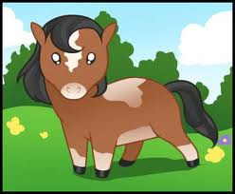 | animal | 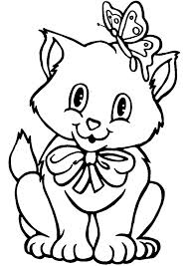 | animal | ?
food |  | food | ? | food | ? | food
colour | red | colour | red | colour | blued | colour | blue
animal | ? | animal | 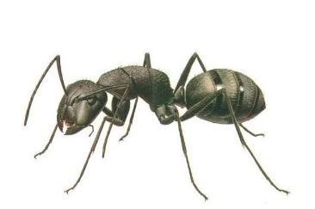 | animal | ? | animal
food |  | food | ? | food |  | food | ?
colour | greennn | colour | green | colour | yellow | colour | yellow
animal | ? | animal |  | animal | ? | animal
food | 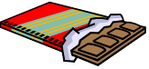 | food | ? | food | 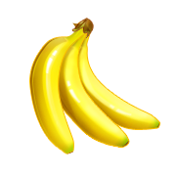 | food | ?
colour | black | colour | 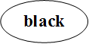 | colour | white | colour | white
animal | ? | animal |  | animal | ? | bird
food | 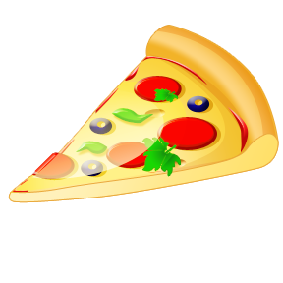 | food | ? | food | 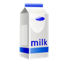 | food | ?
colour | pink | colour | pink | colour | brown | colour | brown

