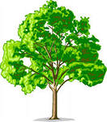
Appendix 3

Bark

Root
Fruit

Photosynthesis

Native range

Crown

Leave

