Индивидуальный раздаточный материал
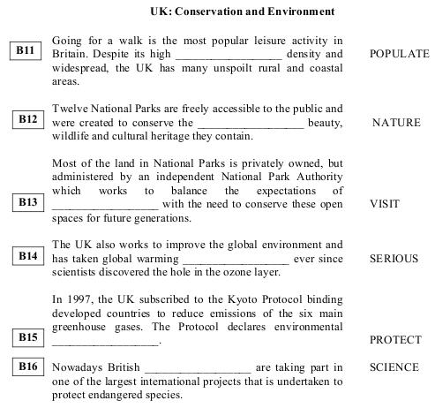

A cup of coffee
В4 Once I was travelling in Italy. It was a lovely day. I wandered  along the street until I came upon some parasol-shaded tables  which seemed to __________________ very nice. I settled and  opened my booк . | I
В5 It was taking a long time for the waiter to arrive, but I was in  no hurry. I was sure that the waiter __________________  soon. | COME
В6 But finally, becoming impatient, I turned to signal for service  and saw the neon sign. That was the __________________  moment ... I discovered that I was sitting outside a store selling  garden furniture. | BAD
The Great Wall of China
В7 The Great Wall of China runs for 6,700 kilometers from east to west of China. It is one of the __________________ wonders  of the world. | GREAT
B8 The Great Wall __________________ in order to protect  the country form different aggressors. | BUILD
B9 The construction of the Wall __________________ in the 6th  century BC and lasted until the 16th century AD. | BEGIN
B10 Since then, the Great Wall of China __________________  a symbol of wisdom and bravery of the Chinese people and  a monument to Chinese nation for many hundreds of years. | BECOME

A lesson on efficiency
В4 I remember my last year at school very well. There were three  boys __________________ William in my class. | NAME
В5 Miss Fisher, one of the teachers, called them all William, and  we __________________ which one she was talking to. | NOT KNOW
В6.One day, during a lesson on efficiency, she thundered,  “William, put that gum you __________________ in the  wastepaper bin at once!” All three of them started to rise,  paused, then walked to the front of the class to dispose of their  gum. The teacher beamed. “Three for one! Now that's  efficiency.” | CHEW
What country has no rivers?
В7 Hard to believe it, but there is such a country! Libya  __________________ in North Africa and borders on the  Mediterranean Sea. | LOCATE
В8 It’s the __________________ largest country on Earth. But more than 90 percent of Libya is desert, and there’s not a single permanent river in Libya! | FIFTEEN
В9 This huge country, more than four times the size of California,  has a __________________ population than a number of cities  in California. | SMALL
В10 Libya __________________ an independent nation in 1951. | BECOME
В11People travel a lot nowadays. Planes are considered to be the  most __________________ means of transport but for some  people airports can be a nightmare. | COMFORT
В12 There are __________________ queues when you check in and you waste lots of time if your flight is delayed. | END
В13 However, there are some airports where you can  __________________ enjoy yourself. | ACTUAL
В14 For example, you’ll never be bored at Hong Kong’s  international airport. There are thousands of people from  __________________ countries here but the passengers never  experience any problems because everything is well organised | DIFFER
В15There are attendants in red coats, who help you to get from one place to another. It’s very good for people with no sense of __________________. | DIRECT
В16The attendants are always very polite and __________________. | HELP

