Plan
Planned timings | Planned activities (replace the notes below with your planned activities) | Resources
Start  2 min.  7 min.  5 min.  6 min. | Before the lesson Teacher prepares the presentation of the house and the list with active vocabulary.  - Warming-up  Teacher: Нello, students!  How are you today?  Whole class  Look at the picture. What’s this? Yes, a house. Let’s repeat the names of the rooms. (They read orally)  Formative assessment (Teacher-based assessment)  The teacher monitors them and corrects the pronunciation if necessary.  Whole class  Teacher asks probing questions:  How many rooms can you see in the picture? Can you name these rooms? It’s a ….  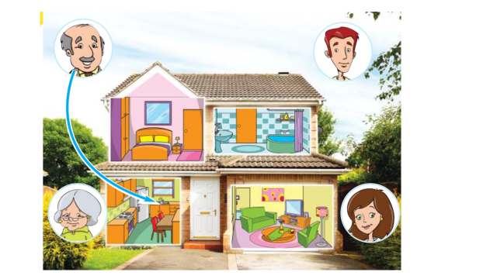  2. Pair work  Speaking  Teacher: Look at the picture!  Let’s talk about the family.  Modelling:  Where is Mummy? She’s in the kitchen.  The teacher distributes the pictures of the house to students, they use paper puppets of members of the family, ask and answer not less than 6 sentences.  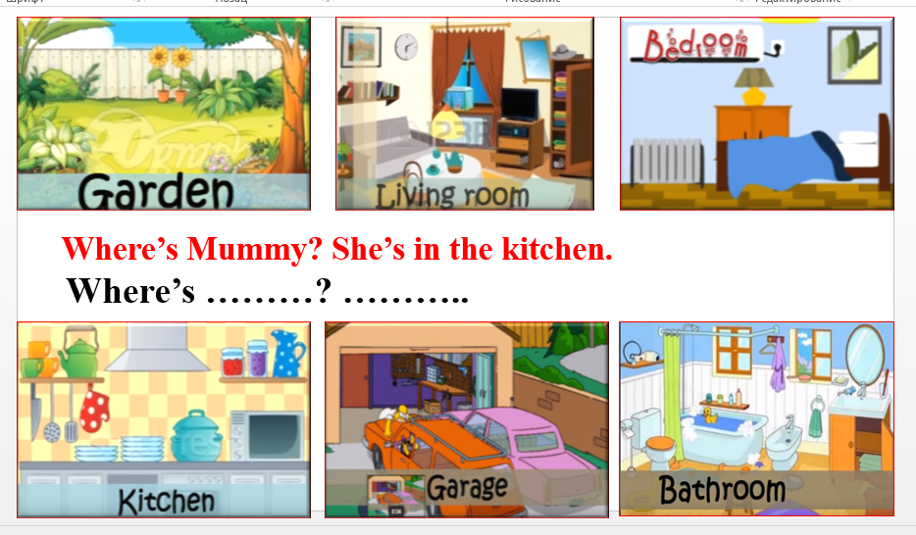  Checking comprehension through statements (True/False)  Teacher:  We ask the question: Where is….? (Yes/No)  We answer the question. (Yes/No)  How many questions do we ask? (6 questions and more)  Low-achieving students will ask 6 questions, high-achieving students will ask more than 6 questions. (Differentiation by task, pace and outcome)  Formative assessment (Teacher-based assessment)  The teacher monitors them and asks some of students to present their question and answer to the class.  3. Whole class  They revise the objects using 3by3 strategy – choral drilling for 3 times after the teacher, then individual drilling.  Individual work  Teacher: Now you!  Modelling: a black fork, a big mirror, a big kettle etc.  Teacher names the object+ adjective, the students do the same.    4. Individual work  Teacher: I have a video for you. It’s about the house. Watch the video. Then tick all the objects from the video which you can see or hear. (Teacher uses gestures to explain the task)  The teacher shows the handouts and distributes them to all the students.  Modelling:  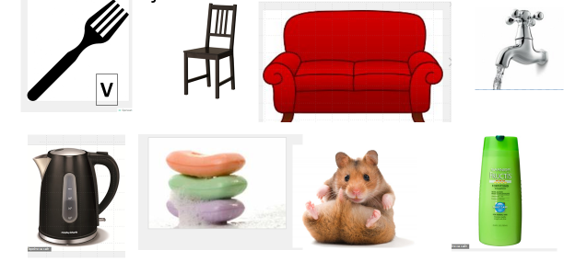  Checking comprehension through statements (True/False)  Teacher:  We watch the video (Yes/No)  We tick all the objects. (Yes/No)  We tick the all the objects which we can see or hear in the video. (Yes/No)  Teacher: Should we watch the video again?  Formative assessment (Criteria-based assessment):  2.L6 understand some specific information in short, slow, carefully articulated talk on routine and familiar topics  Formative assessment (Peer –assessment)  Teacher: Look at the slide and check your answers using the prompt on the slide.  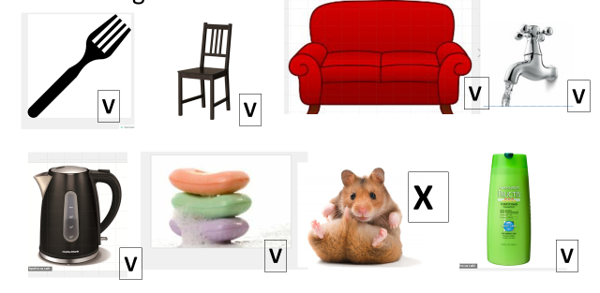 | A list of words: kitchen, bedroom, garden, living room, bathroom, garage  Presentation, slide 2  presentation, slide 3, children have the same handouts for pair work, paper puppets of family members  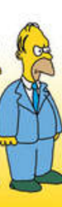  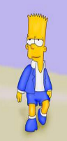  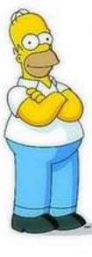  Presentation, slide 4.  presentation, slide 5  https://www.youtube.com/watch?v=j2qKo5_cwdc  presentation, slide 6
  Assessment criteria | Descriptors
  - Recognize words and directions pronounced in a video and follow them | A learner  - defines the correct pictures according to the video  - puts a tick under 7 pictures which were seen or named in the video  - puts a cross or nothing under the picture of a hamster
Middle  6 min.  2 min  5 min.  7 min. | 5. Post-watching activities, reading  Pair work  Teacher: now, let’s listen to Lucy and follow in the text.  The teacher distributes the texts from the video to all the students. They listen to the character (Lucy) and follow in the text. Then the students read the text in pairs working in turns.  Formative assessment (Peer –assessment, Teacher-based assessment)  They listen to each other and give feedback.  The teacher monitors them and corrects the pronunciation if necessary.  Energizer – “In the kitchen, bedroom, bathroom, living room song” (They sing and move)  6. TPS (Think-Pair-Share)  The teacher distributes the handouts to all the students. Students should fill in the gaps with one word given above. They do the exercise according to the text. High-achieving students can make up their own 1-2 sentences. (Differentiation by task, pace and outcome)  Modelling:  Teacher: It is in the bedroom. It begins from “d”. It’s a desk.  Checking comprehension through statements (True/False)  Teacher:  We read and write 2 words (Yes/No)  We read and write 1 word (Yes/No)  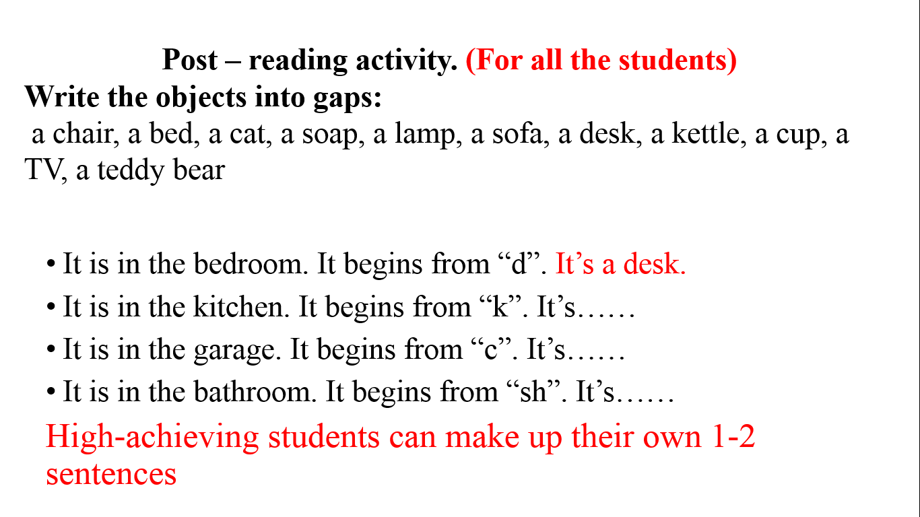  Formative assessment (Peer –assessment, Teacher-based assessment)  The students check each other’s papers and give feedback. The teacher monitors the students who made up their own sentences, praises them.  Checking the outcome: they read their words (or their own sentences) aloud and check.  7. TPS (Think-Pair-Share)  The teacher distributes the next handouts to all the students. They do the exercise according to the text. Low-achieving students write T/F, high-achieving students correct sentences. (Differentiation by task, pace and support)  Handout for low-achieving students:  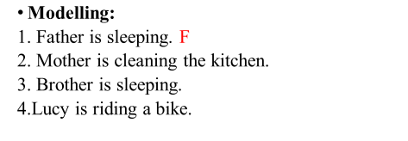  Handout for high-achieving students:  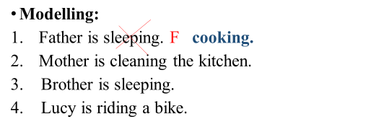  Checking comprehension through statements (True/False)  Teacher:  We write T or F (Yes/No)  We can correct sentences. (Yes/No)  Formative assessment (Teacher-based assessment)  The teacher monitors the students who made up their own sentences, praises them.  Checking the outcome: they read T/F statements (or their own sentences) aloud and check. | Handouts (texts)  The text  Hello! My name is Lucy. This is my home.  He is my grandfather. And she is my grandmother. It is my dog.  This is the kitchen. He is my father. He is cooking. This is a cup. This is a kettle.  This is the living room. She is my mother. She is cleaning the room. This is a sofa.  This is the bedroom. He is my brother. He is sleeping. This is a bed. My brother is in the bed.  This is the bathroom. This is the soap. This is the shampoo.  This is the playroom. She is my sister. This is the teddy bear. It is on the chair.  This is the garage. This is a car. This is a cat. It is under the car.  Energizer https://www.youtube.com/watch?v=EJ1uN6Oo6-  Presentation, slide 7  The children have  the same handouts for individual work  Presentation, slide 8, 9  The children have  the same handouts for individual work
End  3 min.  2 min. | 8. Home task explanation.  Teacher: Look at this girl. Do you like her house? Is it big or small?  The girl says:  “This is my house.  I have a living room. It’s big.  I have a table. It’s small..”  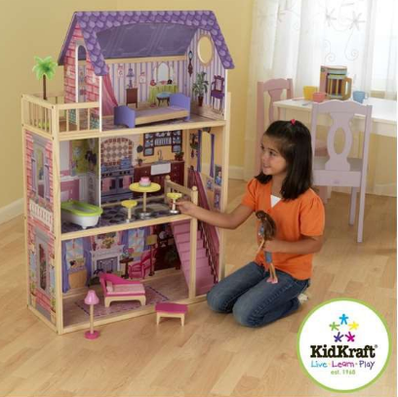  Individual work  Teacher: Draw your house.  Write not less than 5 sentences about your house.  You have the words on the papers. They can help you. (The words are: a house, big, small, nice, garden, car, bath, etc,)  Modelling: You write:  This is my house.  I have a… It’s….  Low-achieving students will write 5 sentences, high-achieving students will write more than 5 sentences (Differentiation by home task)  Checking comprehension through statements (True/False)  Teacher:  You work in pairs. (Yes/No)  You draw your house. (Yes/No)  You write about your house.(Yes/No)  How many sentences? (5 or more)  Teacher: you finish your task at home and tell us about your house at the next lesson.  Feedback – thanks for your answers. Tell me, please, what topic we have today?  Teacher uses voting and “The tree of mood” to get feedback.  Raise your hands, if you think that you can name 5(7, 10) words about the house.  How many sentences about your house can you make up?  In your garden you have “The tree of mood”. Take the smiles and put them on the tree. If you are happy at this lesson, take a happy smile. If you are tired or sad, take a sad smile. | Presentation, slide 10  Sheets of paper with words:  kitchen, bedroom, garden, living room, bathroom, garage, bath, a fork, a knife, a plate, a glass, a cup, a kettle, a sofa, soap, shampoo, a towel, a mirror, a tap, playroom  Tree of mood, happy and sad smiles

