Read each statement and match column A (Type of travel) with column B (Reason for Travel). Use the given table in the presentation. | Statement | Type of travel A | Reason for travel B
 | People from all over South Africa travelling to the Grahamstown arts festival | 2, 4 | 3, 5
 | An American business man travels to attend a meeting in Cape Town
 | A young boy from Limpopo visiting his uncle in Soweto
 | A mother and daughter from  Manchester travelling to the Lake District for a spa weekend.
 | A group of school learners on an educational visit to the Zoo
 | A retired teacher moves to stay permanently with his wife in Australia
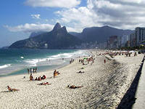 | A family travelling from Brazil to Durban to spend time on the beach
 | A student doing his three year degree in UK
Черкасова Вера Николаевна 232-058-251

