Министерство образования и науки Российской Федерации
Йошкар-Олинский аграрный колледж ГОУ ВПО «МарГТУ»

Рабочая тетрадь
по дисциплине «Иностранный язык»
к открытому уроку для студентов IV курса
специальности 110810.51
«Электрификация и автоматизация сельского хозяйства»

Инструкция по работе с тетрадью:

1. Внимательно слушать объяснения преподавателя;
2. Выполнять задания в специально предоставленное на занятии время;
3. Чётко следовать инструкции по выполнению каждого задания;
4. Записи в тетради выполняются ручкой или карандашом по согласованию с преподавателем.

Студенту разрешается делать записи карандашом на полях тетради, если возникли трудности при выполнении заданий для самостоятельной работы, чтобы в дальнейшем получить консультацию преподавателя.

Unit 2 Receiving of current.

LESSON 9
SAFETY MEASURES FOR ELECTRICIAN AT WORK

Цели занятия:
- обобщить и систематизировать знания по теме занятия;
- раскрыть особенности системы мер безопасности в работе электрика, принятых в международном сообществе;

Task 1. Read the sentences. Fill in the gaps with the words in the box.
Translate the sentences.

Don’t, might, must, mustn’t, should, shouldn’t

1. You _____________ run in the corridor during the lessons or breaks.
2. ______________ touch the alarm button.
3. You ___________ wear sport suits at the lessons, except PT lessons.
4. Be careful! Heavy snow on the roof. You ______________ get injured.
5. You _____________ come for the lessons in time.
6. You _____________ use your mobile phone in case of emergency.
7. ______________ bring flammable or toxic barrels to college.

Task 2. Read the text and march the signs to the description:

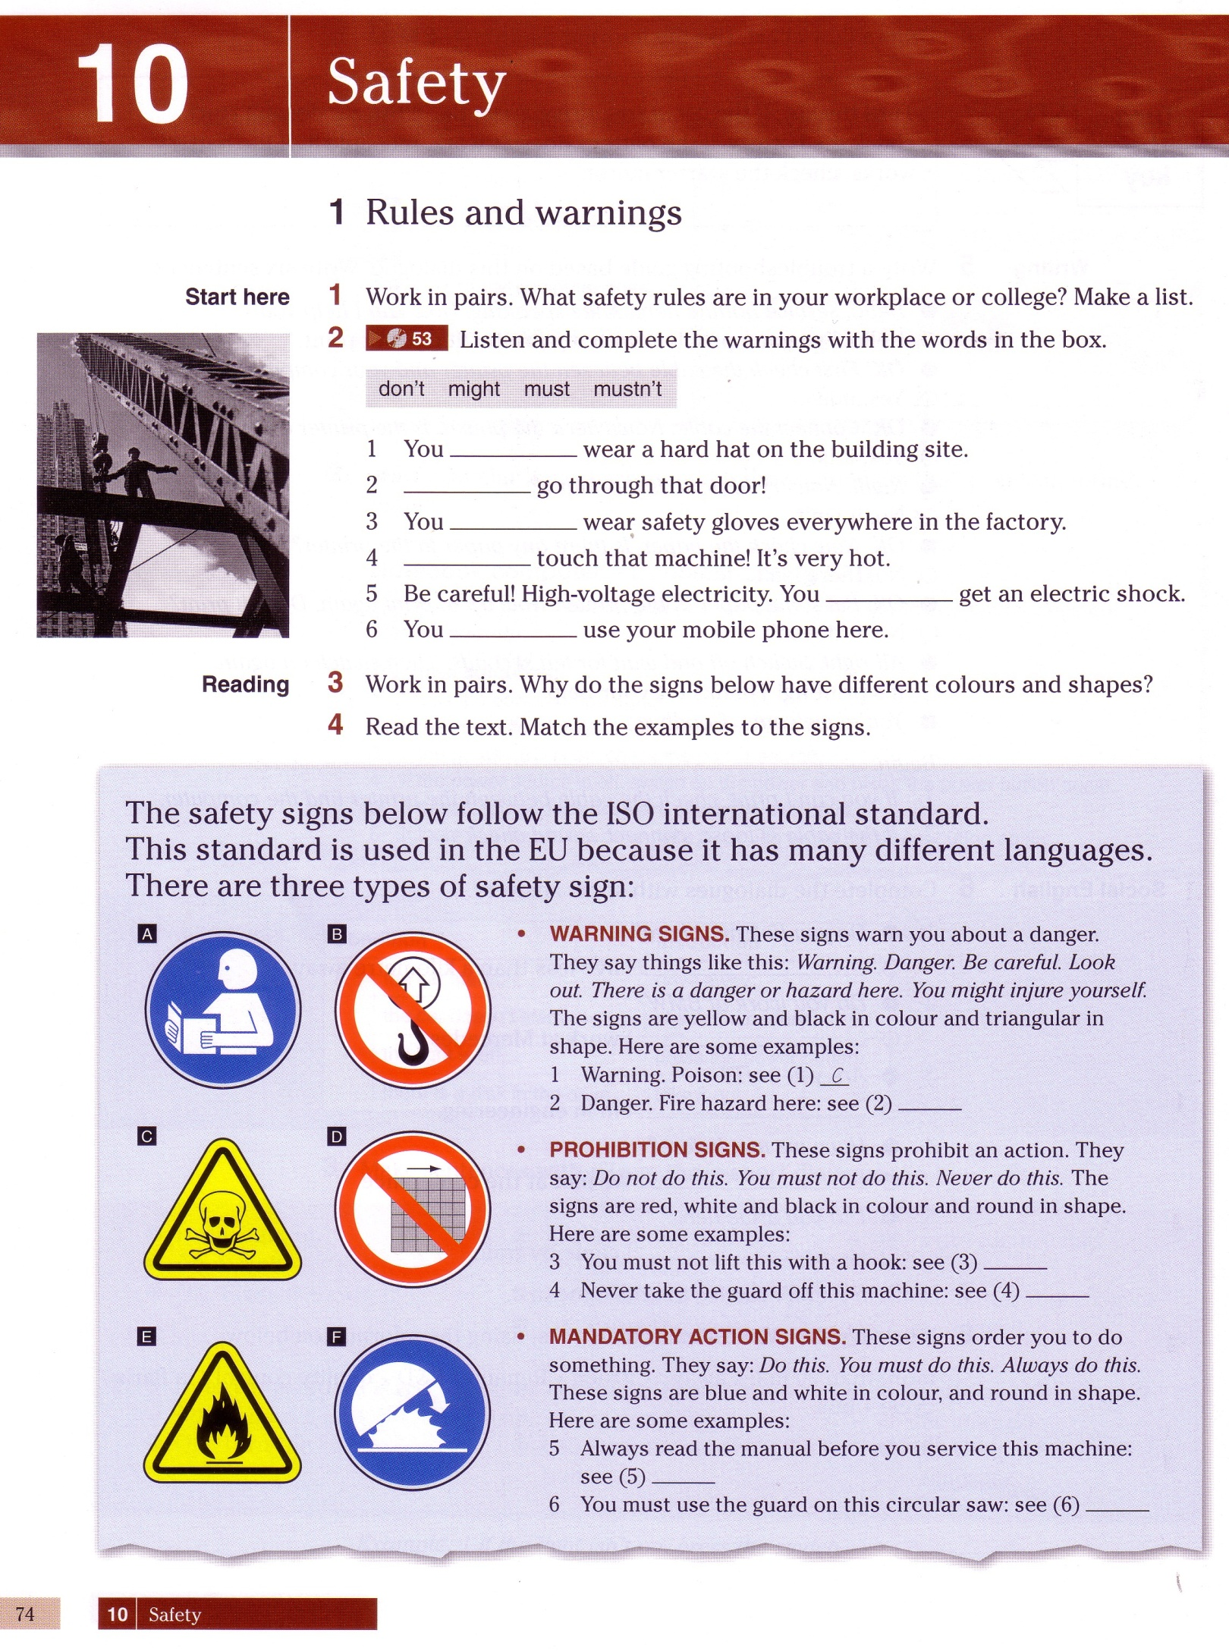

1 | 2 | 3 | 4 | 5 | 6
C
Answer the questions:
1. What is the ISO? 2. What colours are used for warning signs? 3. What colours are used for prohibition signs? 4. What colours are used for mandatory signs?

Task 3 Look and say: Which of these signs are warning, prohibition or mandatory?

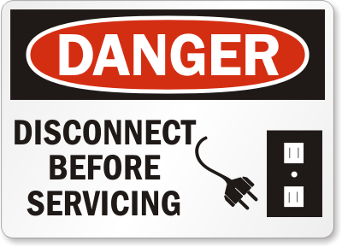 |  | 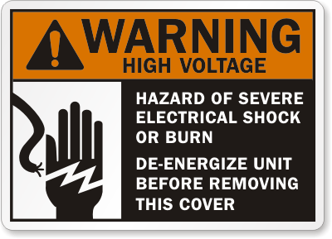 | 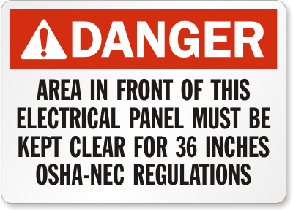
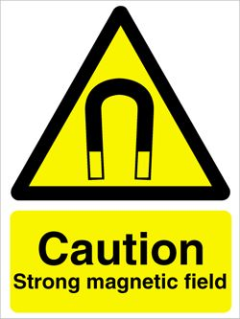 | 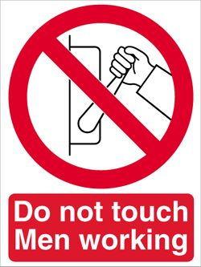 |  | 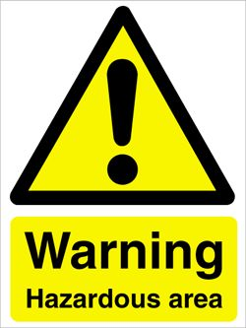

Task 4 Match the signs to the instructions. There is one odd instruction.
Put your answers into the grid bellow:

1 |  | A. Don’t put anything on the electric panel.  B. You mustn’t switch on! It’s dangerous for other people.  C. Be careful in this area.  D. Don’t put anything in front of this electric panel.  E. Be careful and protect your hands.  F. Be careful and protect your head.  G. You can get an electric shock.  H. Your mobile phone might not work here.  I. You must disconnect the power source before servicing. |  | 5
2 |  |  |  | 6
3 |  |  |  | 7
4 | 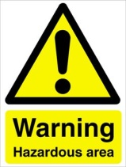 |  |  | 8

1 | 2 | 3 | 4 | 5 | 6 | 7 | 8

Task 5. Complete the chart with amount of current allowed for each line:

Current level  (in milliamperes)* | Probable effect on human body
 | Perception level. Slight tingling sensation. Still dangerous under certain conditions.
 | Slight shock felt; not painful but disturbing. Average individual can let go. However, strong involuntary reactions to shocks in this range may lead to injuries.
 | Painful shock, muscular control is lost. This is called the freezing current or "let-go" range.
 | Extreme pain, respiratory arrest, severe muscular contractions. Individual cannot let go. Death is possible.
 | Ventricular fibrillation (the rhythmic pumping action of the heart ceases.) Muscular contraction and nerve damage occur. Death is most likely.
 | Cardiac arrest, severe burns and probable death.

Task 6 Read the sentences and choose the correct item:
1. A man has climbed
a) a power pole, b) an electric tower
2. The rescue man was informed that power had been
a) put on the line, b) put off the line.
3. When he touched the wire……………. jawed him
a) 50 thousand volt, b) 15 thousand volt
4. Fortunately his ………… prevented him from falling
a) safety strap, b) safety cap
5. He was treated for surprisingly
a) major injuries, b) minor injuries.

Task 7 Listen to the recording. Read the text and fill in the gaps with appropriate words:
A ground fault 0) circuit interrupter is an electrical device which protects personnel by 1) ……..…. potentially 2) …………… ground faults and quickly 3)………….. power from the circuit. A potentially dangerous 4) .............… fault is any amount of 5) ……… above the level that may deliver a dangerous 6) ………….. Therefore, GFСIs are required in such places as 7) ………….., hotels, construction sites, near swimming pools, hot tubs, fountains and other wet places. | ground  disconnecting  circuit  current  hazardous  dwellings  detecting  shock
 |  | 0

Task 8 Watch the video episode 2 and put the steps of the “lockout-tag out”
procedure into correct order:

Apply completed tags
Notify personnel
Shut down, isolate, lock or block
Flag if appropriate
Initial evaluation
Try equipment
Clear the area

Task 9 Complete the report paper. Use the information from the video episode 1.
For the “Description of accident” use your answers in task 6

About the accident |  | About the injured person
Date: ___Sept, 17_____________  Time:___11.40 am____________  Location: ___________________  Height above the ground: _______ |  | Name: _Steve_Robinson_____  Job title: __________________  Injury: ____________________
Type of accident (tick one box) |  | Description of accident
• lifted something and injured self |  | ……………………………….......  ……………………………………  ……………………………………  ……………………………………  ……………………………………  …………………………………..
• received an electric shock
• slipped, tripped or fell on the same level
• fell from a height
• other

AFTER ACTION REVIEW

Now I know | well | not well | so-so
Safety signs

Potential hazards at work

First aid for electric shock

Means of individual protection

Protective equipment

Safe work practices

How to report an accident

Remember!
No matter what type of electrical hazards confronts you,
always stop to notice what’s going on
and think about safe plan of action.
Thoughtful action is the best strategy
for any electrical emergency.

BE SAFE AND DON’T TAKE CHANCES!

