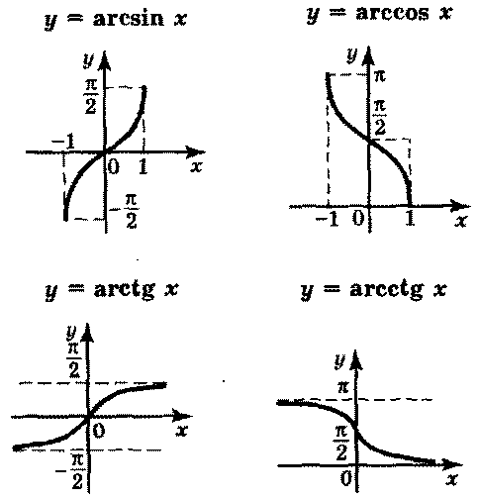

$$\sin^{2}x+\cos^{2}x=1;$$

$$tgx=\frac{sinx}{cosx}; ctgx=\frac{cosx}{sinx};$$

$$tgx∙ctgx=1;$$
$$1+{tg}^{2}x=\frac{1}{\cos^{2}x};$$

$$1+{ctg}^{2}x=\frac{1}{\sin^{2}x};$$

sin(x±y)=sinxcosy$±cosxsiny$;
cos(x±y)=cosxcosy$∓sinxsiny;$

tg(x$±y$)=$\frac{tgx±tgy}{1∓tgxtgy};$ tg2x=$\frac{2tgx}{1-{tgx}^{2}};$ $ctg\left(x±y\right)=\frac{ctgxctgy∓1}{ctgx±ctgy}; ctg2x=\frac{{ctg}^{2}x-1}{2ctgx};$

sin2x=2sinxcosx;

cos2x=$\cos^{2}x-\sin^{2}x;$

$\cos^{2}\frac{x}{2}=\frac{1+cosx}{2}$;

$$\sin^{2}\frac{x}{2}=\frac{1-cosx}{2};$$

$${tg}^{2} \frac{x}{2}=\frac{1-cosx}{1+cosx};$$

sinx+siny=2sin$\frac{x+y}{2}cos\frac{x-y}{2};$
sinx-siny=2cos$\frac{x+y}{2}sin\frac{x-y}{2};$
cosx+cosy=2cos$\frac{x+y}{2}cos\frac{x-y}{2};$
cosx-cosy= - 2sin$\frac{x+y}{2}cos\frac{x-y}{2};$
sinxsiny=$\frac{1}{2}\left(cos\left(x-y\right)-cos\left(x+y\right)\right);$
cosxcosy=$\frac{1}{2}\left(cos\left(x-y\right)+cos\left(x+y\right)\right);$
sinxcosy=$\frac{1}{2}\left(sin\left(x-y\right)+sin\left(x+y\right)\right)$

