Appendix №1
General levels of superstitious behavior and belief
Russia
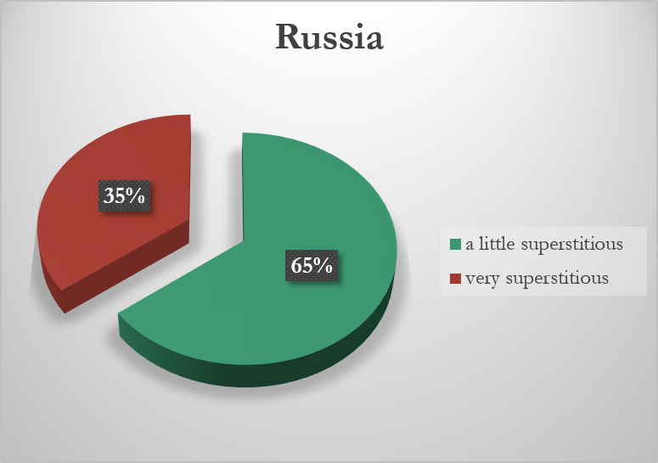

England

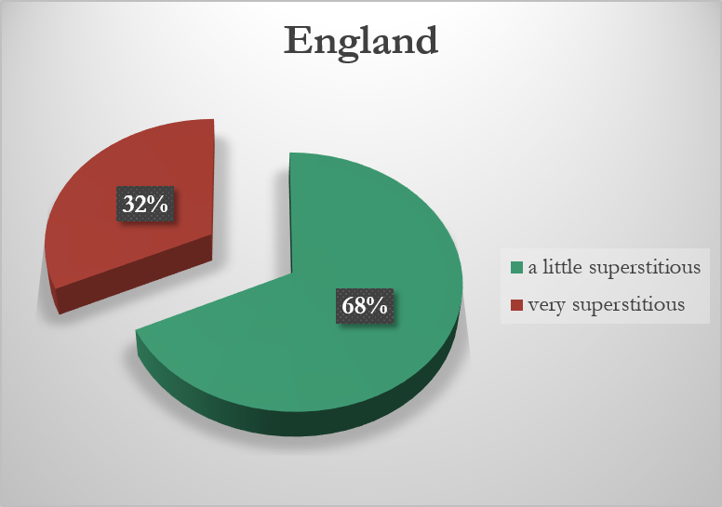

Appendix №2

Rank superstition % of people endorsing each superstition

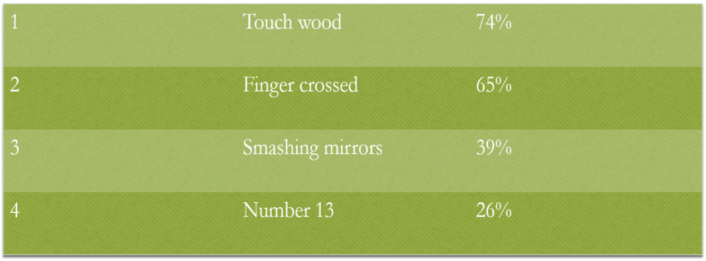

Appendix №3

What sort of people are superstitious?

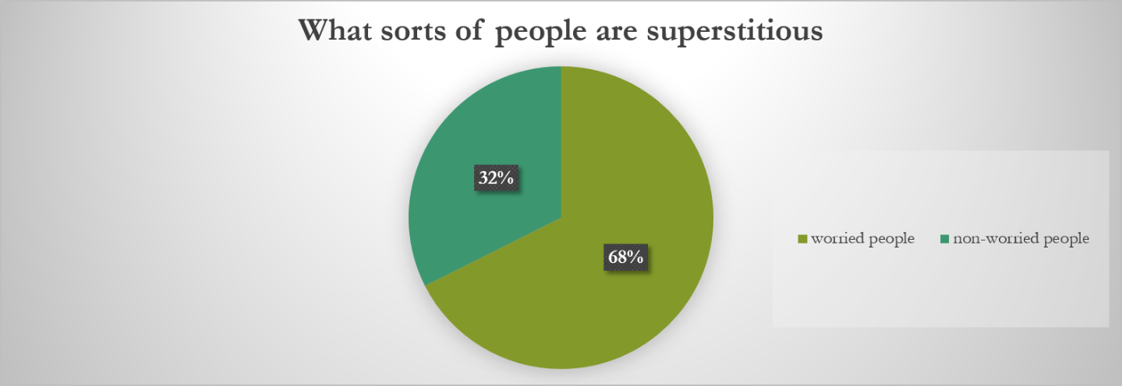

Appendix №4

Tests
The first test
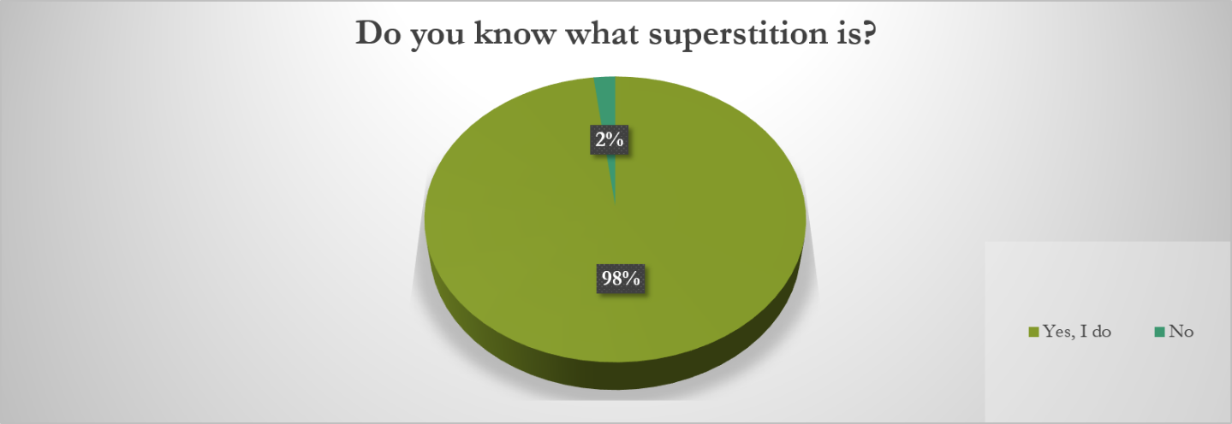
The second test
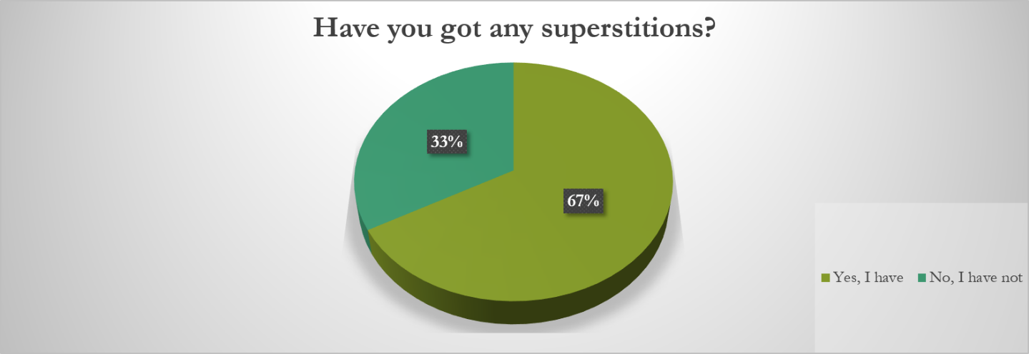
The third test
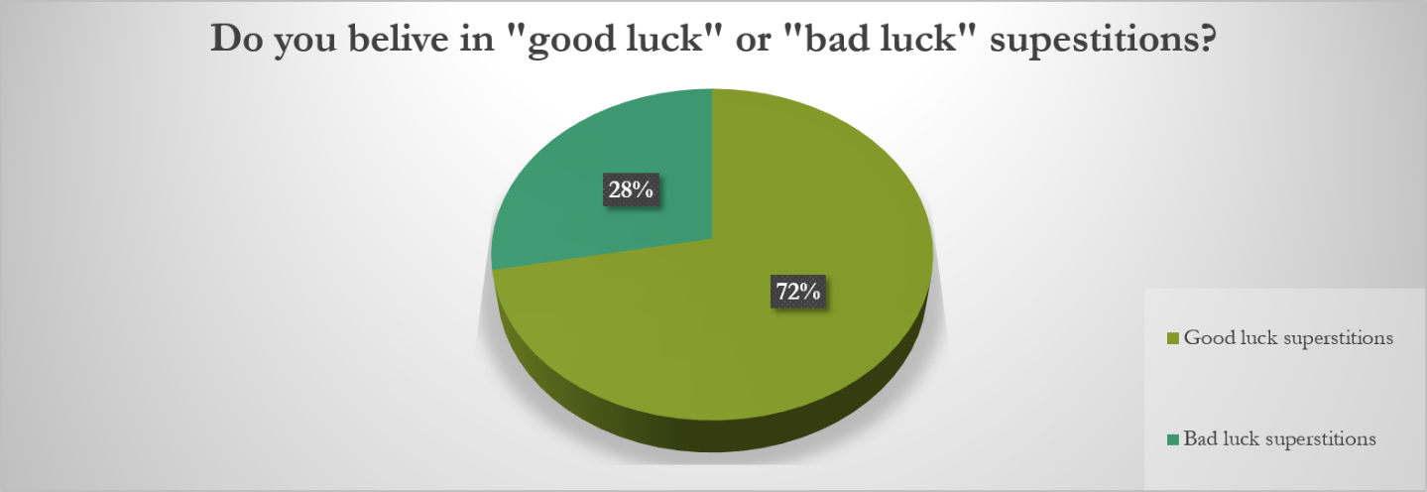

Appendix №5
Differences
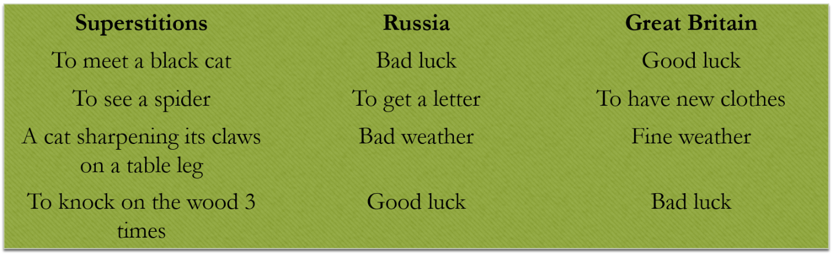
Similarities
