Unique Beauty
Altai Nature Reserve
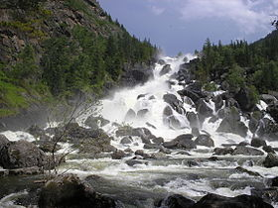
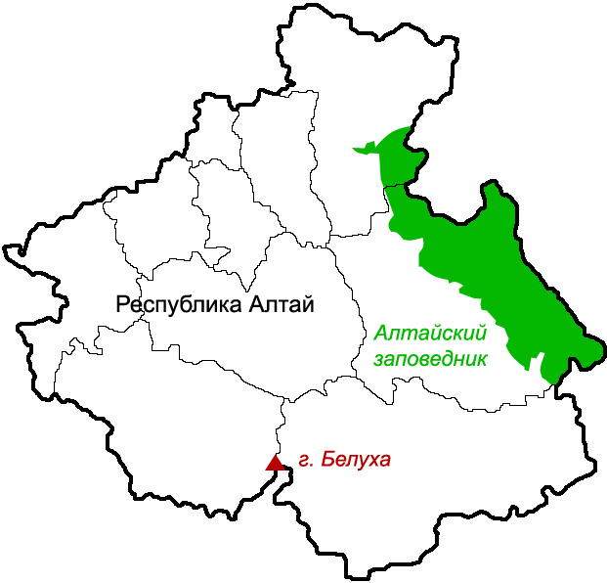
The Altaiskiy State Nature Reserve was established in 1932 on the right shores of the Teletskoye Lake and in the upper reaches of the Chulyshman River.
The reserve has an elongated shape running from the northeast to southwest along the Teletskoye basin and into the high interior.
Elevations rise to 3,500 metres (11,500 ft).
On the high plateaus there are over 1,000 alpine lakes greater than 1 hectare in size.
This ecoregion is characterized by mountains dissected by river valleys, high levels of precipitation, and high biodiversity.
Because of continental climate and constant process of pedogenesis on the territory of the reserve you can meet very peculiar soil complexes.
Flora is generally dependent on the elevation and terrain, with forest having three main subzones based on altitude: light needle-leaf sparse taiga, dark needle-leaf taiga, and dark taiga.
The diversity of flora and fauna makes this place one of the leading Russian reserve in variety of species.
One of the main purposes of establishing this nature reserve is saving the beautiful and unique Teletskoye Lake, relief of mountains, protection of cedar woods and hunting-commercial animals.

Tigirekskiy Nature Reserve
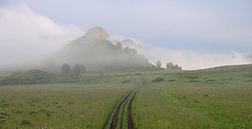
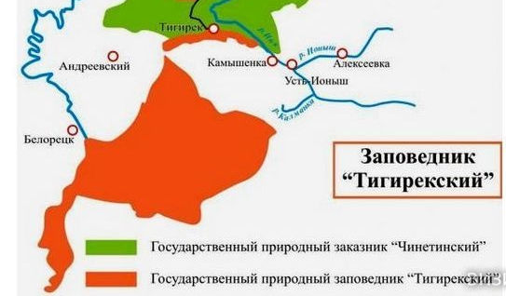
The reserve was established for the protection and study of the relic pre-glacial dark taiga of the higher elevations, and the mountain-steppe of the river valleys and lower regions.
The site features extensive karst landscape and caves.
The reserve is situated in the Zmeinogorsky, Tretyakovsky and Krasnoshchyokovsky districts of Altai Krai.
It was formally established in 1999.
Tigirekskiy is located in the Kazakh forest steppe ecoregion, a steppe region with long ""ribbon forests"" of pine; about 300–500 miles more northerly than the European Russian forest.
There are two general types of plant communities in Tigireksky: forest-steppe in the north and west on smooth domed mountains, and dark taiga along the Tigirek Ridge.
Scientists on the reserve have recorded 811 species of vascular plants.
The reserve hosts the full range of western Altai dark taigi and forest-steppe animals: 67 species of mammal have reported on the site.
Common mammals are the brown bear, red deer, roe deer, moose and especially hare.
All 11 species of bat known to live in the Altai region are found in the caves around the village of Tigirek.
Scientists on the reserve have recorded 142 species of birds.
This ecoregion has more wetlands and more continental climate than the European forest steppe.
Tigirekskiy reserve was created to ensure that biological diversity will be saved and to maintain natural condition of this ecological complex.

Kulundinskiy Nature Reserve
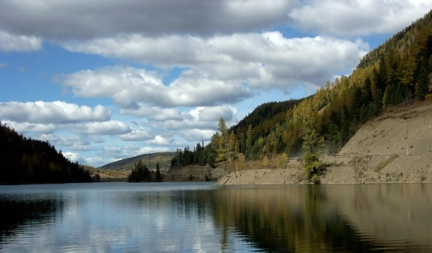

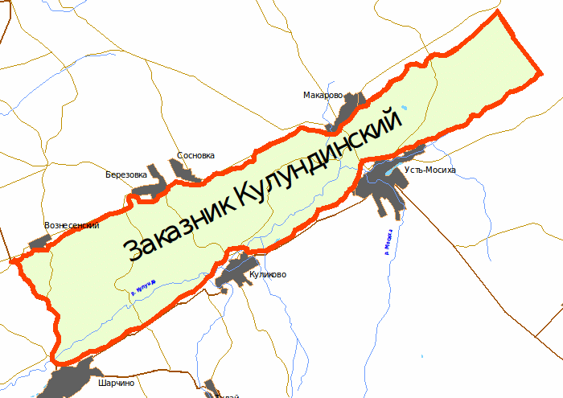
Kulundinskiy Nature Reserve was established in 1966.
It is located on the west part of Altai krai near the village Kulunda.
Kulundinskiy reserve covers the total area of 14000 ha.
Territory of this reserve includes Lake Kulundinskoe – the biggest lake of the Altai district – and contiguous territories.
Though one of the main targets is to save ecosystems of the lake, it covers only 3% of the reserves’ territory.
The lake and the mouths of the rivers flowing into it are important as habitats of nesting and migrating waterbirds.
Kuludinskiy reserve covers different ecosystems such as steppe, solonchaks, solonchakovie meadows.
Also there is presented very rare and beautiful nature complex - ribbon forest that exists only at West Siberia and north Kazakhstan.
Overall it was stated that 158 species of different plants exist here, among them is lady’s slipper that is endangered in Altai krai.
Fauna is presented here by beavers, hares and other species of mammals typical to the pine woods.
Most of the actual fauna are birds.
Another reason to point out the importance of Kulundinskiy reserve is that some birds that are mentioned in the Red Data Book have this place as their natural habitat, for example the greater spotted eagle.

