finally the War of Saint-Sardos (1324), thus reducing England's hold on the continent to a few small provinces in Gascony and the complete loss of the crown jewel of Normandy.
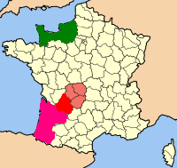
English lands on the Continent after the Treaty of Paris
Normandy (France) Aquitaine
Limousin Gascony

