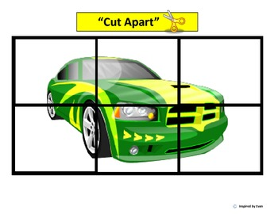

We

often

play

sports

at

school.
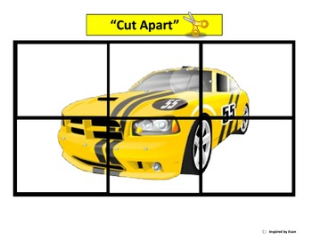
We

usually

play

football

and

basketball.

