- Received Pronunciation  - Cockney  - Kent  - Sussex  - South East  - West Country  - Bristol  - Devon  - Anglo-Cornish  10. Cambridgeshire | 11. Norfolk  12. Suffolk  13. East Midlands  14. West Midland  15. Brummie  16. Potteries  17. Welsh English  18. Lancashire  19. Scouse  20. Mancunian  21. Yorkshire | 22. Pitmatic  23. Geordie  24.Northumbrian  25. Cumbrain  26. Scots  27. Highland Scottish  28. Ulster English  29. Ulster Scots  30. Cheshire  31. Cornwall
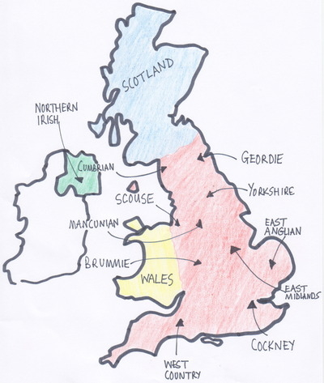
The main accents are:

