Приложение 1
The first letter to a pen-friend
Form 6
Lesson1.
Warming-up: Many children live in small families. They haven’t got any sisters or brothers. But they have friends. Answer the questions.
- Is your family big or small?
- Have you got any sisters or brothers?
- Have you got many friends?
- How much time do you spend with your friends?
- Would you like to have pen-friends?

The steps of the lesson:
Ex. 1 Susan, from the USA, wants to find out a pen-friend in Russia. She wrote a letter and put a photo of her family. Read the letter and complete the information about Susan’s family members.

- Tony is Susan’s ………...
- …………… is her mother.
- …………… and …………… are Tony’s ……………
- Jack is children’s …………….
- ……………. is Susan’s sister.

Hello, guys!
It's great to have a pen friend. My name is Susan. I'm really happy to write to you and tell you about my family.
I'm a student and I live with my family in Maryland, USA. I'm short and slim with long brown hair and green eyes. My brother's name is Tony. He's six years old. He's got short fair hair and blue eyes. He's too noisy. Jane, my sister, is tall with blonde hair and blue eyes. She is an attractive girl of seventeen.
My mother's name is Rose. She's thirty-nine years old and she's a dentist. She's not tall, she's very pretty, kind and friendly. She's got curly brown hair and brown eyes.
My dad's name is Jack. He's forty-two years old and he's a teacher of English. He's quite tall and he's got short fair hair and green eyes. He's very clever.
This is a picture of all of us in the garden. There's my dad, my mum and my sister in the centre. My brother and me are sitting on the bench.
Please write me soon, tell me about your family and send me a photo of all of you. Have you got any brothers or sisters? What about your family members’ occupations? Have you got any pets? What's your favourite sport? What's your favourite music?
Susan.

Ex.2. In her letter Susan describes the appearance of her family members. Look through the letter again and find the sentences which describe Susan, her mother, father, sister and brother.
Ex.3. Susan’s family members have got different occupations. Look at these pictures and try to guess who these things belong to. Why do you think so?
Use the example: I think …... …… belong to……..., because ……...

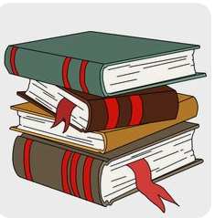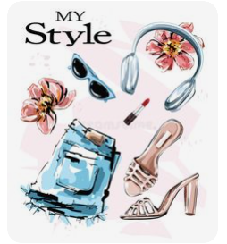

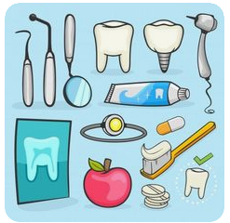

Ex.4. What do you know about Susan’s family? To check yourself scan the letter, find and read out the sentences which are close in meaning to the following ones.
- Susan is not tall and not fat.
- Her father teaches students.
- Her mother is Rose.
- Susan’s brother is six.
- Susan’s hair is not short.
- Her eyes are green.
- She doesn’t work, but study.
- Tony’s her brother.
- His hair is blond and his eyes are blue.
- Tony likes to make noise.
- Susan’s sister is beautiful.
- Her mother’s hair is not straight.
- The picture of Susan’s family is taken in the garden.
Homework: answer the questions from Susan’s letter.

