K 2. Divide the text into paragraphs and write their headings and the title of the text.
________________________________________
Nowadays, people around the world are hanging out there. More than half of all people on the Internet belong to one and go there every day so everybody’s talking about social-networking sites. A social networking site is an online place or a website that is designed to help people communicate and share information, photographs, videos and music with a group. To join a social-networking site, you need an email address. After you fill out your profile, you get a webpage. You control your page and can change it as often as you like. You can write about your hobbies, add photos and music you like. Then you link to your friends’ pages – and decide who can link to yours. Be careful about the information you give and who you give it to! Set your profile so only your friends can see it and only add people who are your friends. Never write your address, phone number or email address online for others to see! Never agree to meet up with someone you’ve met online without telling your parents. Many sites have safety features. Follow the tips they give about online safety. Never set up a profile without telling your parents! There are some advantages of social network. First, if you have a business or a personal brand, social networking can help you reach a larger audience and build your brand. Second, social networking sites are a great way to find people who share your interests and hobbies. Then, social networking sites allow you to showcase your skills and talents to a wider audience. Moreover, social networking sites can be a great source of information and knowledge. Finally, social networking sites can help you stay up-to-date with news and events happening in your country or around the world. There are some disadvantages of social networking sites. The main one is cyberbullying. People can easily hide behind fake profiles and hurt others with their words. Another disadvantage is addiction because spending too much time on social media can lead to addiction. Also, social media can be a major distraction from real-life activities, such as schoolwork, work, and socializing in person. It can also negatively impact one’s ability to focus and concentrate.

- ___________________________________________
- ___________________________________________
- ___________________________________________
- ___________________________________________
- ___________________________________________

K2 МНОГОКРАТНАЯ ЛОГИЧЕСКАЯ ПЕРЕРАБОТКА
- Match the notions and their definitions.
notions | definitions
- stay in touch | - being with your friends, doing nothing special
- photo-sharing | - a ____________ thing is one that many people like
- hanging out | - to keep in contact with other people
- strangers | - a description of a person, maybe with a photo, hobbies, likes and dislikes
- announced | - special parts of a website about something in particular, e.g. videos or music
- profile | - people you do not know
- popular | - when something was said publicly
- details | - a type of website where other people can see your pictures
- features | - a part or piece of something, a division _____________
- section | - small facts and information

1 _____ 2 _____ 3 _____ 4 _____ 5 _____ 6 _____ 7 _____ 8 _____ 9 _____ 10 _____

- Complete the mind-map with notions and linking words from the table.
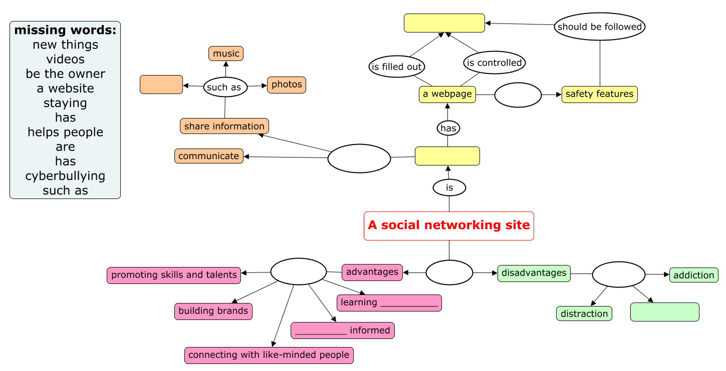

КОНТРОЛЬ ПЕРВИЧНОГО УСВОЕНИЯ

- Дополните таблицу «Advantages and disadvantages of social networking sites” недостающей информацией.

Advantages | Disadvantages
- ________________ skills and talents | - Cyberbullying
- ________________ with like-minded people | - Distract
- _______________ brands | - ___________ addicted
- _______________ informed
- _______________ new things

- State whether the sentences are True, False or Not Stated. Correct false sentences.

1. More than half the teenagers in the world belong to a social-networking site. T / F / NS
2. You should never add your personal details to your social-networking site. T / F / NS
3. You have to be 18 years old to join social-networking sites. T / F / NS
4. Any person can change information on the website. T / F / NS
5. The first website was set up by a US university student. T / F / NS
6. All social networking sites are free of charge. T / F / NS
7. Social media can distract from schoolwork, work and socializing. T / F / NS

K2 Answers
МНОГОКРАТНАЯ ЛОГИЧЕСКАЯ ПЕРЕРАБОТКА
- Match the notions and their translation.
C
I
A
F
G
D
B
H
E
J

КОНТРОЛЬ ПЕРВИЧНОГО УСВОЕНИЯ
Task 1
Advantages | Disadvantages
- promote skills and talents | - Cyberbullying
- connect with like-minded people | - Distract
- build brands | - become addicted
- stay informed
- learn new things

Task 2 State whether the sentences are True, False or Not Stated. Correct false sentences.
1. F
2. T
3. NS
4. F
5. NS
6. F
7. T

