Фигуры в координатной плоскости

1 Рыбка

(3; №), (0; 3), (-3; 2), (-5; 2) (-7; 4), (-8; 3)
(-7; 1), (-8; -1), (-7; -2), (-5; 0), (-1; -2), (0; -4)
(2; -4), (3; -2), (5;-2), (7; 0), (5; 2), (3; 3),
(2; 4), (-3; 4), (-4; 2) глаз (5; 0)
№ 1
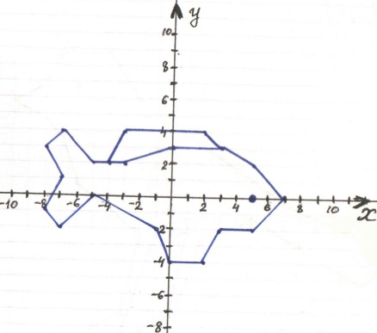
№ 2 Воробей

(15; -2), (8; 1), (-1; 7), (-3; 10), (-6; 10),
(-7; 8), (-9; 7), (-7; 6), (-6; 5), (-5; 2), (-1; -1)
(-2; -6), (-4; -7), (-2; -7), (0; -1), (2; -1), (1; -6)
(-1; -7), (1; -7), (3; -1), (4; -1), (6; 0), (13; -4)
(15; -2) глаз (-5; 8)
№ 2
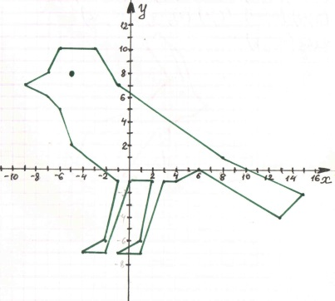
№ 3 Заяц

(1; 7), (0; 10), (-1; 11), (-2; 10), (0; 7), (-2; 5), (-7; 3), (-8; 0), (-9; 1), (-9; 0), (-7; -2), (-2; -2), (-3; -1), (-4; -1), (-1; 3), (0; -2), (1; -2), (0; 0), (0; 3), (1; 4), (2; 4), (3; 5), (2; 6), (1; 9),
(0; 10) глаз (1; 6)
№ 3
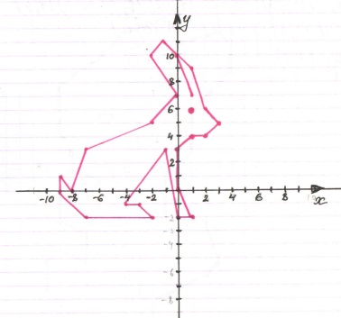
№ 4 Зайчишка

(1; -12), (1; -10), (5; -8), (6; -7), (5; -4),
(2; -4), (2; -1), (4; 1), (4; 4), (7; 7), (7; 9),
( 6; 10), (3; 9), (3; 10), (2; 11), (-1; 10),
(-3; 8), (-6; 6), (-6; 3), (-5; 1), (-5; 0), (-3; -1)
(-4; -2), (-6; -2), (-6; -4), (-4; -5), (-4; -7),
(-6; -6), (-7; -7), (-7; -9), (-4; -12), (1; -12)
Глаз (-3; 4), (-2; 4), (-2,5; 3), (-3; 4)
№ 4
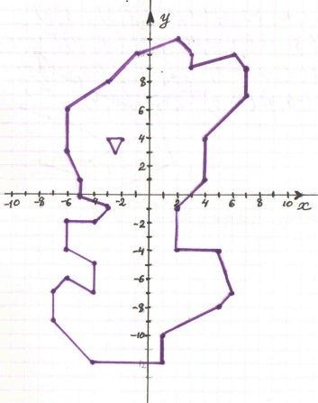
№5 Лебедь

(4; 9), (3; 9,5), (3; 10), (2; 10), (0; 8), (0; 7)
(1; 5), (0; 5), (-1; 8), (-4; 9), (-6; 10), (-8; 12)
(-7; 10), (-9; 11), (-7; 9), (-9; 10), (-8; 8),
(-9; 8), (-7; 7), (-6; 7), (-2; 5), (-4; 4), (-8; 4)
(-5; 3), (-5; 2), (-2; 2), (0; 3), (2; 4), (1; 7)
(1; 8), (2; 9), (4; 9) глаз (2,5; 9,5)
№ 5
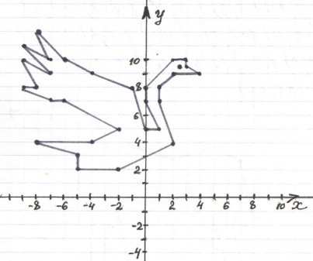

№ 6 Волк

(7; -3), (8; -2), (7; 2), (5; 3), (2; 2), (-1; 3)
(-3; 4), (-5; 6), (-5; 7), (-6; 6), (-7; 6),
(-7,5; 5,5), (-10; 5,5), (-9,5; 4,5), (-7; 4),
(-5; 2), (-5; 0), (-4; -2), (-4; -5,5), (-5; -6,5)
(-4; -6,5), (-3; -5,5), (-3; -3), (-2; -2), (-2; -1)
(1; -1), (3,5; -0,5), (5; -2), (6; -5,5), (5; -6,5),
(6; -6,5), (7; -5,5), (6,5; -2,5), (7; -1), (7; 0) и (-2; -2), (-1,5; -5,5), (-2,5; -6,5), (-3,5; -6,5)
(-2,5; -5,5), (-3; -3) и (5; -2), (5; -5), (4; -6), (5,5; -6) глаз (-7; 5)

№ 6
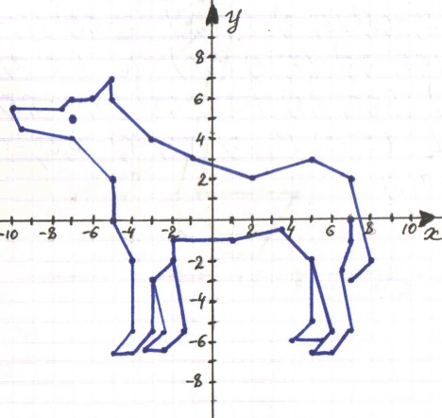
№ 7 Гусь

(3; 12), (2; 12), (2; 11), (3,5; 12,5), (4; 12,5)
(4; 11), (2; 4), (2; 2), (5; 1), (6; 1), (8; 4),
(3; 4), (5; 13), (4; 13,5), (3; 13,5), (2; 13),
(2; 12) и (3; 3), (4; 2), (6; 2)
глаз (2,5; 12,5)
№ 7
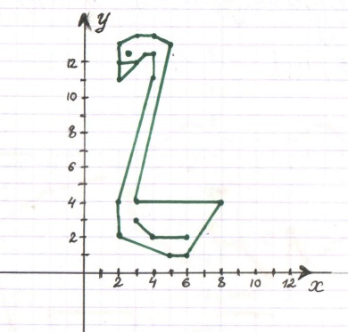
№ 8 Слон

(2; -9), (2; -11), (0; -15), (-2; -13), 9-1; -11),
(-1; -10), (-2; -10), (-2; -15), (-5; -15), (-5; -9), (-10; -9), (-9; -13), (-10; -13), (-10; -14),
(-13; -14), (-12; -10), (-13; -7), (-16; -9),
(-14; -7), (-13; -4), (-10; -2), (-6; -1), (-2; 2), (0; 1), ((4; 1), (6;, 2), (8; 0), (8; -4), (5; -6),
(4; -4), (4; -8), (3; -9), (0; -9), (0; -8), (2; -8),
(3; -7), (1; -5), (0; -5), (-1; -4), (-2; -6),
(-5; -4), (-6; -1) глаза (0; -2) и (4; -2)
№ 8
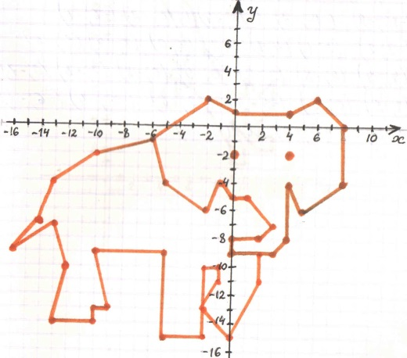
№ 9 Норка

(10; 5), (10; 4), (11; 3), (12; 3), (12; 2), (11; 2) (9; 4), (10; 2), (10; 1), (9; 1), (9; 2), (6; 7),
(6; 6,5), (5; 7), (5; 5), (4; 5), (4; 6), (5; 8),
(5,5; 7,5), (6; 9), (3; 14), (4; 14), (6; 12), (7; 9)
(9; 6), (10; 6), (10; 7), (11; 6), (12; 7), (12; 5),
(11; 4), (10; 5)
глаза (10,5; 5,5) и (11,5; 5,5)
№ 9
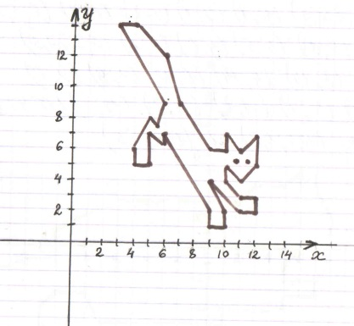
№ 10 Кот

(-4; -11), (-11; -11), (-15; -6), (-15; -2),
(-12; -1), (-10; -1), (-10; 1), (-6; 3), (2; 3),
(3; 4), (5; 4), (6; 5), (6; 4), (7; 5), (7; 4), (8; 2)
(8; 1), (5; -1), (5; -2), (7; -2), (7; -3), (5; -3), (5; -4), (1; -4), (1; -5), (-7; -5), (-8; -3),
(-10; -3), (-11; -4), (-11; -5), (-6; -7), (-4; -9)
(-4; -11) глаз (6; 2)
№ 10
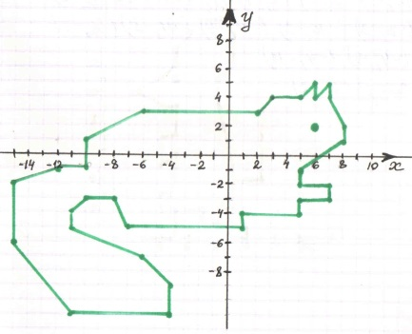

№ 11 Мышка

(9; 4), (8; 9), (8; 11), (9; 12), (9; 14), (8; 15)
(7; 15), (5; 13), (5; 12), (4; 11), (2; 10), (4; 9)
(5; 9), (5; 7), (4; 7), (4; 5), (5; 6), (5; 3), (4; 3)
(4; 1), (3; 1), (3; 0), (5; 0), 95; 2), (7; 2), (7; 1)
(9; 1), (9; 0), (10; 0), (10; 2), (8; 2), (9; 3),
(9; 4), (11; 4), (11; 9) глаз (5; 11)

№ 11
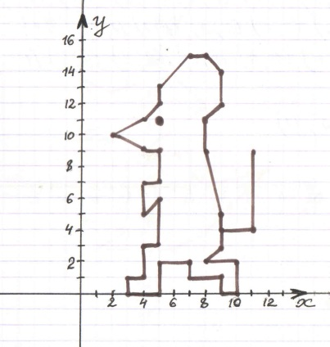
№ 12 Утёнок

(6; 1), (3; 0), (1; 2), (-1; 2), (3; 5), (1; 7),
(-3; 6), (-5; 7), (-3; 4), (-6; 3), (-3; 3), (-5; 2), (-5; -2), (-2; -3), (-4; -4), (1; -4), (3; 3), (6; 1)
Глаз (1; 5)
№ 12
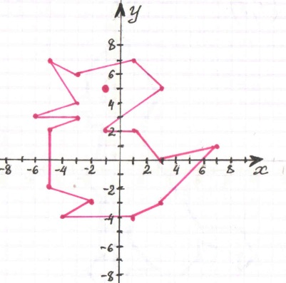
№ 13 Котенок

(9; -7), (10; -6), (9; -4), (6; -4), (2; 2), (2; 3)
(3; 3), (2; 7,5), (1; 8), (1; 9), (0; 8), (0; 9),
(-2; 7), (-2; 5), (-3; 5), (-3; 4), (-2; 4), (-2; 3), (-1; 3), (-1; 2), (-2; -1), (-1; -2), (-1; -6),
(-2; -7), (-1; -8), (0; -7), (0; -5), (1; -4), (1; -5)
(3; -7), (1; -7), (1; -8), (4; -8), (6; -6), (6; -5),
(9; -6), (9; -7) глаз (-1; 5)
№ 13
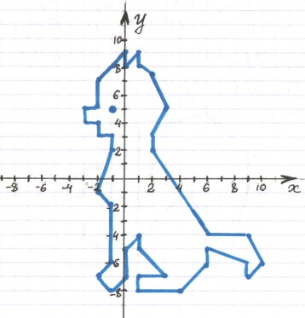
№ 14 Белка

(0; 6), (-1; 4), (-3; 3), (-1; 2), (-1; 1), (-3; 1),
(-4; 0), (-4; -1), (-3; -1), (-3; 0), (-1; 0), (-1; -1)
(-3; -3), (-3; -4), (-1; -5), (-3; -5), (-4; -6),
(1; -6), (1; -4), (4; -1), (5; -1), (6; -4), (8; -4),
(9; 0), (9; 2), (6; 5), (3; 4), (1; -2), (1; 4),
(0; 6) глаз (-1; 3)
№ 14
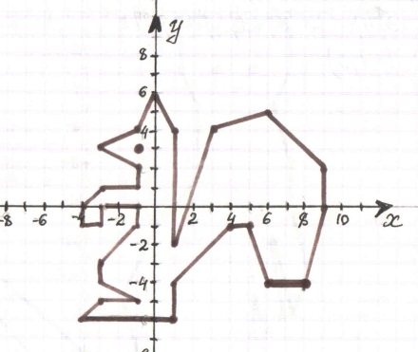
№ 15 Суслик

(-7; -12), (-6; -15), (-2; -19), (3; -21), (5; -22)
(7; -21), (8; -20), (8; -21), (9; -21), (10; -19),
(9; -17), (9; -15), (9,5; -17), (10,5; -16),
(10; -12), (11; -16), (12; -14), (11; -10),
(11; -8), (10; -5), (11; -3), (11; -1), (10; 0),
(9; -1), (7; -1), (6; 0), (5; -1), (5; -3), (6; -5),
(6; -9), (4; -11), (2; -15), (3; -19), (0; -18),
(-7; -12)
глаза и нос (7; -3) и (9; -3) и (8; -4)
№ 15
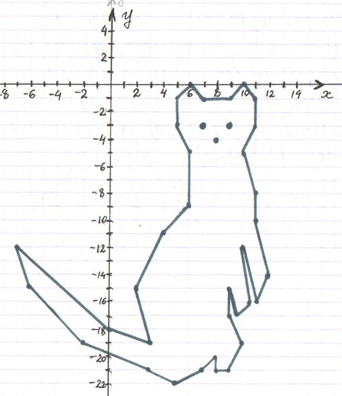
№ 16 Конь

(6; 0), (8; -2), (9; -1), (6; 2), (5; 1), (4,5; 2,5),
(5; 4), (7; 4), (9; 5), (9; 7), (8; 7), (7; 6), (5; 6), (3; 3), (-2; 1), (-4; 4), (-5; 4), (-5; 5), (-10; 2), (-9; 2), (-10; 1), (-6; 1), (-6; -1), (-5; -2),
(-7; -2), (-12; -5), (-11; -6), (-8; -4), (-7; -4),
(-10; -7), (-9; -8), (-6; -4), (0; -2), (2; -1),
(4; -2), (5; -1), (7; -4), (8; -3), (7; -1)
Глаз (-7; 5)
№ 16
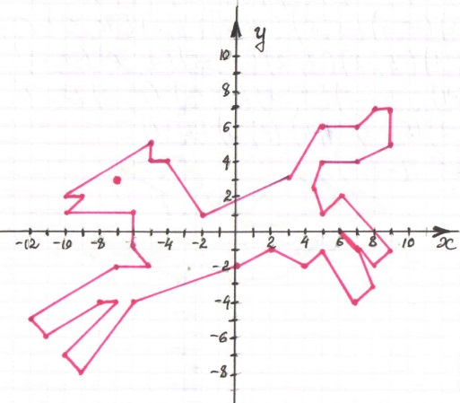
№ 17 Морской котик

(11; 2), (10; 3), (9; 3), (8; 2), (8; 3), (7; 4),
(6; 4), (7; 3), (7; 2), (5; 1), (3; 1), (2; 2), (3; 2), (4;3), (2; 3), (1; 2), (0;, 4), (-1; 5), (-2; 5),
(-4,5; 4,5), (-2; 3), (-1; 0), (-2; -1), (-3; -1),
(-1; -2), (0; -1), (2; -2), (5; -2), (7; 0), (10; 2),
(11; 2) глаз (-2; 4)
№ 17
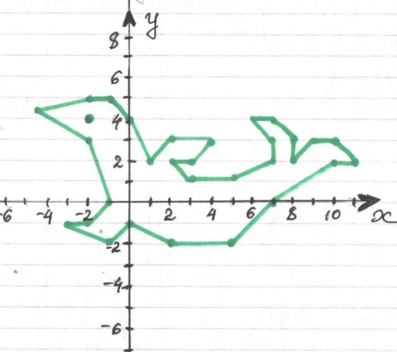
№ 18 Лось

(3; -1), (2; -3), (2; -5), (3; -5), (3; -4), (5; 0), (6; -1), (6; -6), (8; -6), (7; -3), (7; 1), (5; 3),
(6; 5), (6; 7), (4; 8), (-2; 8), (-4; 10), (-6; 9),
(-7; 9), (-6; 11), (-7; 11), (-11; 9), (-13; 7),
(-13; 6), (-12; 7), (-12; 6), (-10; 6), (-10; 7),
(-8; 5), (-7; 5), (-5; 3), (-6; 0), (-6; -4), (-5; -5)
(-4; -5), (-5; -4), (-5; -2), (-4; 1), (-3; -1),
(-3; -3), (-2; -4), (-3; -5), (-1; -6), (-1; -4),
(-3; 3), (-1; 2), (2; 3), (3; 1), (3; -1)
Глаз (-9,5; 8,5)
№ 18
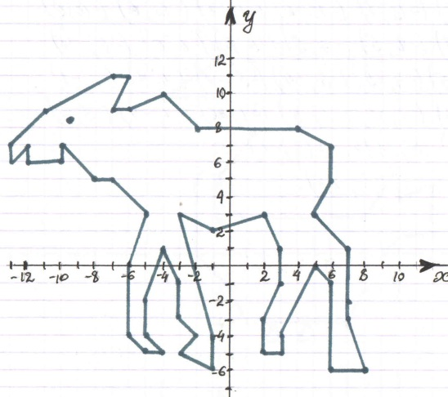
№ 19 Гусак

(0; -2), (1; -4), (7; -4), (8; -2), (10; -2), (9; 0), (10; 1), (12; 1), (12; 4), (10; 3), (10; 5), (8; 2), (1; 2), (-0,5; 3), (-0,5; 4), (1,5; 7), (1,5; 11), (0; 12), (-1; 11), (-4; 9), (0; 9), (0; 7), (-2; 4), (-2; 0), (0; -2) и (2,5; -4), (2; -5), (3; -5),
(2,5; -4) и (4,5; -4), (4; -4), (5; -4), (4,5; -4) глаз (-1; 10)
№ 19
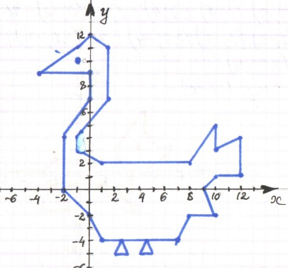
№ 20 Лиса

(4; 0), (5; 0), (7; 1,5), (7; 2), (6; 2), (5; 3),
(5; 5), (3; 2), (3; 1), (-2; 1), (-3; 0), (-7; 0),
(-8; -1), (-7; -2), (-4; -2), (-3; -1), (-2; -1),
(-3; -2), (-3; -3), (-1; -3), (-1; -2,5), (-2; -2,5), (-2; -2), (-1; -1), (2; -1), (2; -1,5), (3,5; -3), (4,5; -3), (4,5; -2,5), (4; -2,5), (3; -1,5), (3; -1)
(4; -1,5), (4; 0) глаз (4,5; 2).
№ 20
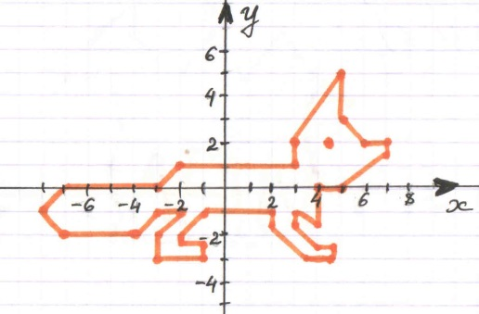
№ 21 Верблюд

(-5; 1), (-4,5; -1), (-5; -2), (-3,5; -2), (-4; -1),
(-3; 2), (-2,5; -1), (-3; -2), (-1,5; -2), (-2; -1),
(-1,5; 2), (0; 2), (1; -1), (0,5; -2), (2; -2),
(1,5; -1), (2; 2), (3; -1), (2,5; -2), (4; -2),
(3,5; -1), (4; 1), (3,5; 3), (4; 4,5),(5,5; 4),
(4; 5), (2,5; 7), (1; 5), (-0,5; 7), (-2; 5), (-4; 7), (-4; 8), (-5,5; 7), (-6,5; 6), (-7; 5), (-5; 5),
(-4,5; 2,5), (-5; 1) глаз (-5,5; 6)
№ 21
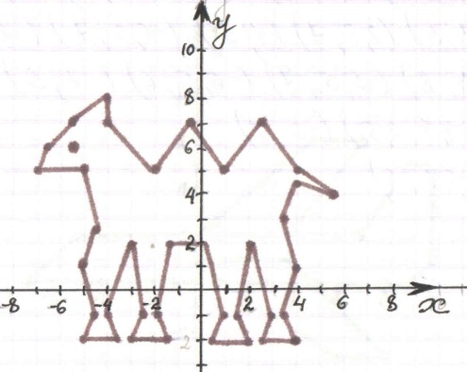
№ 22 Самолет

(9; 0), (10; 1), (10; 5), (9; 5), (7; 2), (-5; 2),
(-7; 0), (9; 0) и (0; 2), (5; 6), (7; 6), (4; 2)
и (0; 1), (4;, 1), (8; -3), (6; -3), (0; 1)
№ 22
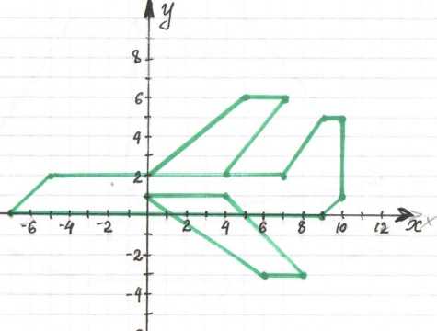
№ 23 Яхта

(0; 0), (-9; 0), (-8; -1), (-6; -2), (-3; -3),(5; -3), (10; -2), (12; -1), (13; 0), (0; 0), (12; 2),
(0; 16), (-10; 1), (0; 0), (-1; 2), (0; 16), (0; 0)
№ 23
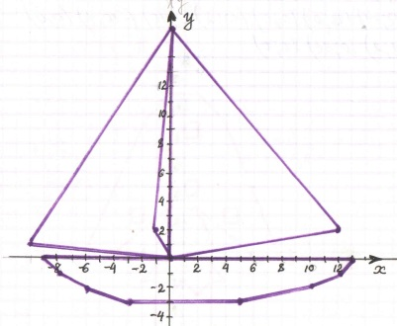
№ 24 Мухомор

(1; 3), (-1; 3), (-2; 1), (-2; -8), (-1; -9), (1; -9), (2; -8), (2; 1), (1; 3), (5; 0), (7; 0), (3; 9),
(1; 11), (-1; 11), (-3; 9), (-7; 0), (-5; 0), (-1; 3), и (-2; -1), (-3; -2), (-2; -2), (-1; -3), (0; -2),
(1; -3), (2; -2), (34 -2), (2; -1) и (3; 2), (4; 2), (4; 3), (3; 3), (3; 2), и (0; 4), (1; 4), (1; 5),
(0; 5), (0; 4), и (0; 8), (1; 8), (1; 9), (0; 9),
(0; 8) и (-2; 6), (-1; 6), (-1; 7), (-2; 7), ( -2; 6) и (-4; 2), (-3; 2), (-3; 3), (-4; 3), (-4; 2)

№ 24
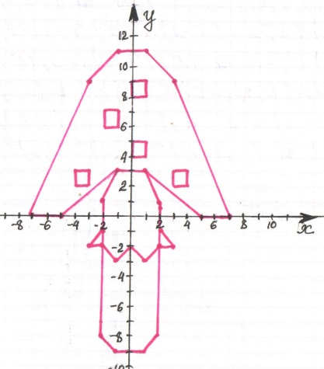
№ 25 Ракета

(0; 12), (-1; 10), (-4; -6), (4; -6), (1; 10),
(0; 12) и (0; 1), (-1; -10), (0; -8), (0; 1) и
(-2; 1), (-6; -7), (-3; -6), (-2; 1) и ( -1; 5),
(0; 4), (1; 5), (0; 6), (-1; 5)
№ 25
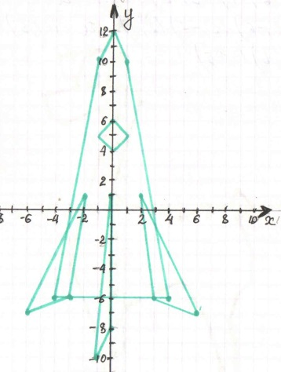
№ 26 Собака Дружок

(0; -7), /(4; -5), (6; -8), (7; -11), (6; -13),
(4; -15), (4; -16,5), (6; -15), (8; -12), (8; -9),
(7,5; -8), (8; -6), (9; -5), (9; -3), (8; -1), (9; 0), (8; 1), (7,5; 0), (5,5; 0), (4; -1), (0; 0), (-1; 1), (1; 7), (0; 10), (-1; 10,5), (-2; 10,5), (-3; 10),
(-3,5; 8), (-6; 7,5), (-5,5; 6), (-4,5; 5,5),
(-2; 6,5), (-1,5; 5), (-2; 3), (-3; 0), (-4; -4),
(-2; -9), (-1; -13), (-3; -15), (-2; -16), (0; -14), (0; -7) и (-1; 10), (-1,5; 8), (0; 8) и
(-2; 10,5), (-5; 10), (-4,5; 8,5), (-3,5; 8,5)
Глаз (-2; 9), (-3; 8), (-2; 8), (-2; 9)
№ 26
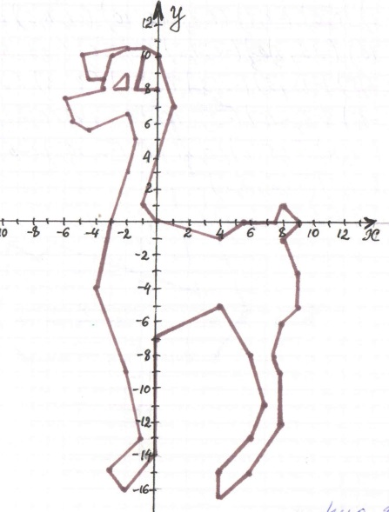
№ 27 Лебедь

(4; -3), (6; 0), (1; 12), (5; 12), (1; 14), (0; 12), (3; 1), (-6; 4), (-7; 3), (-9; 4), (-9; 1), (-10; 0), (-8; -3), (4; -3) глаз (2; 13)
№ 27

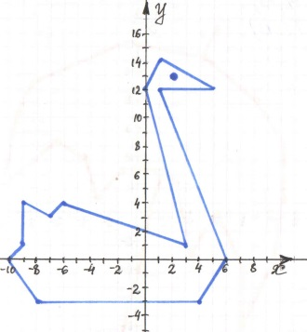
№ 28 Зонт

(-5; -10), (-6; -10), (-8; -12), (-8; -14),
(-7; -15), (-4; 15), (-3; -14), (-2; -12), (0; -5), (1; 0), (2; 3), (3; 2), (4; -3), (6; 0), (8; -4),
(8; -8), (10; -4), (11; 1), (11; 5), (9; 8), (5; 11), (6; 13) и (5; 11), (-1; 12), (-8; 9), (-9; 7),
(-10; 2), (-6; 5), (-4; 4), (-3; 1), (-1; 3), (2; 3).
№ 28
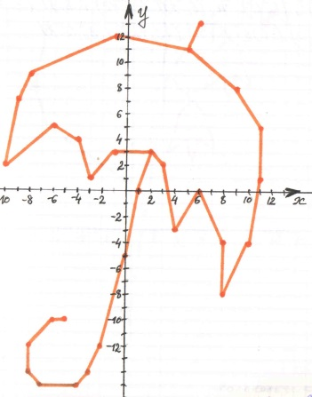

№ 29 Колокольчик

(0; -6), (1; 0), (3; 12), (13; 25) и (1; 0),
(1; 3), (3; 15), (1; 21), (-3; 25), (-6; 20),
(-8; 11), (-7; 8), (1; 3), и (3; 12), (5; 10),
(6; 9), (7; 6), (5,5; 7), (5; 5), (4,5; 7), (3; 6), (4; 9), (5; 10) и (6; 16), (7; 16), (8; 15),
(9; 14), (9; 13), (10; 11), (8,5; 12), (8; 10),
(7,5; 12), (6; 11), (7; 13), (7; 14), (8; 15) и (10; 21), (11; 20), (12; 19), (13; 16),
(11,5; 17), (11; 15), (10,5; 17), (9; 16),
(10; 19), (11; 20) и (13; 25), (13,; 24),
(14; 23), (14,5; 21), (13,5; 22), (13; 20),
(12,5; 22), (11,5; 21), (12; 23), (13; 24)

№ 29
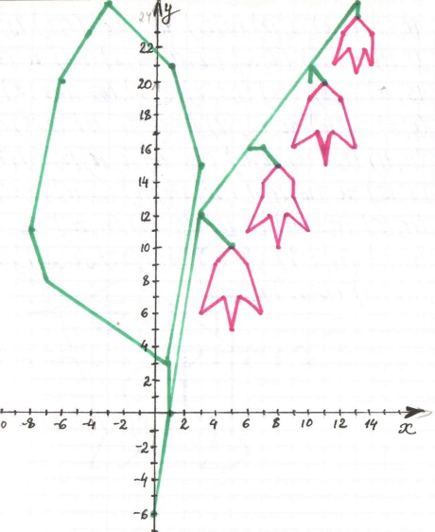
№ 30 Кот Васька

(3; 0), (2; -1), (2; -3), (4; -5), (3; -7) (5; -7), (6; -6), (5; -5), (5; 1), (6; 6), (5; 7), (4; 7),
(3; 6), (4; 2), (4; 1), (1; 3), (-1; 3), (-3; 1),
(-4; 2), ( -3; 3), (-3; 6), (-4; 5), (-6; 5), (-7; 6), (-7; 3), (-6; 2), (-3; -5), (-4; -7), (-2; -7),
(-1; -6), (-2; -2), (-1; -1), (1; -1), (2; -2) и
(-8; 3), (-2; 3) и (-9; 5), (-5; 3), (-1; 5) и
(-7; 2), (-5; 3), (-1; 2). Глаза (-6; 4) и (-4; 4)

№ 30
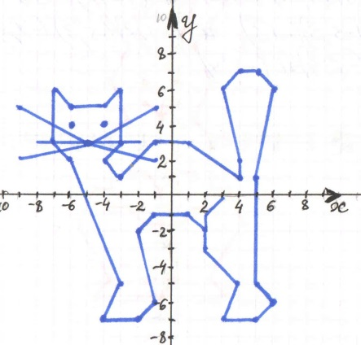
№ 31 Заяц

(-1; -9), (0; -8), (-2; -8), (-1; -9), (-5; -9),
(-4; -8), (-6; -5), (-5; -3), (-4; -3), (-4; 0),
(-3; 1), (-4; 3), (-3; 5), (-6; 9), (-6; 11), (-4; 10)
(-2; 5), (0; 5), (2; 10), (4; 11), (4; 9), (1; 5),
(2; 3), (1; 1), (2; 0), (2; -3), ( 3; -3), (4; -5),
(2; -8), (3; -9), (-1; -9) и (-2; 2), (-1; 1),
(0; 2), (-1; 1), (-1; 2) и (-3; -2), (-2; -2),
(-1; -3), (-1; -5), (-2; -5), (-3; -4), (-4; -4) и (1; -2), (0; -2), (-1; -3), (-1; -5), (0; -5), (1; -4), (2; -4). Глаза (-2; 3) и (0; 3)

№ 31
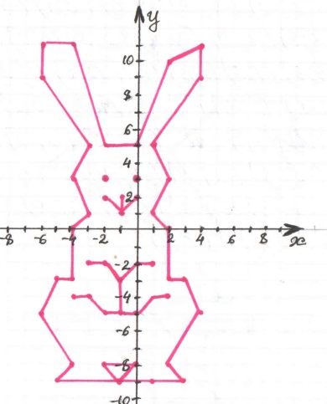
№ 32 Петух

(1; -5), (2; -4), (2; -1), (1; -1), (-4; 4), (-4; 8), (-5; 9), (-7; 9), (-4; 11), (-5; 12), (-5; 13),
(-4; 12), (-3; 13), (-2; 12), (-1; 13), (-1; 12),
(-2; 11), (-1; 10), (-2; 6), (-1; 5), (4; 5), (1; 10)
(4; 13), (8; 13), (9; 10), (7; 11), (9; 8), (7; 8),
( 9; 6), (8; 6), (3; -1), (3; -4), (4; -5), (1; -5) и (-4; 11), (-2; 11) и (0; 1), (0; 3), (1; 4), (2; 4), (4; 1), (0; 1) глаз (-4; 10)

№ 32
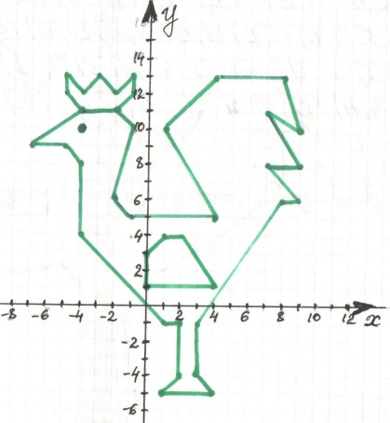
№ 33 Верблюд

(-10; -2), (-11; -3), (-10,5; -5), (-11; -7),
(-12; -10), (-11; -13), (-13; -13), (-13,5; -7,5), (-13; -7), (-12,5; -5), (-13; -3), (-14; -1),
(-14; -4), (-15; -6), (-15; -3), (-14; 2), (-11; 4), (-10; 8), (-8; 9), (-6; 8), (-5; 5), (-3; 8), (-1; 9), (0; 8), (0,5; 6), (0,5; 4), (3; 2,5), (4; 3), (5; 4), (6; 6), (8; 7), (9,5; 7), (10; 6), (11,5; 5,5),
(12; 5), (12; 4,5), (11; 5), (12; 4), (11; 4),
(10; 3,5), (10,5; 1,5), (10; 0), (6; -3), (2; -5),
(1; -7), (1,5; -11), (2; -12), (1; -13), (0; -5),
(-0,5; -11), (0; -13), (-1,5; -13), (-1,5; -7),
(-2; -5), (-3; -4), (-5; -4,5), (-7; -4,5), (-9; -5), (-10; -6), (-9; -12), (-8,5; -13), (-10; -13),
(-10,5; -10), (-10,5; -9,5), (-11; -7)
Глаз (8,5; 5,5)

№ 33
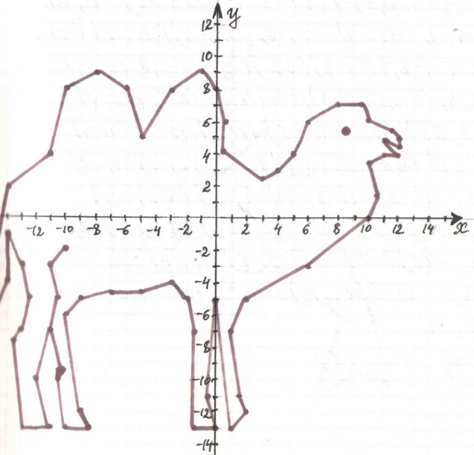
№ 34 Дельфин

(-7; -2), (-3; 4), (-1; 4), (2; 7), (2; 4), (5; 4),
(9; -5), (10; -9), (8; -8), (5; -10), (7; -5), (3; -2)
(-7; -2) и (0; 0), (0; 2), (2; 1), (3; 0), (0; 0),
Глаз (-4; 0), (-4;1), (-3; 1), (-3; 0), (-4; 0)
№ 34
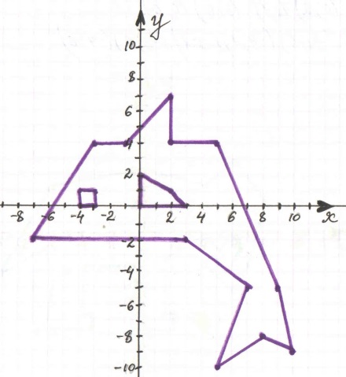

№ 35 Слоненок

(-9,5; -2,5), (-6; 3), (0; 4), (4; 3), (6; 4,5),
(8; 2), (7; -2), (6; -3,5), (4; -2), (4,5; -1,5), (5,5; -2,5), (6,5; -1), (6; 0), (5; -1), (4; 0),
(1,5; -1, 5), (1,5; -5), (2; -5), (2; -6), (-1; -6),
(-0,5; -3), (-1; -2), (-4; -2), (-4; -5), (-3,5; -5), (-3,5; -6), (-6,5; -6), (-6; -3), (-6,5; -1),
(-9; -2,5) глаз (6; 2)
№ 35
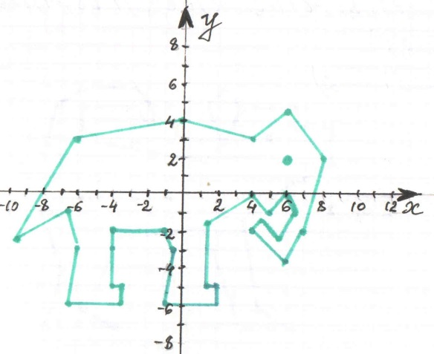
№ 36 Собака

(3; 5), (2; 3), (1; 5), (2; 6), (3; 5), (6; 5), (6; 4), (8; 4), (8; 2), (6; 1), (3; -1), (4; -6), (6; -7),
(3; -7), (1; -1,5), (-4; -2), (-5; -5), (-6; -6),
(-4; -7), (-8; -7), (-7; -4), (-8,5; 0), (-7; 2),
(-8; 3), (-7,5; 5), (-6; 6), ( -3;, 6), (-2; 5),
(-2; 4), (-3; 5), (-6; 5), (-6; 3), (1; 2), (2; 3)
Глаз (4,5; 3,5

