Приложение 2

START | I feel … that a boy saved his sister. | 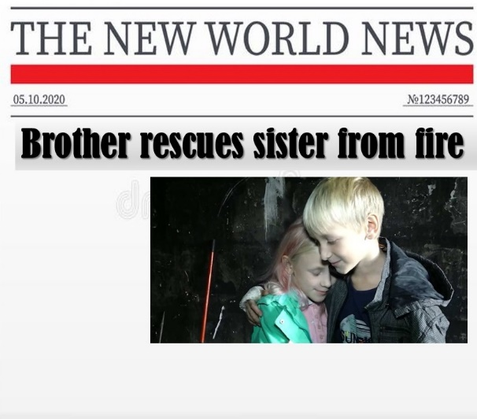 | I feel … that a turtle stopped taxi.
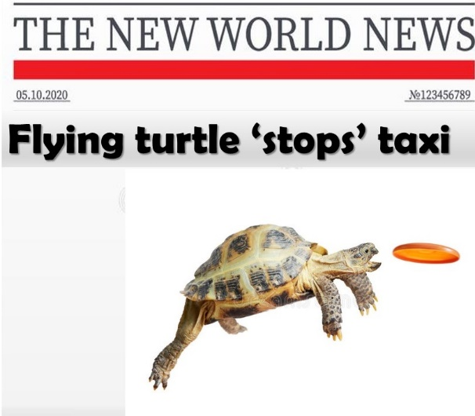 | I feel … about schools on Saturdays. | 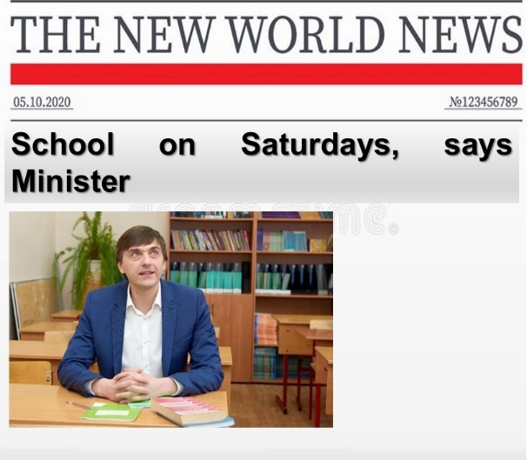 | I feel … about 130 injured.
 | I feel … about puppies. | 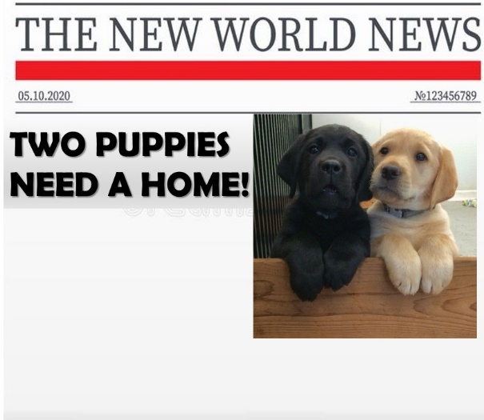 | I feel … that an actress visited kids I n hospital.
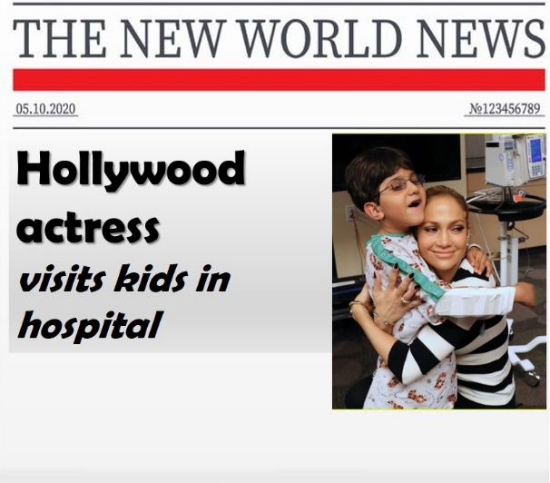 | I feel … that a dog missed in the park. | 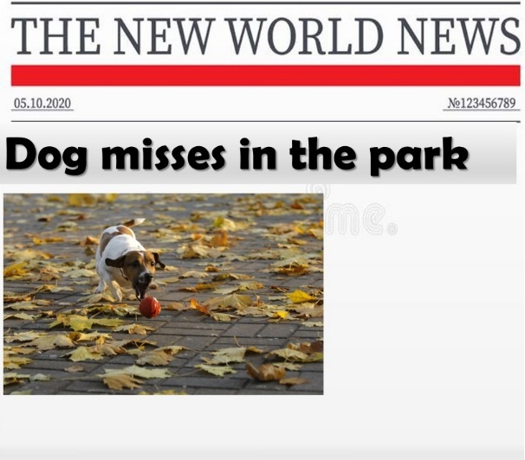 | FINISH

