Приложение 6

HOW GREEN ARE YOU?

Do the survey and find out if you help save our planet. Ask and answer in pairs.

1.Do you sort out glass, paper, plastic?

a ❒ Yes, always.

b ❒ Sometimes.

c ❒ Never.

2. Do you use your own shopping bags?

a ❒ Yes, always

b ❒ Often

c ❒ Never

3. Do you recycle batteries?

a ❒ Yes, always.

b ❒ Sometimes.

c ❒ Never.

4. Do you pick up other people’s litter?

a ❒ Yes, always.

b ❒ Sometimes.

c ❒ Never

5. Do you turn off the lights when you leave a room?

a ❒ Yes, always.

b ❒ Sometimes.

c ❒ Never

6. Do you turn off devices at night? (TV, computer..)

a ❒ Yes, always.

b ❒ Sometimes.

c ❒ Never

7. Do you have showers instead of baths?

a ❒ Yes, always.

b ❒ Often.

c ❒ Never

8. Do you turn off the tap when you brush your teeth?

a ❒ Yes, always.

b ❒ Sometimes.

c ❒ Never, I never think about it.

9. Do you use public transport or a bike or walk?

a ❒ Yes, always.

b ❒ Sometimes.

c ❒ Never



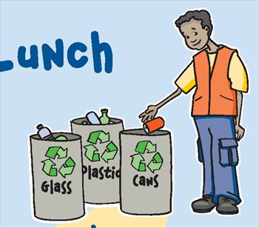

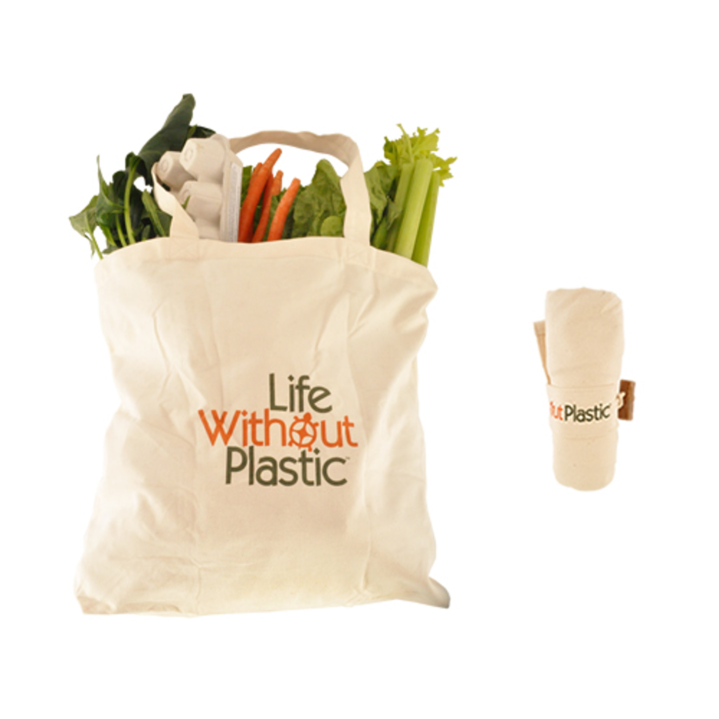

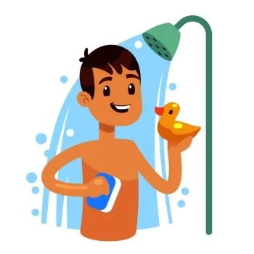

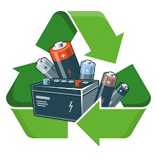

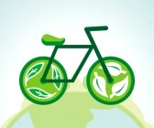

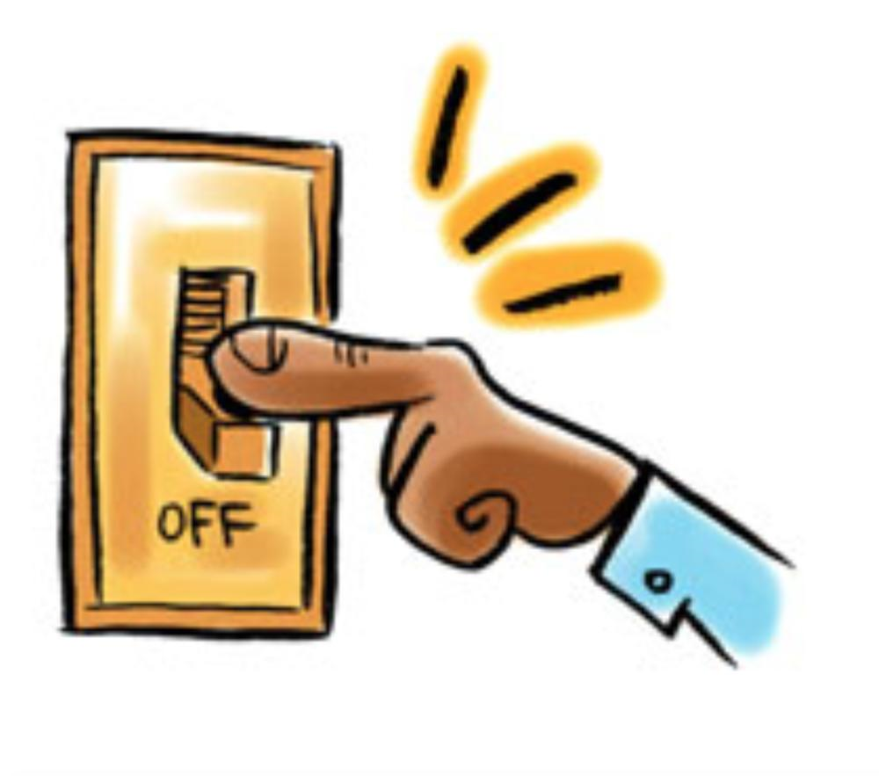

Check the number of points you have and see if you are GREEN !

RESULTS

a 2 points b 1 point c 0 point

Below 8.

No, no, no! You should do a lot more to save the planet to your children and grandchildren!

From 8 to 13.

Well, you should do better.

From 14 to 18

Congratulations, you are making real good efforts to help save our planet. Keep up the good work!