Приложение 2
1. Tick the activities that are good for the planet.
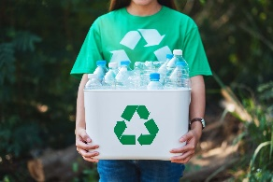
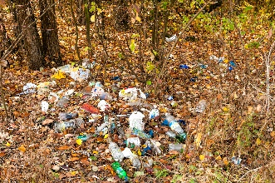
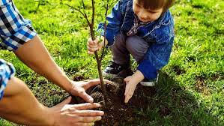
a. __ b.__ c.__

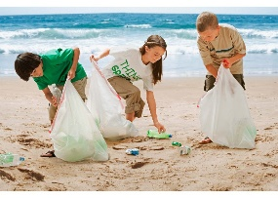
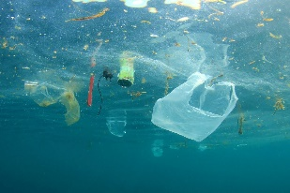
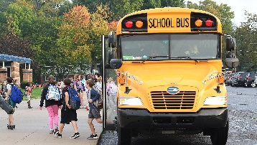
d. __ e. __ f. __

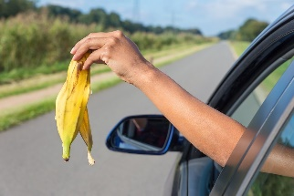
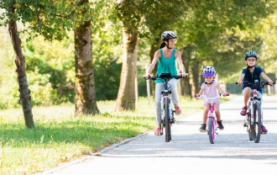
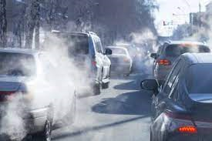
g. __ h. __ i. __

2. Match ideas with the pictures.
Save the planet from home

1. Turn off the lights when not in use. ___
2. Turn off the tap when you brush your teeth. ___
3. Recycle paper, glass and plastic. ___
4. Don’t use plastic bags when shopping. ___
5. Take a shower not a bath. Save water! ___
6. Unplug your devices. ___

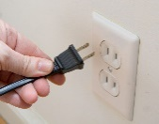
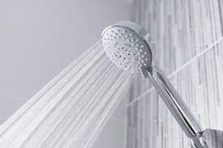
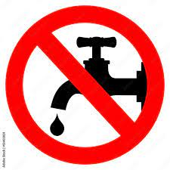
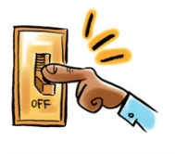
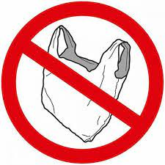
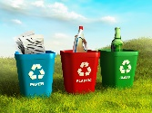
a. b. c. d. e. f.

