Раздаточный материал

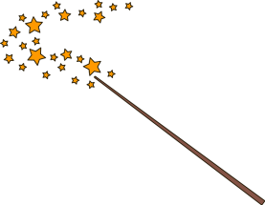
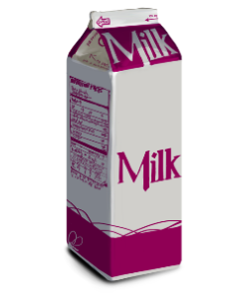
“Magic milk experiment”

- Fill in the gaps with the words from the box.

hydrophilic | water | two | hydrophobic

- Fat and ____________ “don’t like” each other.
- Soap molecule has ___________ parts.
- The part that loves water is called __________________.
- The part that hates water and loves fat is called __________________.

- Read and tick.

Milk consists of:

 | Water |  |  | Fat
 | Lemonade |  |  | Carbohydrates
 | Protein |  |  | Cream
 | Meat |  |  | Vitamins and minerals
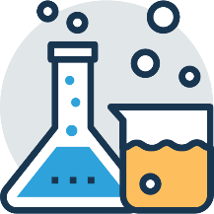
- Are these sentences true or false? Read and tick.
 |  | True |  |  | False
- To do an experiment “Magic milk” you need water, soap, food colouring and a cotton bud.
- In “Magic milk” experiment we can see the reaction between milk and soap.
- The reaction happens because milk has water and fat in it.
- The soap is scared of water and fat.

