Приложение 2
Read picture descriptions and match the correct paintings.
A. The picture shows a lot of sunshine. The sky is blue. It’s warm and sunny. But there is snow and the trees have no leaves. There is a birdhouse in the tree. The nature is nice. ____

B. The picture shows the early spring because there is a lot of water. But the water is quiet. In the light blue sky there are soft clouds. ___

С. The picture is very colorful and positive. It shows a spring day of a small village and its busy people. In the spring water you can see the blue sky. The picture makes you feel the spring air. ___

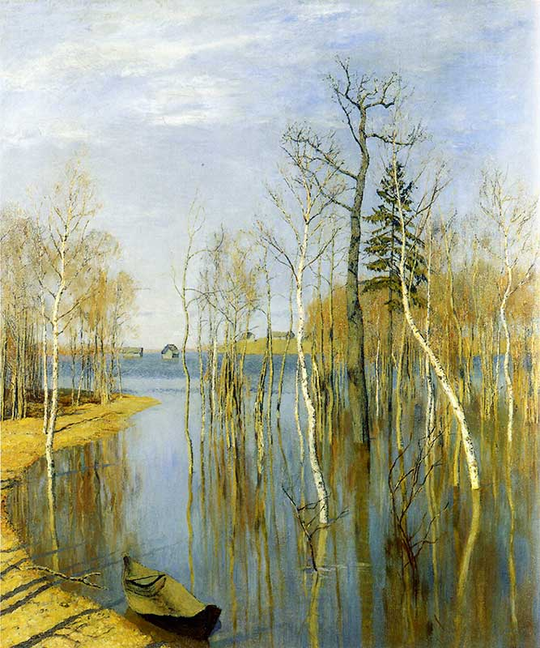
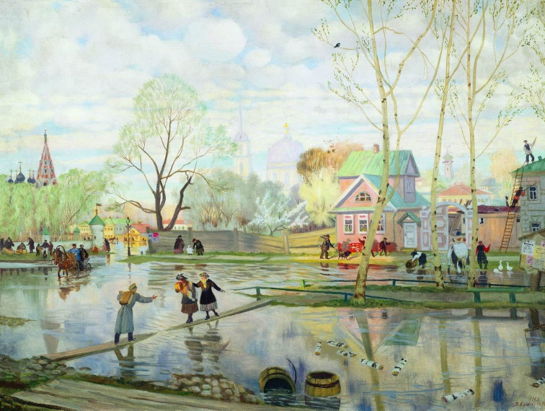
1. 2.

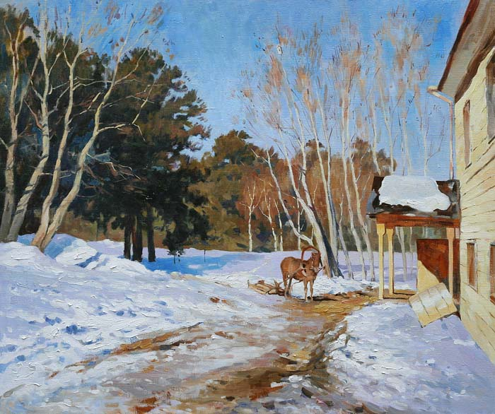
3.

