Welcome to the exhibition!

You will see the photos of the rain forests made by our photographer James Johnson. People know that rain forests are broken every year. We should stop it together. Come to our exhibition and see all the beauty and terror concerning this wonder of nature.
You won`t be indifferent to this problem. The entrance is free.
Our exhibition is working
Weekdays 9.00am – 7.00pm
Weekends 10.00am-8.00pm
Phone number 89092875413
email: m.egorov@yandex.ru

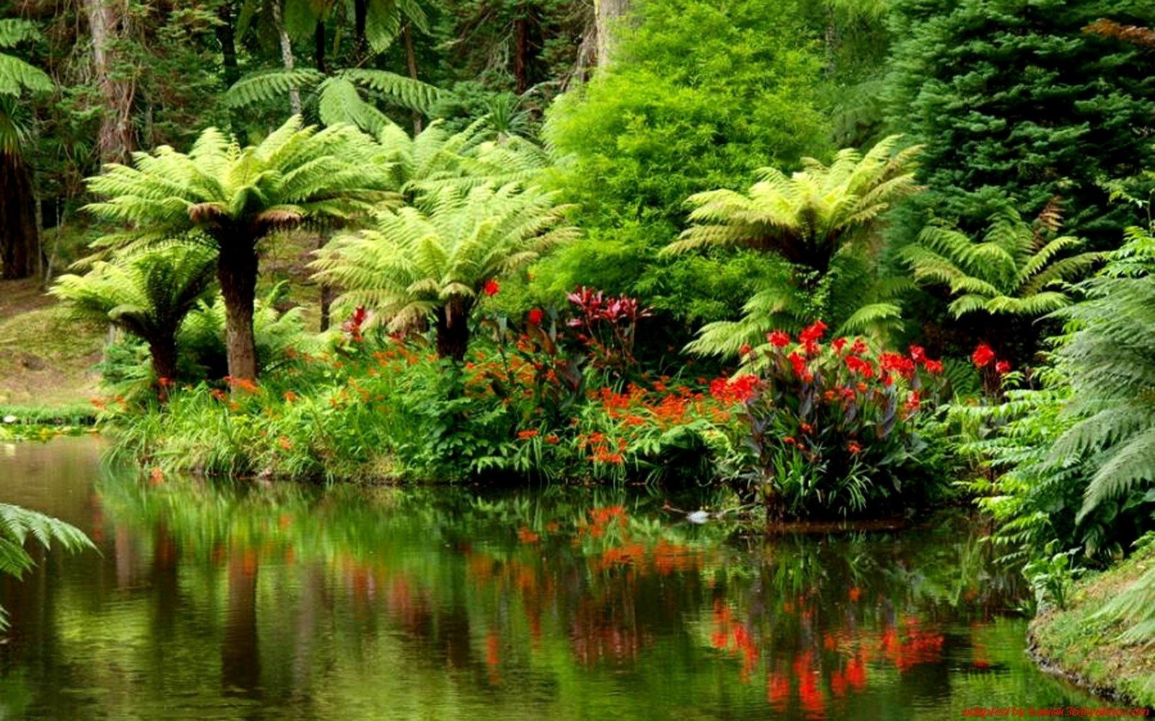

Welcome to the exhibition!

You will see the photos of the rain forests made by our photographer James Johnson. People know that rain forests are broken every year. We should stop it together. Come to our exhibition and see all the beauty and terror concerning this wonder of nature.
You won`t be indifferent to this problem. The entrance is free.
Our exhibition is working
Weekdays 9.00am – 7.00pm
Weekends 10.00am-8.00pm
Phone number 89092875413
email: m.egorov@yandex.ru

