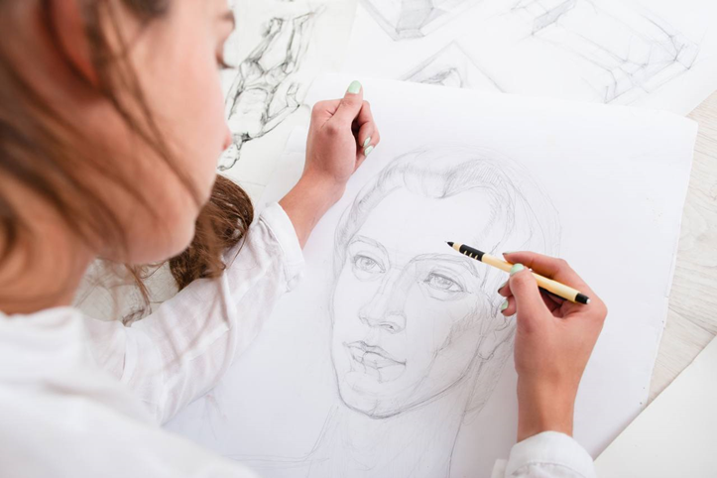
1.4 https://www.artistsnetwork.com/art-mediums/drawing/drawing-basics-learn-10-new-habits/

2.6 https://www.ascasogallery.com/the-theory-of-how-to-make-it/

3.8 https://fromthemedian.org/2022/07/22/babl-spotlight-2019-less-activism-more-factivism-2/

4.10 https://929thelake.com/bless-it-louisianas-gorilla-glue-girl-is-back-minus-more-hair/

5.12 https://ifaces.ru/%D0%BF%D1%80%D0%BE%D1%84%D0%B8%D0%BB%D0%B8/93023481/

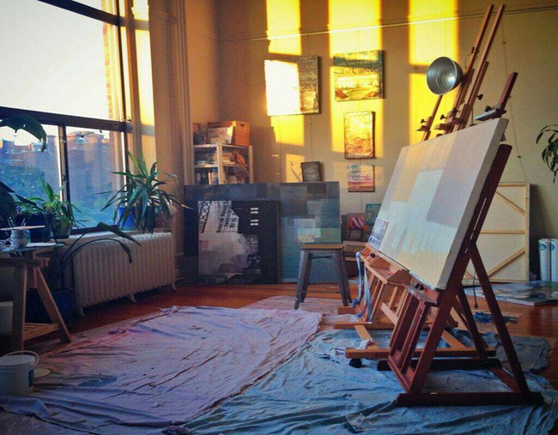
6.14 https://idei.club/26595-komnata-masterskaja-hudozhnika-31-foto.html

7.16 https://music.yandex.ru/artist/7518545/similar

8.18 https://gifer.com/ru/XVIf

9.20 https://xn--46-kmc.xn--80aafey1amqq.xn--d1acj3b/program/11995-akvarelka

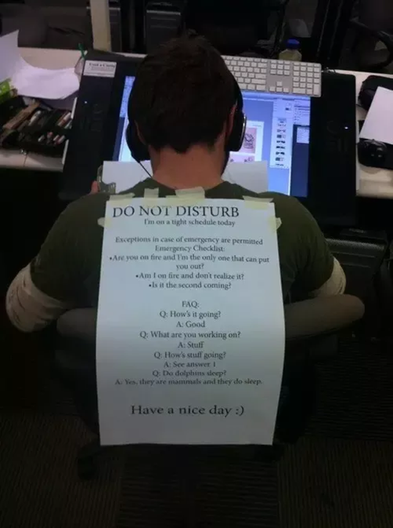
10.22 https://triftpida.blogspot.com/2021/04/club-penguin-usernames-and-passwords.html

11.24 https://decomotive.ru/podarki-vpecatlenia-ili-priklucenia-v-podarok-cto-eto-takoe/

12.26 https://hdfootagestock.com/video/24286931/paints-and-brushes

13.28 https://www.pinterest.com/pin/244461086003250579/
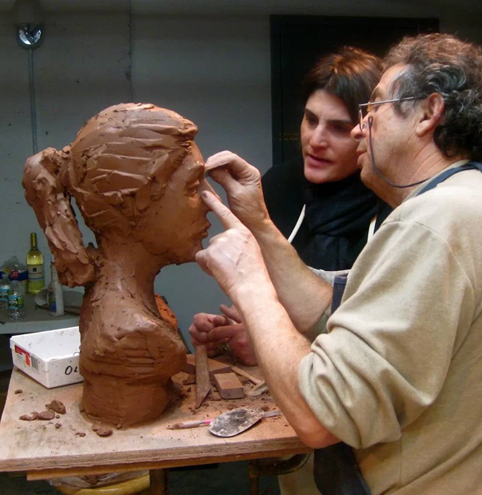
13.30 https://klubmama.ru/podelki-iz-prirodnyh-materialov/19782-glina-dlja-skulpturnoj-lepki-vakuumirovannaja-podelki-38-foto.html

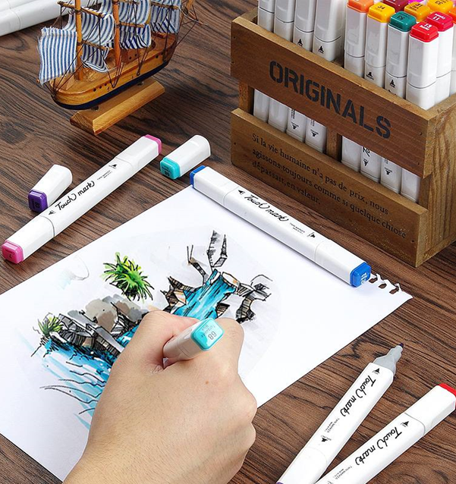
14.32 https://iprofiles.ru/sveta-akvarel/573191968/

15.34 https://www.progress-index.com/story/news/2022/01/24/virginia-lottery-thank-a-teacher-art-contest-va-k-12-public-school-students-three-top-prize-winners/6634407001/

16.36 https://lux-cinema.ru/

17.38 https://preply.com/en/blog/speak-american-english/
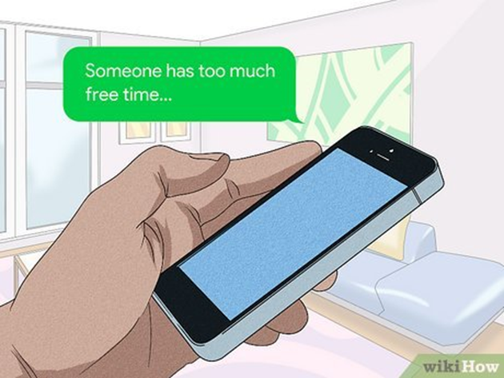
18.40 https://ru.how-what-do.com/13159011-how-to-talk-to-girls-on-tinder-8-steps-with-pictures

19.42 https://www.fruitfulenglish.com/blog2/nic-16/
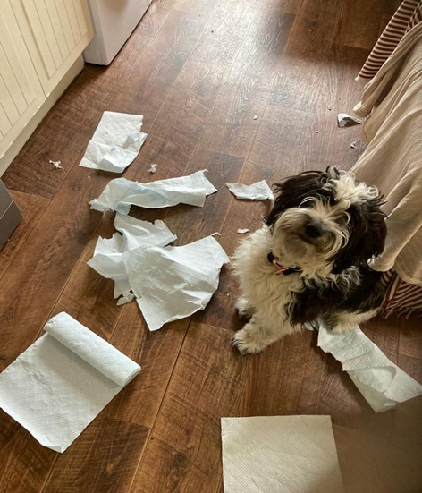
20.44 https://www.belfastlive.co.uk/news/belfast-news/dog-hack-4-people-dog-25327169
21.46 https://sandesh.com/kutch-district-is-coronavirus-epidemic-free-now-in-gujarat/feed

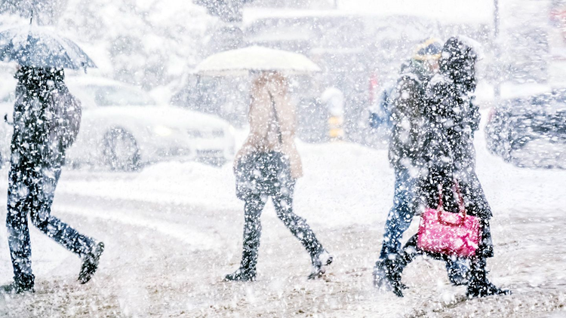
22.48 https://zen.yandex.ru/a/YrgRJz1SExcD0YnJ

23.50 https://informativelog.com/be/12020-5-experiments-who-teach-you-to-communicate-with-unfamiliar-people/

24.52 https://medium.com/hackernoon/agile-didnt-eat-your-homework-269cece92274

25.54 https://www.vectorstock.com/royalty-free-vectors/fatty-cat-vectors

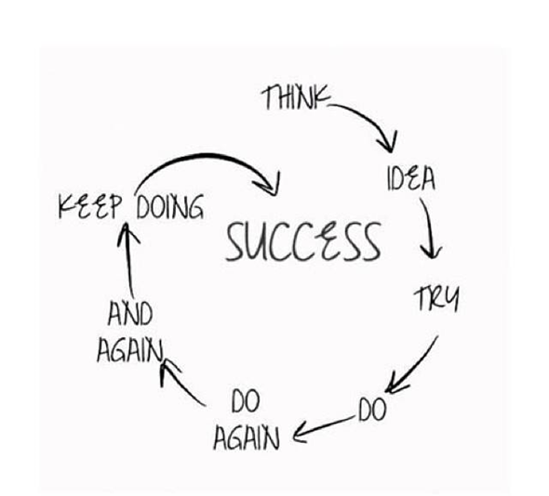
26.56 https://www.pinterest.com.mx/pin/416371928038202544/

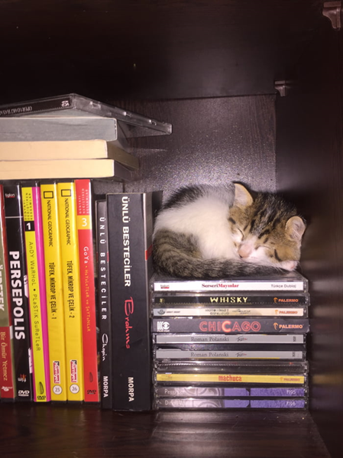
27.58 http://vrn.best-city.ru/photoalbum/delaya/photo179/

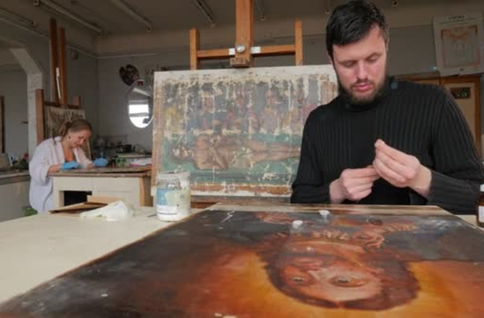
28.60 https://ru.depositphotos.com/122309822/stock-video-artists-man-is-painting-carefully.html

29.60 https://imgflip.com/memetemplate/231297199/good-job

30.64 https://live24.ru/obschestvo/zdorove/somnolog-plemyannikova-predupredila-ob-opasnom-vide-dnevnoj-sonlivosti.html

31.66 https://ru.pinterest.com/pin/788270741018619201/

32.68 https://masterok.livejournal.com/5387942.html

33.70 https://rula.co.id/ketahui-pengertian-nft-dan-penerapannya-dalam-berbagai-sektor/

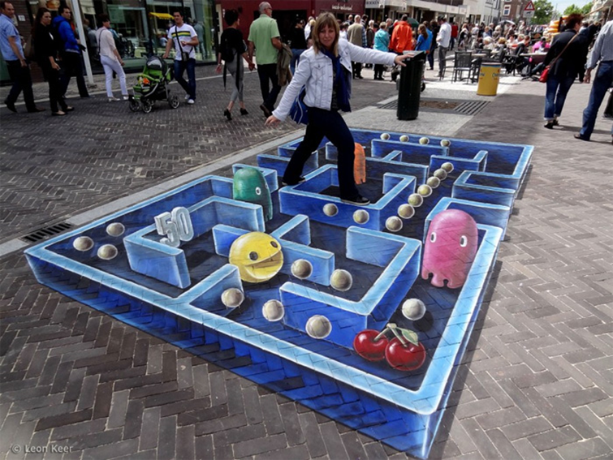
34.72 https://mirpozitiva.ru/photo/606-topics72.html

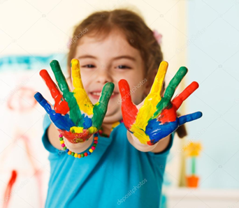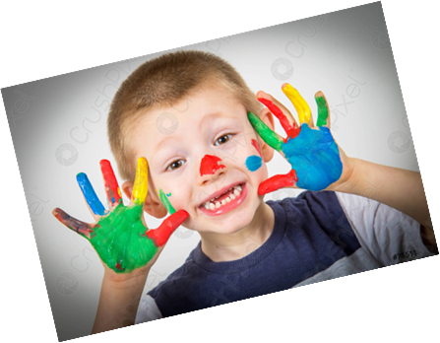
35.74 https://it.depositphotos.com/62765555/stock-photo-cute-kid-playing-with-paint.html

https://www.pngaaa.com/detail/1411630
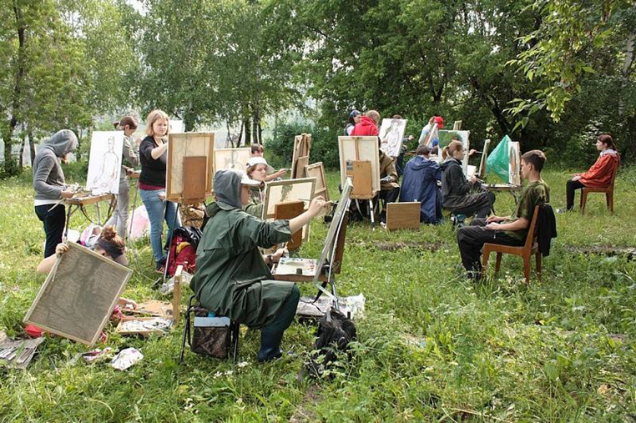
36.76 https://uyrgii.ru/node/1000

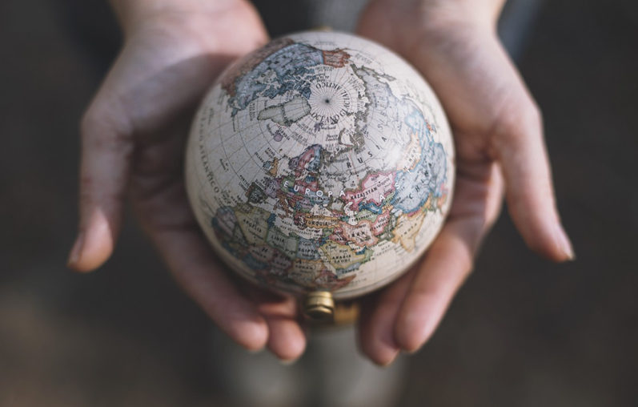
37.78 https://pin.it/4dW5cAB

38.80 https://ptt.life/kak-najti-svoj-talant-i-oleg-gadeckij
39.82 https://kuban.aif.ru/money/vinovata_psihologiya_bednosti_pochemu_molodyozhi_i_starikam_ne_hvataet_deneg

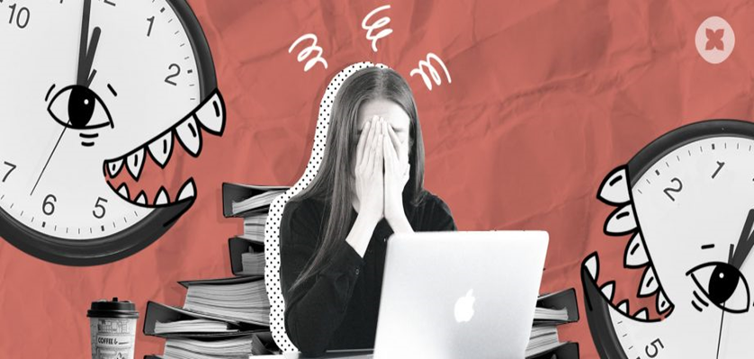
40.84 https://hurma.work/rf/blog/kak-dedlajny-vliyayut-na-produktivnost-sotrudnikov-2/

41.86 https://kratkoe.com/mechta-v-zhizni-cheloveka-sochinenie/

42.88 https://ru.pinterest.com/pin/819936675884669635/feedback/?invite_code=70e5e014a08a4bf6a2c7e8986a16304b&sender_id=634022591199364355

43.90 https://ltg-academy.ch/fide-how-to-successfully-pass-the-exam/

44.92 https://pin.it/4whUyi7

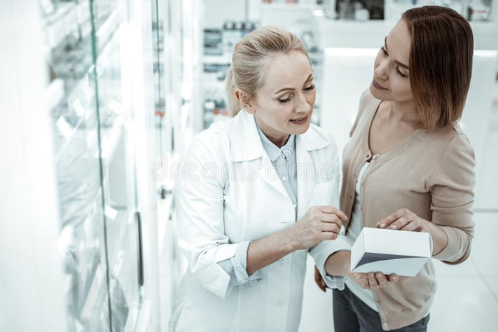
45.94 https://pin.it/1IbM9qK

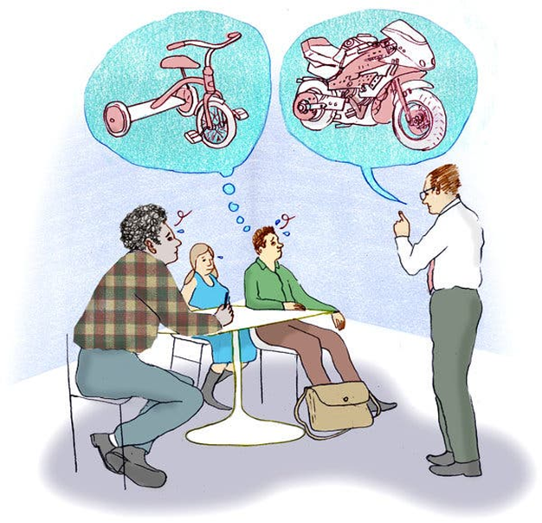
46.96 https://pin.it/6aJKO5Z

47.98
https://pin.it/1I8A7AA

