Приложение:
- What kind of Santa Claus are you? Read the tongue-twisters according to your image.
Merry Santa | Sad Santa | Fast Santa  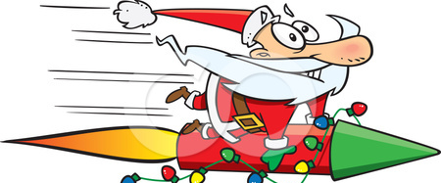

Tongue-twisters
  - May the joy and peace of Christmas be with you now and throughout the new year.

  - May your Christmas be like Santa Claus - fat, jolly and generous.

Out with the old, in with the new: may you be happy the whole year through. Happy New Year!

- ‘Crocodile game’
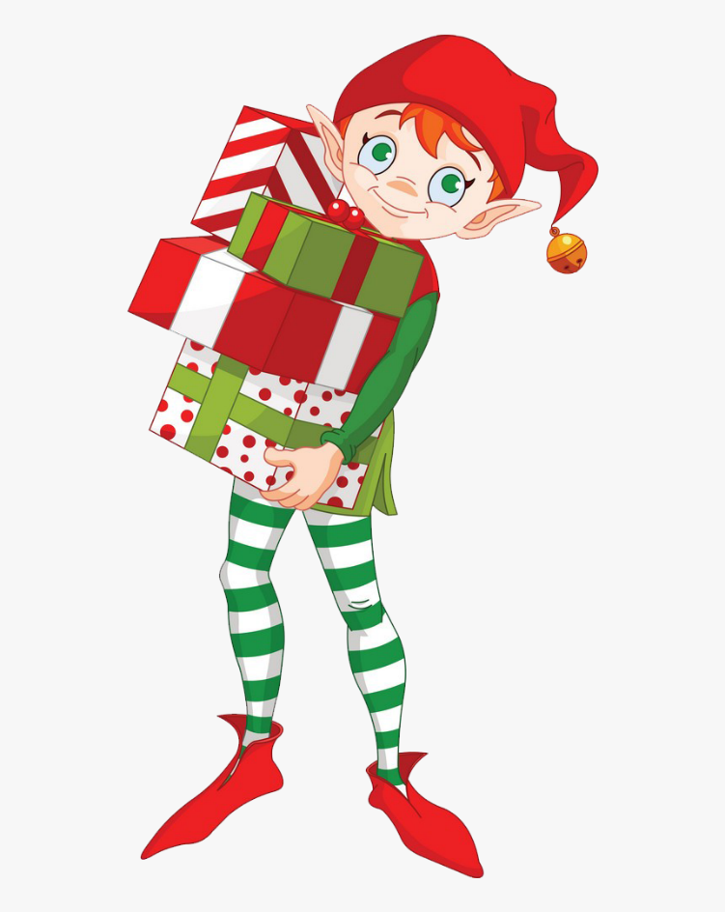
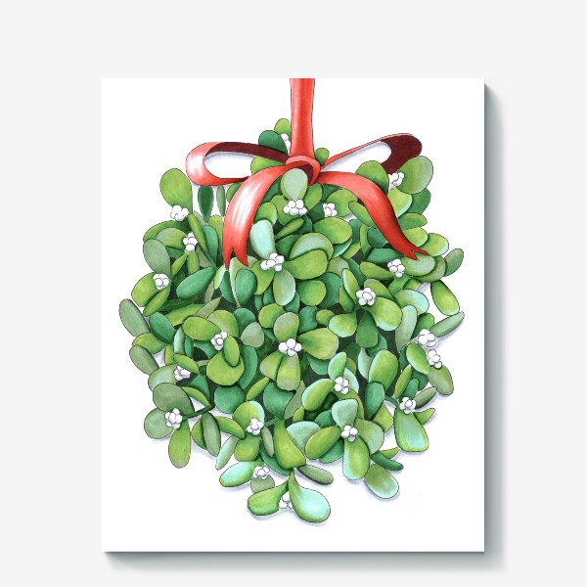

- Labelling the pictures

_________ ________ _________ _________ _________ __________ _________ _________

