Кроссворд по теме «Русская кухня»
- It is cold soup with kvas, hard boiled eggs, chopped spring onions, cucumbers and dill, boiled meat; everything is chopped.
- It’s tender pork fat.
- Potato pancakes are called …
- It’s a yougurt-like drink.
- It’s a powdered cream cheese.
- It’s a thick sour cream.
- It’s a traditional Russian salad; a mixture of vegetables, boiled and chopped.
- It’s thin fruit jelly made from berry juice and potato flour.
- It’s a famous Russian dish made of flour, water or milk and eggs. In Britain they are called pancakes.
- It’s a traditional Russian dish. In Britain it’s called porridge.
- It’s a very popular dish of grilled cubes of meat, it can be called kebabs.
- It’s a famous Russian dish represent a mix of rice and mincemeat wrapped inside cabbage leaves.
- It’s Russian cabbage soup.
- They are dumplings of Russian cuisine that are stuffed with meat and onion.
Ответы:
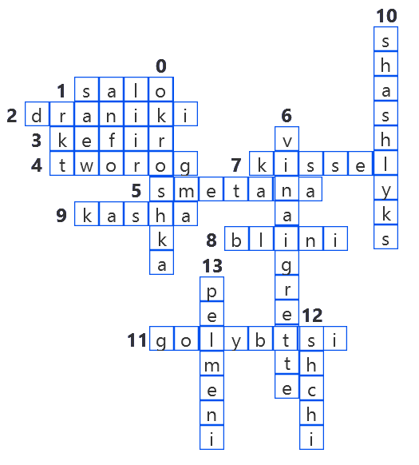
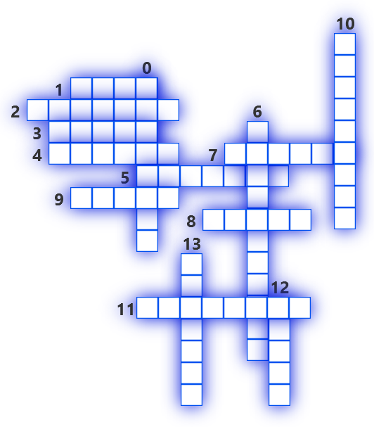

- Okroshka
- Salo
- Draniki
- Kefir
- Tworog
- Smetana
- Vinaigrette
- Kissel
- Blini
- Kasha
- Shashlyks
- Golybtsi
- Shchi
- Pelmeni

