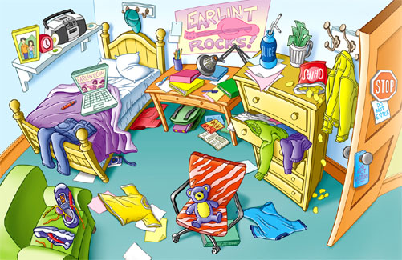
My bedroom

Look at the picture and mark true [T] or false [T]
- There is a camera under the bed.
- There are trainers on the table.
- There is a cap on the wall.
- There are two teddy bears on the chair.
- There are four books on the table.
- There is a schoolbag under the table.
My bedroom

Look at the picture and mark true [T] or false [T]
- There is a camera under the bed.
- There are trainers on the table.
- There is a cap on the wall.
- There are two teddy bears on the chair.
- There are four books on the table.
- There is a schoolbag under the table.

