WALL-E
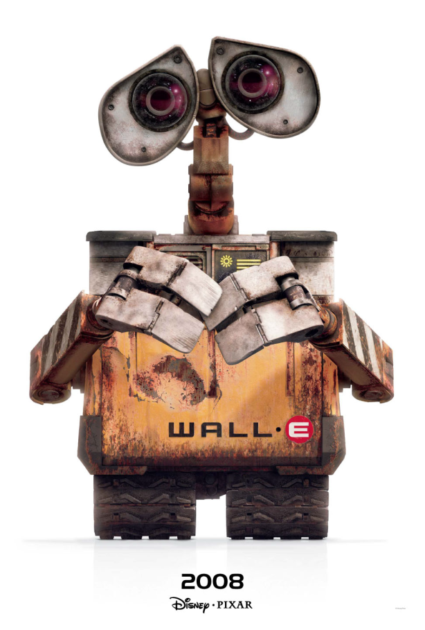

- Wall-E is designed to clean up a waste-covered Earth far in the future.
- He collects artifacts of human civilization, and keeps these items in his storage truck home.
- He enjoys listening to “Hello, Dolly!”

ASIMO
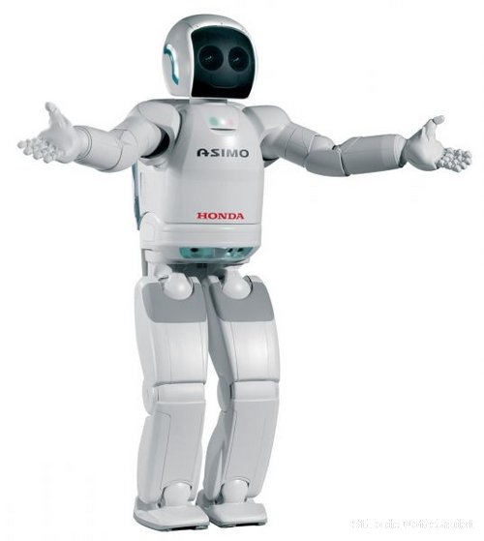
- It is a humanoid robot created by Honda.
- It was created to be a helper to people.
- It is used to encourage young people to study science and mathematics.
- It is 130 cm tall and 54 kg.
- It can walk or run on two feet at speeds up to 6 kilometres per hour.

TOPIO
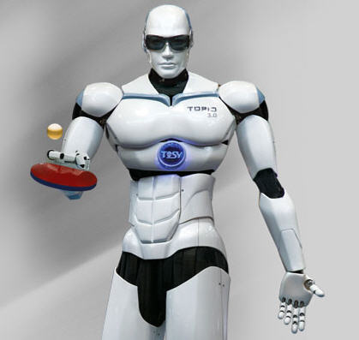
- It was designed to play table tennis against a human being.
- It is 1.88 meters tall and weighs 120 kg.

ENON
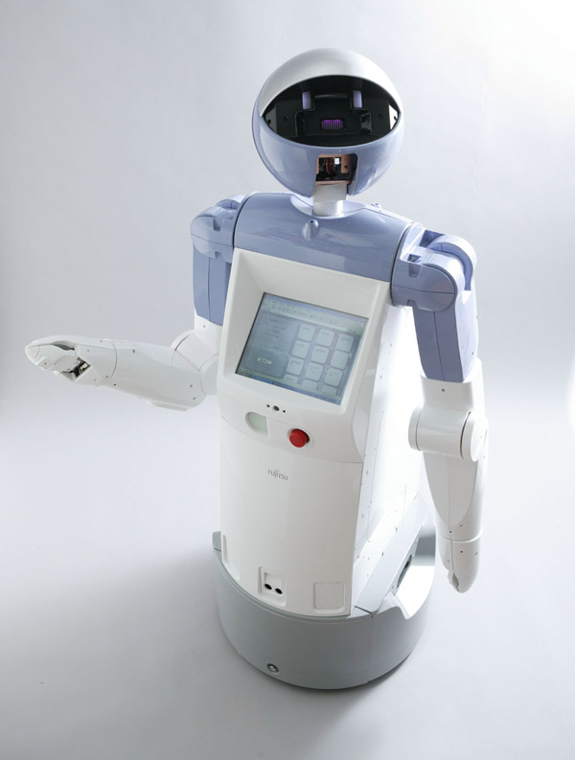

- It is a personal assistant robot.
- It can pick up and carry 500 grams in its arms.

Wakamaru
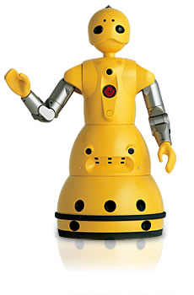
- It is a Japanese domestic robot.
- It was designed to provide companionship to elderly and disabled people.
- It can connect to the Internet, and has limited speech (in both male and female voices) and speech recognition abilities.
- It can remind the user to take medicine on time, and call for help if it suspects something is wrong.

Actroid

- It can blink, speak and breathe.
- It looks like a real human.
- The Actroid can also dance very well.
- It helps to direct people to specific locations and events.

REEM
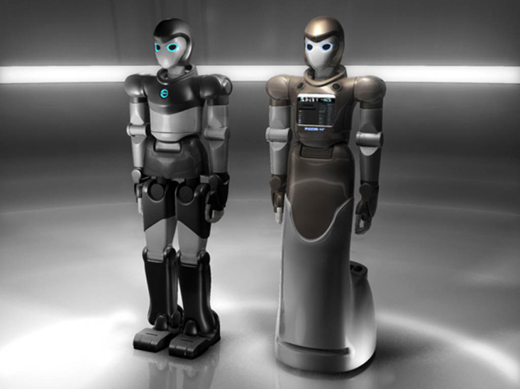
- It can find its way safely, avoiding obstacles and people.
- It can be used as a guide, entertainer, and dynamic information point.
- The robot accepts voice commands and can recognize faces.
- It is a 1.70 meters high.

Future Life
Can you imagine what our lives will be like in the year 2050? Perhaps you will be flying off for a holiday on the moon, or maybe you will be taking your dog for a walk in the virtual reality.
We recently carried out a survey of 1,000 people from different countries to find out what they think life will be like in the future. The results clearly demonstrate both our hopes and fears. The survey suggests that friendship - one of the most important human relationships -will have changed dramatically.
People will make friends through the Internet. What is more, a large number of people will even come across their future husbands or wives in this way! Computers will have become essential by 2050. Even now, some people describe them as their best friend! Others, however, say that we will become much more isolated from each other because we will have little real human contact.
Education will have changed a lot too. As more and more children will be using computers in schools, certain abilities, such as mental arithmetic will not be necessary since there will be computer programs. Even writing by hand will have become outdated.
According to the survey, home life will be better. Most people believe that by 2050 robots will be doing the housework and we will be eating ready-made food. A lot of people think that we might only cook for fun in the future.
Space exploration will become increasingly popular. Fifty per cent of the people we talked to believe that man will regularly visit Mars. They also believe that travel on our own planet will probably change. Almost everyone thinks that there will be no cars in the city centers. Some even think that environmentally friendly electric or solar-powered cars will have replaced the cars we use nowadays. Pollution is something that seems to worry many people. Some fear that it will continue to get worse, and that our planet will become impossible to live on. Others even foresee that one day we will have to pay for clean air just as we do now for clean water.
On the other hand, people seem to be quite optimistic about the benefits of genetic engineering, as they think scientists will use it to cure diseases like cancer and AIDS. If scientists manage to find a cure for these, we will have a much healthier society. Some people worry about the future, while others are full of hope and enthusiasm. No matter how dark or bright it may seem, it is up to us to look after our planet and try to make it a better place to live.

- I think they _____(come).
- She _____(drive) a car all night long.
- She _______(study) English.
- The bus______( depart) at four o’clock.
- I _______ (celebrate) my birthday on the weekend.

Facts | Comments
Date
Company
Robot’s name
Price
Designer
Vocabulary
Three major functions

