Приложение №1.

Для формирования патриотических чувств учащимся 8-9 классов предложено разгадывание кроссворда на английском языке на тему «Великая отечественная война»

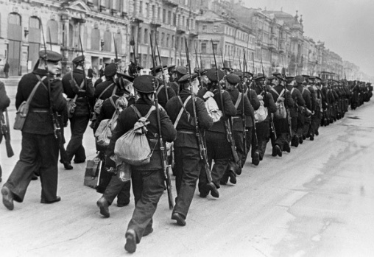
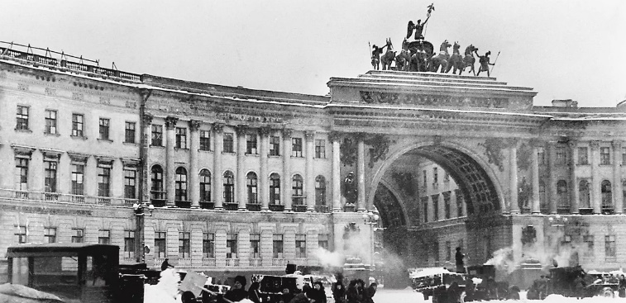
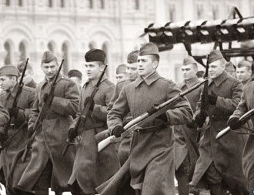
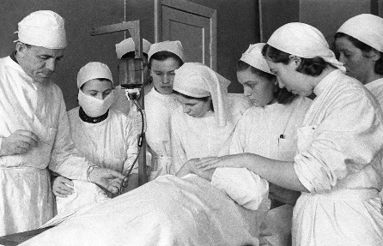
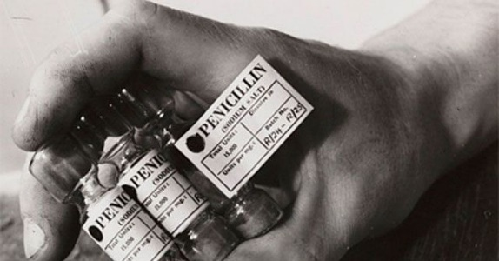
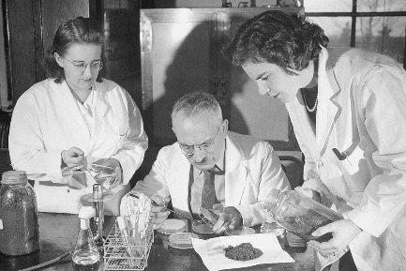
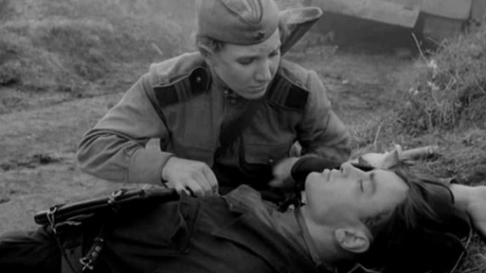

Across
3. / a situation in which soldiers stop goods or people from entering or leaving a place
6. / a vehicle designed for air travel that has wings and one or more engines
9. / a disease in a part of your body that is caused by bacteria or a virus
10. / someone who loves their country and is proud of it
14. / one of several liquid substances with a pH of less than 7 that react with other substances, often burning or dissolving them
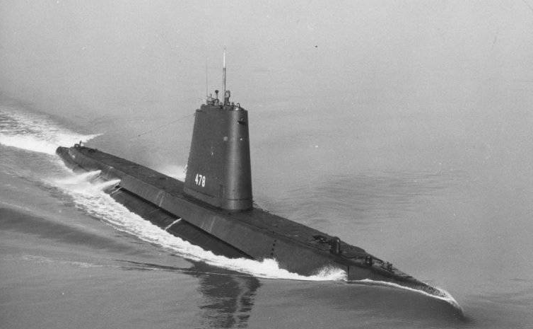
16. / an expert who studies or works in one of the sciences
17. / a fight between armed forces
18. / a product which has never existed before
19. / the end or destruction of something
20. / a person who hates or opposes another person and tries to harm him or her

Down
1. / a room used for scientific work
2. / a person whose job is to treat people who have an illness or injury
4. / the process of finding information or an object, especially for the first time, or the thing that is found
5. / a gun, knife or other object used to kill or hurt someone
6. / a medicine or chemical that can destroy harmful bacteria in the body
7. / thin, flat material used for writing on, covering things in
8. / a ship that can travel underwater
11. / a type of medicine that kills bacteria and is used to treat illness
12. / a win in a fight or competition
13. / the scientific study of substances and how they change when they combine
15. / a soldier, usually one who has both experience and skill in fighting, especially in the past

Answers:
- Laboratory
- Doctor
- Blockade
- Discovery
- Weapon
- Airplane, 6. Antibiotic
- Paper
- Submarine
- Infection
- Patriot
- Penicillin
- Victory
- Chemistry
- Acid
- Warrior
- Scientist
- Battle
- Invention
- Death
- Enemy

