Приложение 1
Уровень С

Read the words. Make up the groups and write the words to the groups.
Parrot, squirrel, tuna, turtle, cow, chicken, goldfish, bear, crocodile, mosquito, carp, bee

_______________ - ________________________________________________________
_______________- _________________________________________________________
______________ - __________________________________________________________
______________ - __________________________________________________________
______________- ___________________________________________________________

Уровень В.
Write the words to the groups.
Parrot, squirrel, tuna, turtle, cow, chicken, goldfish, bear, crocodile, mosquito, carp, bee

Fish - ____________________________________________________________________
Birds - ____________________________________________________________________
Animals - ___________________________________________________________________
Insects - _______________________________________________________________
Reptiles - _________________________________________________________________

Уровень А
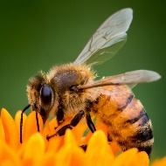
Продолжи ряд / Write the words in the groups.
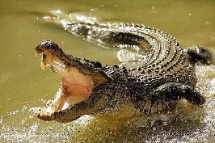
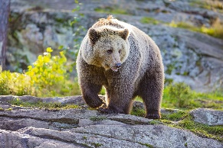
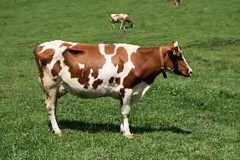
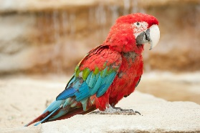
parrot cow bear crocodile bee
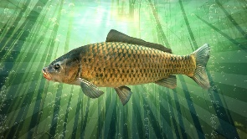
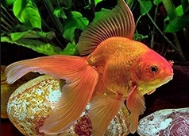

goldfish carp

Fish – tuna,_____________________________________________________________
Birds - chicken, ___________________________________________________________
Animals - squirrel, _________________________________________________________
Insects – mosquito, ______________________________________________________
Reptiles - turtle, ________________________________________________________

