Тексты для чтения

Текст №1. A Snowman
Прочитай текст и ответь на вопросы. Прочти и переведи выделенный отрывок текста.
It was the first day of the winter holiday. It was a beautiful day. The trees were white with snow. Peter and his friend went for a walk to the yard. There was a lot of snow. Peter said, “Let’s make a snowman, Tom!” “Oh! That’s a good idea,” Tom said.
They made three big snowballs. The first snowball was very big. The second was smaller than the first one. The third was the smallest. The smallest snowball was the “head”. Then they took three sticks: one for a “mouth” and two small sticks for “eyes”.
Tom had an idea. “We can make the nose out of a big carrot.” They ran home, took a big carrot and an old pot. The boys put the pot on the snowman’s head and made the “nose” out of the carrot. The snowman was ready. How funny it was! The friends were happy. They had a lot of fun.

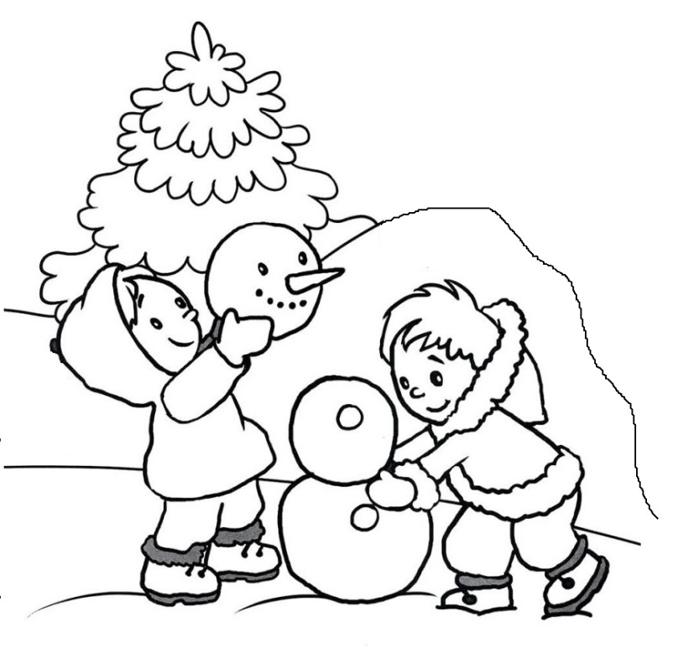

Questions:
1) What colour were the trees?
2) What was Peter’s friend name?
3) What did Peter and Tom want to make?
4) How many snowballs did the boys make?
5) What did they use to make the snowman’s mouth and eyes?

Текст №2. A Nice Day
Прочитай текст и ответь на вопросы. Прочти и переведи выделенный отрывок текста.
Dan’s family is not big. He lives with his mother and father. Dan’s father is usually very busy at work. He is free only at weekends and he always spends them with his son and wife.
On Sunday Dan woke up and looked at the clock. It was nine. He got up and his mother called him for breakfast. After breakfast Dan and his father went for a walk to the park. There they saw a squirrel and played with it.
When they came home they had lunch. Then mother said that there was an interesting film on TV. “I’d like to watch it very much,” said Dan. In the evening Dan was busy. He wrote a letter to his friend who lives in Manchester. It was a very nice day!

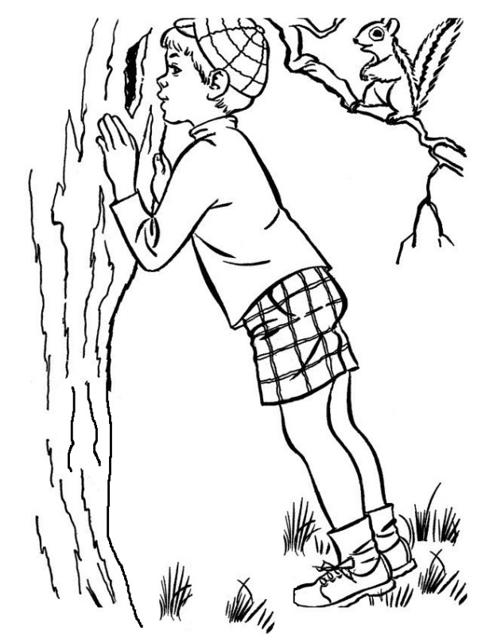

Questions:
1) When does Dan spend time with his father?
2) What time did Dan get up on Sunday?
3) Where did Dan and his father see a squirrel?
4) What did Dan want to watch on TV?
5) When did Dan write a letter to his friend?

Текст №3. Nina
Прочитай текст и ответь на вопросы. Прочти и переведи выделенный отрывок текста.
Nina is a nice little girl. She is eight. Nina and her parents live in a big city. Sometimes the girl is sad because she misses her grandmother, who lives in a small village far from the city.
One morning the girl opened her eyes and saw her grandmother smiling at her. Nina was so happy! She wanted to tell her granny so many things. It was Saturday so Nina didn’t go to school. She doesn’t have classes at the weekend.
In the afternoon Nina and her granny were in the city centre. They did shopping. Granny bought some nice toys for Nina and then the girl helped to choose presents for granny’s friends. They found some nice books about gardening.

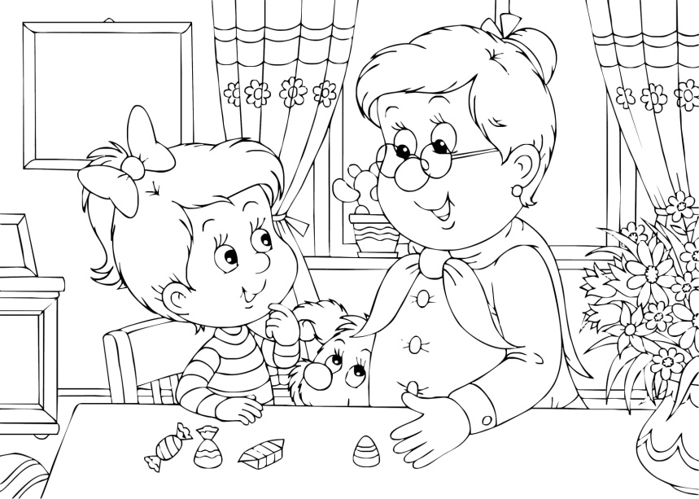
Questions:
1) Where does Nina’s family live?
2) Who did Nina see when she woke up on Saturday?
3) When doesn’t Nina go to school?
4) Where did Nina and her granny go shopping?
5) What presents did they buy for granny’s friends?

Текст №4. A Birthday
Прочитай текст и ответь на вопросы. Прочти и переведи выделенный отрывок текста.
It’s Saturday morning. Ann is still in bed, when her parents come into her room. It’s Ann’s birthday today. She’s ten. Her parents say: “Happy birthday!” They give Ann her presents and kiss her. Ann is happy to get roller skates, interesting books and a box of sweets. They also give her a telegram from Ann's grandparents, who don’t live with them.
In the afternoon Ann has a birthday party. Her friends bring her many different presents and a lot of flowers. Ann likes all of the presents very much. Best of all she likes a nice big beautiful doll and a horse.
At three o'clock the children sit down at the holiday table. They eat a big birthday cake, fruit, ice-cream and many other tasty things. They drink tea, orange and apple juice. Then they sing songs, play games and have a very good time. On that day all the children are happy.

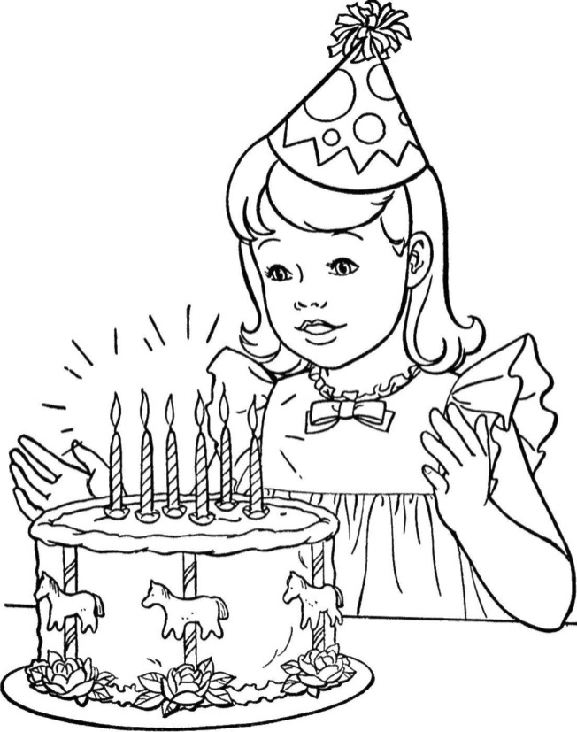

Questions:
1) How old is Ann today?
2) What do Ann’s parents give her?
3) What presents do Ann’s friends bring her?
4) When do the children sit at table?
5) What do the children eat and drink?

Текст №5. Going shopping
Прочитай текст и ответь на вопросы. Прочти и переведи выделенный отрывок текста.
This morning Mother looks in the fridge and cupboard and sees that she doesn’t have enough bread, butter and milk. She asks her son Ben to go shopping.
“Ben,” she says, “I want you to go and buy some things. First, buy three kilos of potatoes. Then buy two hundred and fifty grammes of butter, two hundred grammes of cheese and a litre of milk. You can buy bread, too. Here is the money.”
Ben takes shopping-bag and goes to the supermarket. He goes along the street, past the toy shop. At the shoe shop he goes across the street and comes into the supermarket. There he sees his friend Henry.
“What are you doing here?” asks Ben.
“I'm going to buy potatoes,” says Henry. “And what do you want to buy?”
“Milk and butter”.
“Let’s go shopping together”.
Soon the boys come out of the shop and get on a bus.
“Do you often go shopping? “ asks Ben.
“Very often“, says Harry. “Mum says I know a lot about shopping and I can buy almost anything“.

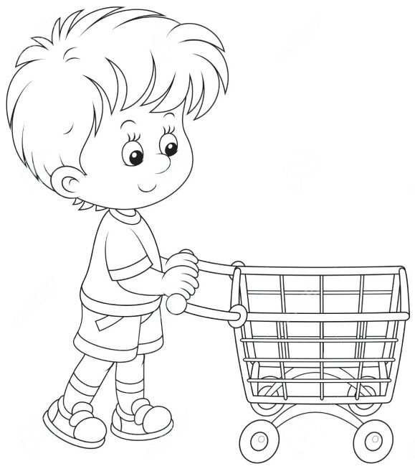

Questions:
1) What does the Mother see in the fridge?
2) What does the Mother asks Ben to buy?
3) How does Ben go to the shop?
4) What is Henry going to buy?
5) How often does Henry go shopping?

Текст №6. William
Прочитай текст и ответь на вопросы. Прочти и переведи выделенный отрывок текста.
Do you see the little boy in this picture? He is an English schoolboy. His name is William Brown. He lives in a small town near London with his family.
William is eleven. He goes to school every day. He likes holidays very much: he can play with his friends all the time then.
In English schools lessons begin at nine o'clock in the morning. Some children go home at twelve o'clock and have dinner and some children have dinner at school. Then they come back to school at two o'clock and have lessons again from two to half past three.
Williams’s father, Mr. Brown, works in London. He goes to work by train in the morning and comes back home at six o'clock in the evening. He doesn’t go to work on Saturdays and Sundays.
William’s mother is a housewife. She cleans the house, washes dishes and makes breakfast, dinner and supper for her family. William has a brother, called Robert and a sister, called Judy. Robert is 21 and Jusy is 18.

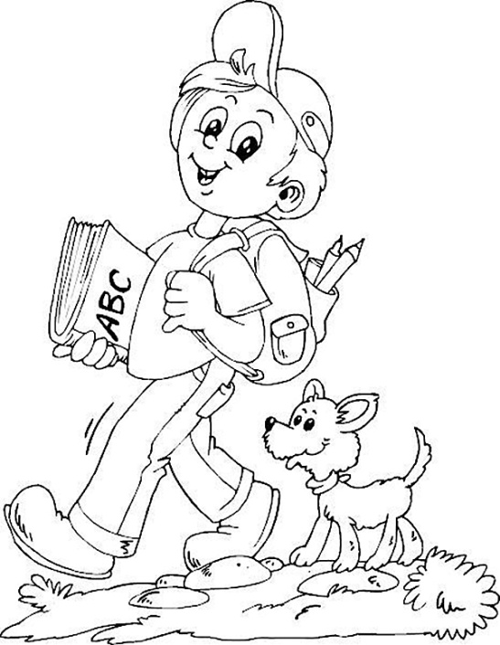

Questions:
1) Where does William live?
2) How old is he?
3) When does William’s father come back home?
4) What is William’s mother?
5) Who is older - Robert or Judy?

Текст №7. The Best Time for Apples
Прочитай текст и ответь на вопросы. Прочти и переведи выделенный отрывок текста.

The children were at a lesson at a country school. The lesson was about
the seasons of the year.
"There are four seasons in a year," said the teacher. ''They are: spring, summer, autumn and winter. In spring it's warm and the trees are green.
In summer it's hot, and there are a lot of flowers in the fields, in the parks and in the gardens.
In autumn there are a lot of apples. They are red and sweet and good to eat.
In winter it's cold and it snows...''
Suddenly the teacher stopped and looked at John. '' John, stop talking! Now, answer my question! When is the best time for apples?''
''It's when the farmer isn't at home and there is no dog in the garden,'' said John.

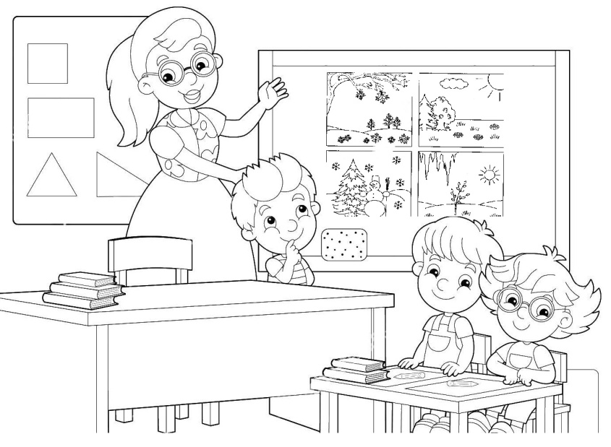

Questions:
1) Where did John study?
2) What did the teacher ask Tom?
3) What did Tom answer?
4) What is your favourite season?
5) Why do you like it?

Текст №8. Last Summer Story
Прочитай текст и ответь на вопросы. Прочти и переведи выделенный отрывок текста.
Last summer Jim and Jill went to the forest. They liked walking very much. The day was fine. It was very hot and sunny. Jim and Jill walked in the forest and then they sat under a big tree. There were a lot of red apples in the tree. They took two apples and ate them. The apples were very tasty.
They talked and talked. Suddenly they saw a small bird. It was on the ground. Jim took the bird in his hands and the children went home.
They put the bird into the box. The children liked the bird very much. They gave the bird apples, bread, corn and water.
The bird lived in their house for two weeks. Then the children took it back to the forest. The bird was very happy.

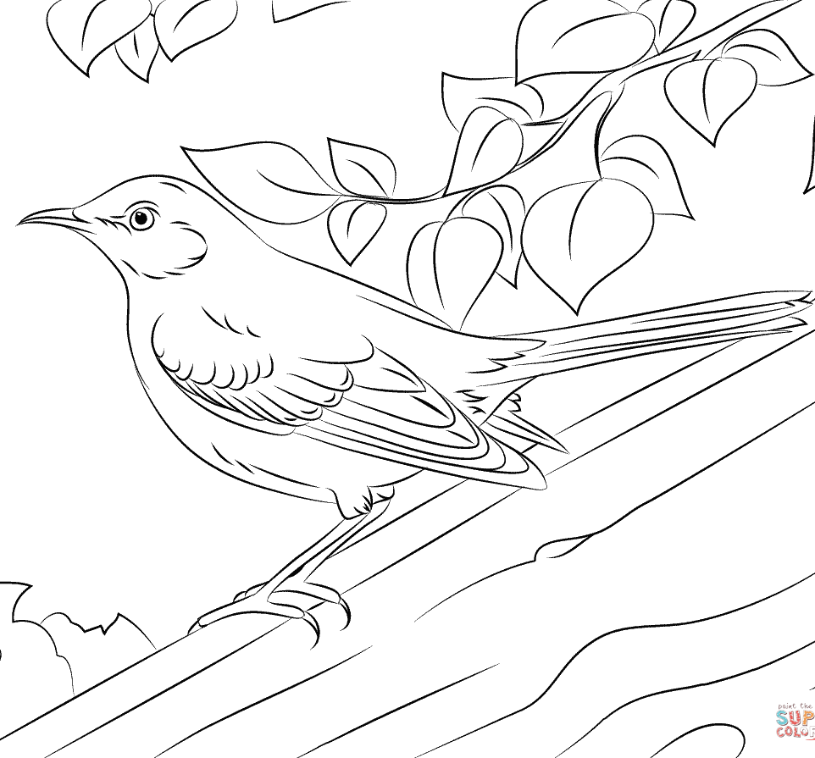
Questions:
1) Where did the children go to walk?
2) When did they go to the forest?
3) What was the weather like?
4) What did Jim and Jill see in the forest?
5) What did the children give the bird?

Текст №9. The Donkey’s Favourite Season
Прочитай текст и ответь на вопросы. Прочти и переведи выделенный отрывок текста.
It’s winter. It’s cold and snowy. The Donkey is sad. “I don’t like winter because I haven’t got any green grass. I can’t walk in the park. In spring I will walk and play with children,” says the Donkey.
Spring comes. It’s warm and sunny. Now the Donkey is in the park. He has got a lot of green grass to eat. But he is sad again.
“I don’t like spring! The children are very noisy (шумные) in the park. In summer I will dive and swim,” says the Donkey.
Summer comes. It’s hot and sunny. The children swim, ride bikes, play soccer and basketball. But the Donkey is sad again.
“I don’t like summer because it is too hot. In autumn I will eat apples and carrots,” says the Donkey.
Autumn comes. It is cloudy and rainy. “I don’t like autumn because it is cloudy, windy and rainy. In winter I will ski and skate.”
Winter comes. But the Donkey is sad again…

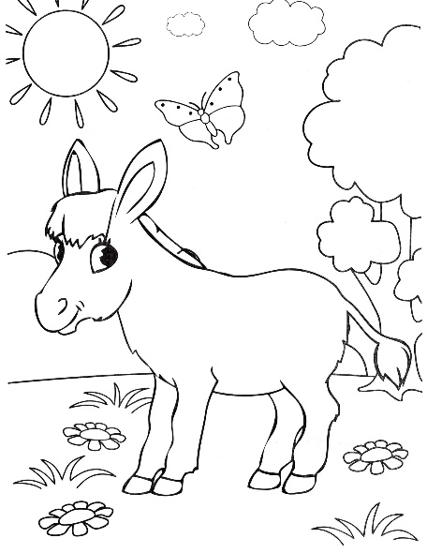

Questions:
1) Does the Donkey like autumn? Why?
2) What does the Donkey like to eat in spring?
3) What do the children do in summer?
4) Where does the Donkey walk?
5) What is the Donkey going to do in winter?

Текст №10. Two Ducks and the Frog
Прочитай текст и ответь на вопросы. Прочти и переведи выделенный отрывок текста.

The frog lives in the river. She is very kind. But she likes to chat (болтать) a lot. She can chat from morning till night. She has got two good friends. They are big ducks.
Autumn comes. It’s cold, cloudy and windy. It’s time for the ducks to fly to Africa. They like summer because it’s hot and sunny. They don’t like winter. It’s snowy and cold. The Frog likes summer too. She wants to see Africa. She says,” My friends, take me to Africa with you, please!”
“Good!” say the ducks. “But you must not speak! Don’t open your mouth!”
So the Frog takes a stick in her mouth. Then one duck takes one end of the stick, the other duck takes the other end. They start to fly.
The children see the ducks in the sky.
“Look! What have the ducks got? What is it?
“It is a big clock!”
“I am not a clock! I am a Frog!”
And flop! The Frog falls down from the sky.

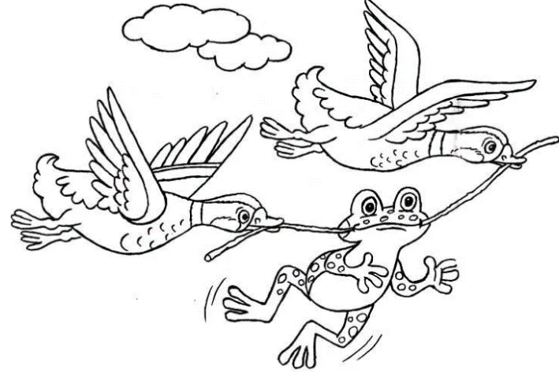
Questions:
1) Do the ducks like winter? Why?
2) Where does the Frog live?
3) What country does she want to see?
4) What do the children see in the sky?
5) Is the Frog clever or silly? Why do you think so?

