dwarf | giant | hole | average  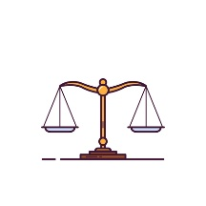 | massive
gas  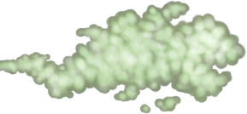 | dust | explode  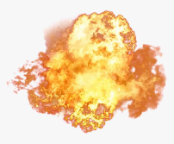 | cycle | size

Description | Russian translation
___________means very big and heavy. | массивный
_________ is any substance like air, for example oxygen. | газ
A ____________ is an extremely small person who will never grow to a normal size. | карлик, гном
__________ is very small pieces of matter in the air or on surfaces. | пыль
A ____________ is an extremely big, tall and strong person. | гигант
To ________ means to break up into pieces violently. | взорваться
_______ tells us how big or small something is. | размер
A _____ is an empty space in an object. | дыра
A ______ is a series of events being repeated many times, always in the same order. | цикл
_________ means not very big and not very small. | средний

