Приложение №4
«Домашние обязанности»
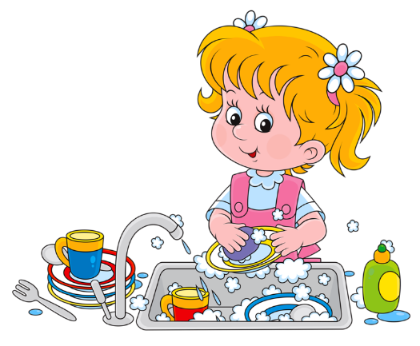 | 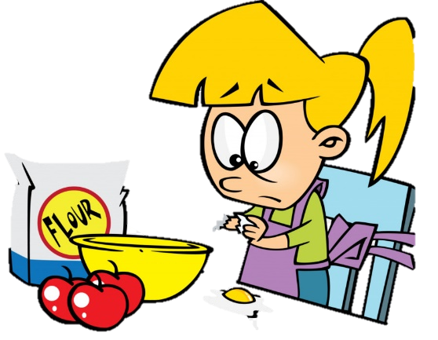 | 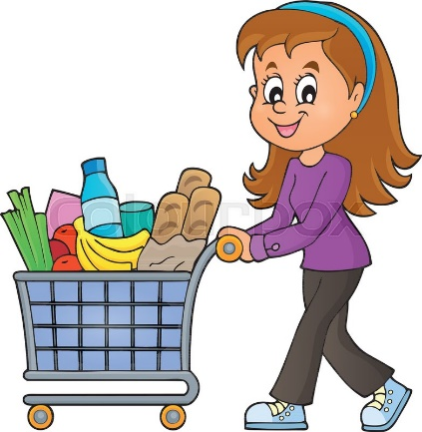
do the washing up | cook the dinner | do the shopping
 | 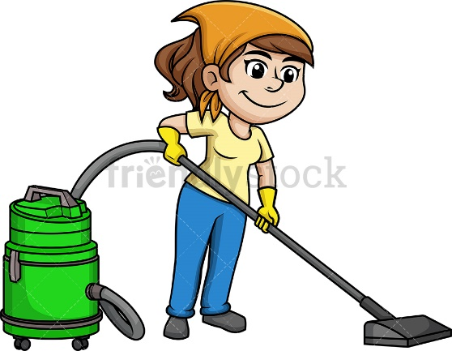 | 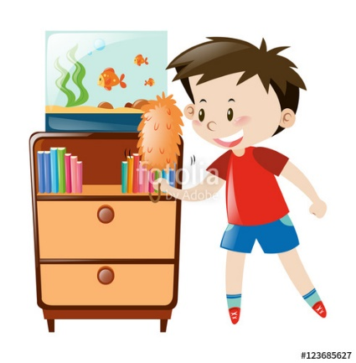
make the bed | vacuum the floor | do the dusting the furniture
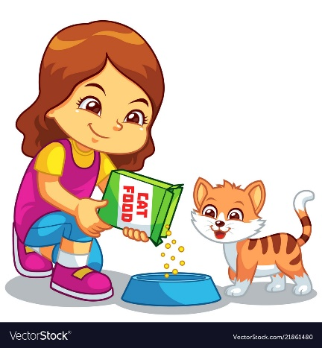 |  | 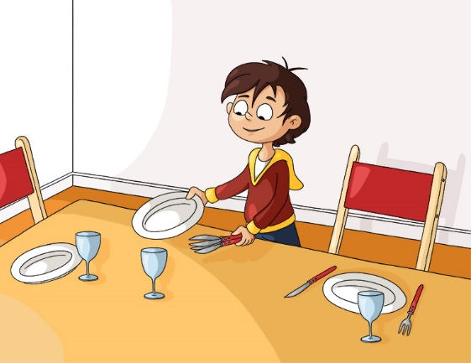
feed the cat | take the rubbish out | serve the table
Go to bed | Have breakfast | Play sports
Draw pictures | Brush teeth

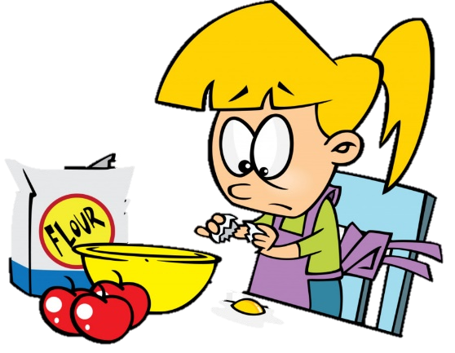

go to bed | have breakfast | play sports
draw pictures | brush teeth
feed the cat | take the rubbish out | serve the table
make the bed | vacuum the floor | do the dusting the furniture
do the washing up | cook the dinner | do the shopping

go to bed | have breakfast | play sports
draw pictures | brush teeth
feed the cat | take the rubbish out | serve the table
make the bed | vacuum the floor | do the dusting the furniture
do the washing up | cook the dinner | do the shopping

go to bed | have breakfast | play sports
draw pictures | brush teeth
feed the cat | take the rubbish out | serve the table
make the bed | vacuum the floor | do the dusting the furniture
do the washing up | cook the dinner | do the shopping

go to bed | have breakfast | play sports
draw pictures | brush teeth
feed the cat | take the rubbish out | serve the table
make the bed | vacuum the floor | do the dusting the furniture
do the washing up | cook the dinner | do the shopping

