Приложение 1
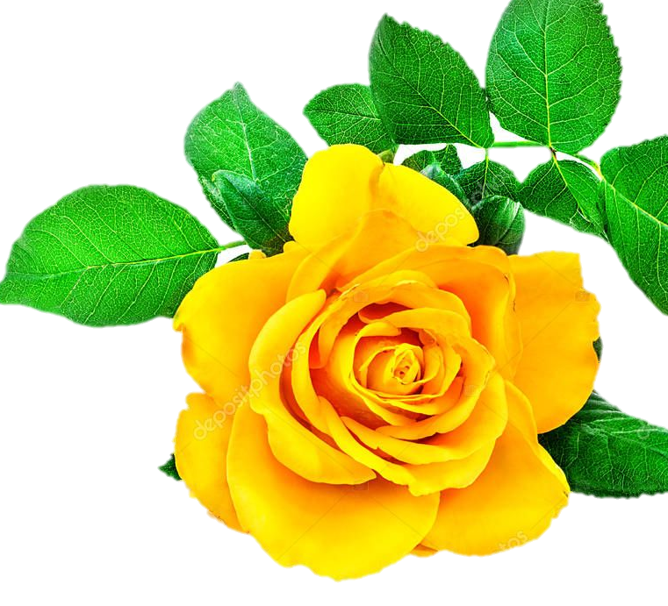

Mommy, I love you!  These flowers are for you! | Mommy, I love you!  These flowers are for you!
Mommy, I love you!  These flowers are for you! | Mommy, I love you!  These flowers are for you!
Mommy, I love you!
These flowers are for you!

