Приложение 1
Материал для отработки навыков письмя.
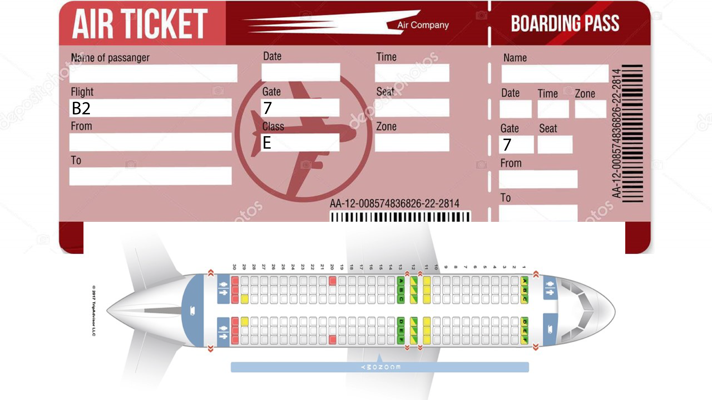

Приложение 2
Готовые монологи о интересных местах во Флориде
Interesting places in Florida
Kennedy Space Center is an active spaceport and control center. You can visit The Space Museum there. You can see rockets, satellites, control center, space suit and other things there. Come there, if you like space.
Sea World Orlando is a theme park and marine zoological park. There are lots of water coasters of different kinds and swimming pools in the park. In addition, there is one of the biggest aquarium in the world in this place. Come there, if you want to have fun and watch sea animals.
Dry Tortugas National Park is famous for its sea life, tropical birds and colorful coral reefs. The guides will tell you about shipwrecks and treasure. Come there, if you like diving and nature.
Walt Disney World. There are 4 theme parks and 2 water parks on the territory of Walt Disney World. You will meet Cinderella, Mermaid, Winnie the Pooh, Mickey Mouse and other Favorite characters. Come there, if you like Walt Disney’s cartoons.

