Appendix 1
Mission one: Match. Do you know these animals?
bee ox toad hare bear whale bird mouse wolf fox tiger

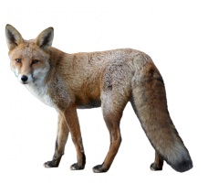 | 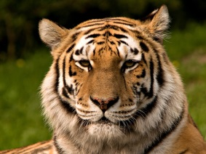 | 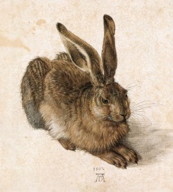 | 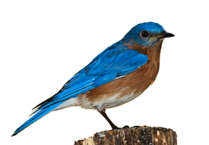 | 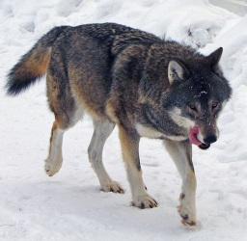 | 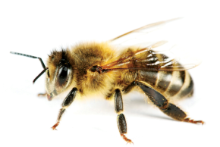
__________ | __________ | __________ | __________ | __________ | __________
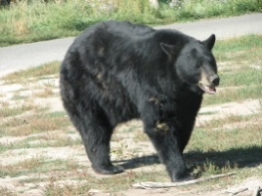 | 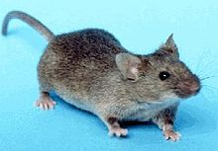 | 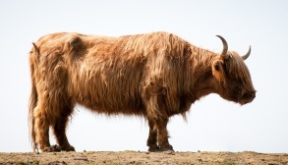 | 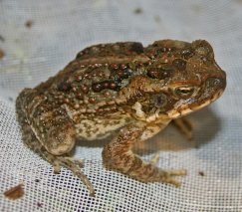 | 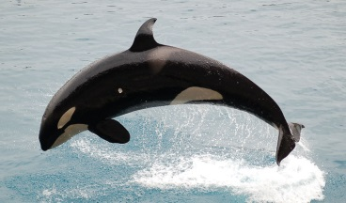
__________ | __________ | __________ | __________ | __________

- Misson two: Listen to the song, “Everything at Once” and fill in the blanks.

As sly as a ________, as strong as an _______
As fast as a ________, as brave as a ________
As free as a ________, as neat as a word
As quiet as a ________, as big as a house
All I wanna be, all I wanna be, oh
All I wanna be is everything
As mean as a ________, as sharp as a tooth
As deep as a bite, as dark as the night
As sweet as a song, as right as a wrong
As long as a road, as ugly as a ________
As pretty as a picture hanging from a fixture
Strong like a family, strong as I wanna be
Bright as day, as light as play
As hard as nails, as grand as a ________
All I wanna be, all I wanna be, oh
All I wanna be is everything everything at once
As warm as the, the sun, as silly as fun
As cool as a tree, as scary as the sea
As hot as fire, cold as ice
Sweet as sugar and everything nice
As old as time, as straight as a line
As royal as a queen, as buzzed as a ________
Stealth as a ________, smooth as a glider
Pure as a melody, pure as I wanna be

All I wanna be, all I wanna be, oh
All I wanna be is everything at once
Artist: Lenka
Album: Two
Year: 2011

