I Wish I Was a Pirate
by Tony Bradman
1) Choose the correct words A, B, C
I (1) _______ I was a pirate  With a long beard hanging (2) ________,  A cutlass dangling (3) ________ my belt,  My teeth all black (4) ________ brown.  A parrot on my shoulder,  A (5) _________upon one eye,  A pirate ship to sail on,  A pirate flag to fly.  The rolling waves (6) ______ be my home,  I’d live through (7) ________ wrecks.  I’d always have the best of maps -  The ones marked with an X!  Pirates (8) ______ have parents,  They don’t get sent to school.  They never have to (9) _______ a bath,  For them there are no rules.  Yo-ho-ho me hearties!  It’s a pirate’s life (10) _____ me …  Pistols in my pockets,  Salt-pork for my tea! | A B C  1 am wish would  2 down out of under  3 from Through of  4 but or and  5 path patch rope  6 would will are  7 much any many  8 doesn’t don’t not  9 take make do  10 to of for  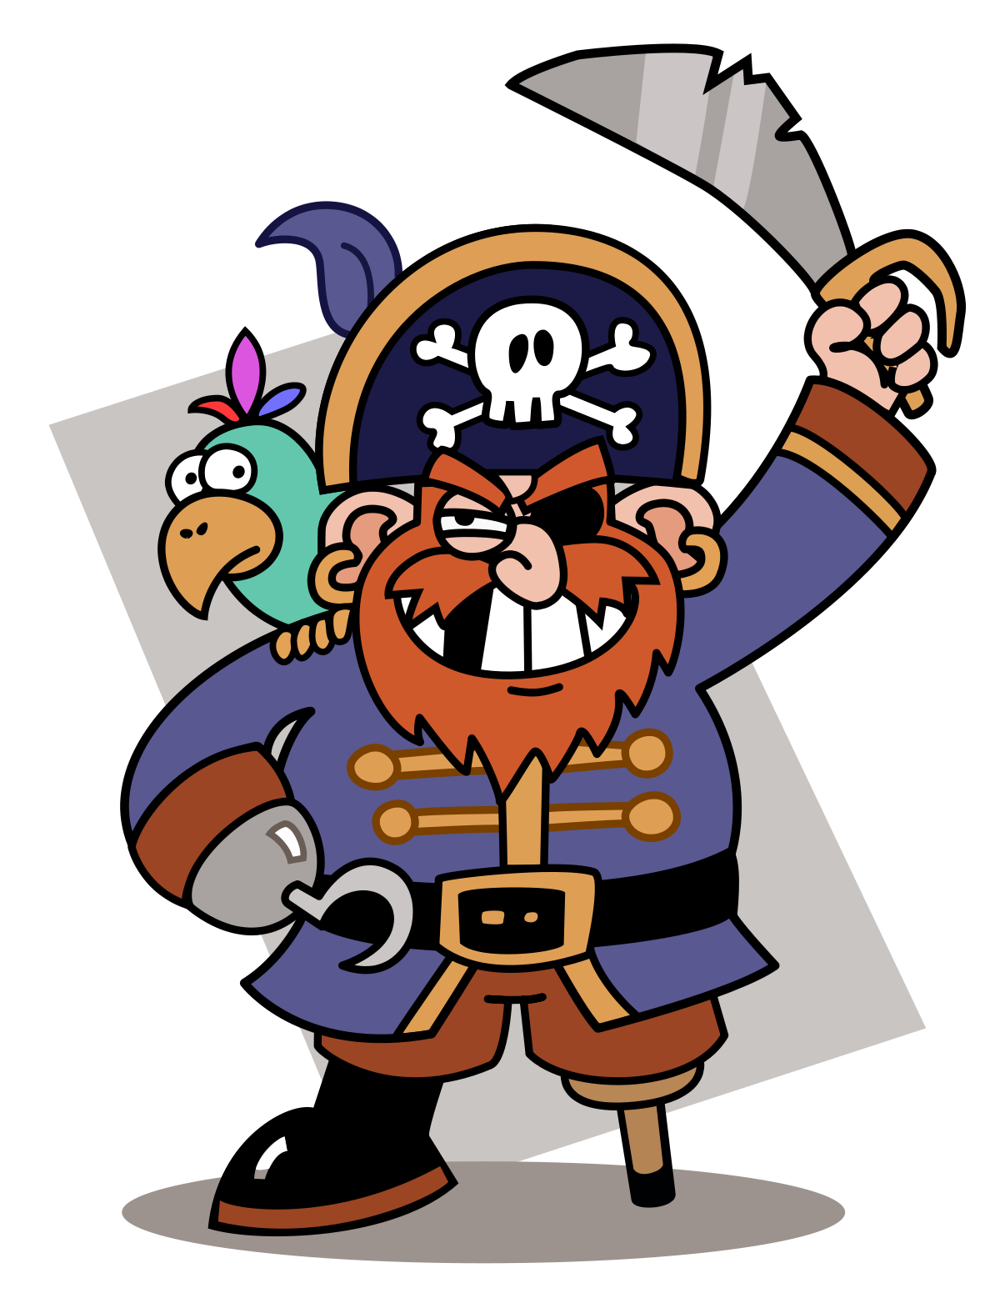
2) Write the words in the correct box.
Body | Clothes | Food | Ship

3) Match the words to form collocations.
1 |  | get | A | a bath
2 |  | sail | B | from
3 |  | hang | C | send
4 |  | take | D | on
5 |  | dangle | E | down

4) Write and draw!
Imagine, you are a pirate! Draw a pirate and tell your partner three things you know about pirates.

_________________________________

_________________________________

_________________________________

_________________________________

Answers
I Wish I Was a Pirate
by Tony Bradman
1) Choose the correct words A, B, C
I (1) _______ I was a pirate  With a long beard hanging (2) ________,  A cutlass dangling (3) ________ my belt,  My teeth all black (4) ________ brown.  A parrot on my shoulder,  A (5) _________upon one eye,  A pirate ship to sail on,  A pirate flag to fly.  The rolling waves (6) ______ be my home,  I’d live through (7) ________ wrecks.  I’d always have the best of maps -  The ones marked with an X!  Pirates (8) ______ have parents,  They don’t get sent to school.  They never have to (9) _______ a bath,  For them there are no rules.  Yo-ho-ho me hearties!  It’s a pirate’s life (10) _____ me …  Pistols in my pockets,  Salt-pork for my tea! | A B C  1 am wish would  2 down out of under  3 from through of  4 but or and  5 path patch rope  6 would will are  7 much any many  8 doesn’t don’t not  9 take make do  10 to of for  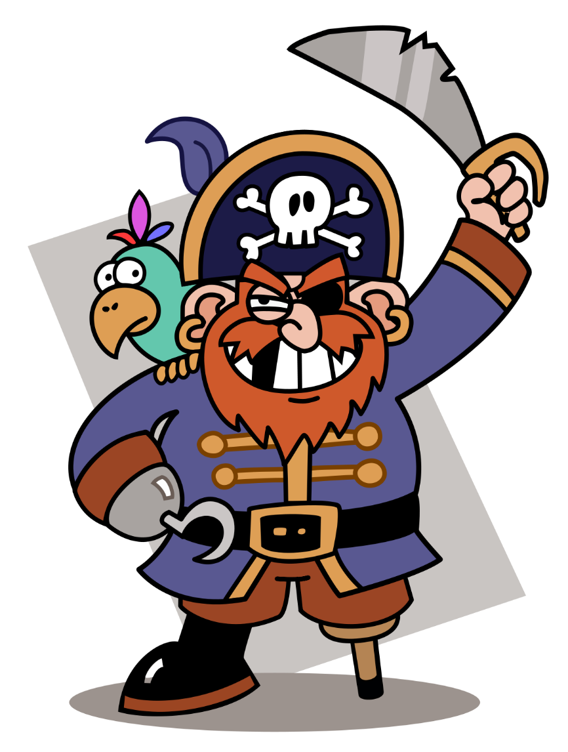
2) Write the words in the correct box
Body | Clothes | Food | Ship
beard | belt | Salt-pork | flag
teeth | pockets | tea | wrecks
shoulder | - | - | maps
eye | - | -

3) Match the words to form collocations.
1 | C | get | A | a bath
2 | D | sail | B | from
3 | E | hang | C | send
4 | A | take | D | on
5 | B | dangle | E | down

