Supplement
Cards for small talks
Task: Use the given prompts and have a small conversation with your partner about reading. Make some notes, if necessary. Then present the received information to the class.
Prompts for your questions | Notes about your partner
- Like or dislike reading books?
- The role of books.
- Favorite kinds of books.
- Favorite author.
- Favorite book.
- The last book you read.
- Reading books or watching films based on books?
- Reading paper books or electronic books (eBooks)?

Pictures for groups discussion
Group 1
Task: Look at the following picture and describe it (Who are the people, where are they, what are they doing, what are the advantages and disadvantages of this type of reading)
Picture 1
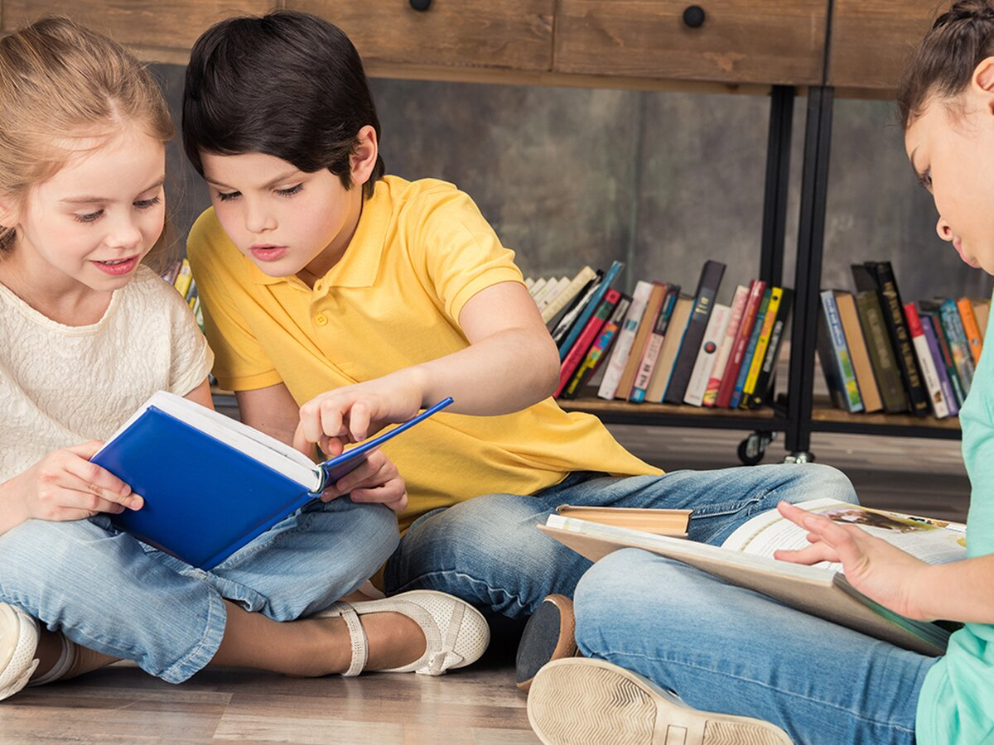
Group 2
Task: Look at the following picture and describe it (Who are the people, where are they, what are they doing, what are the advantages and disadvantages of this type of reading)

Picture 2
Cards for the game “Who Am I?”
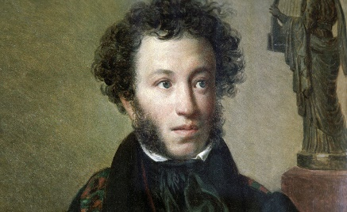  A. S. Pushkin | Harry Potter | Mowgli | Doctor Powerpill
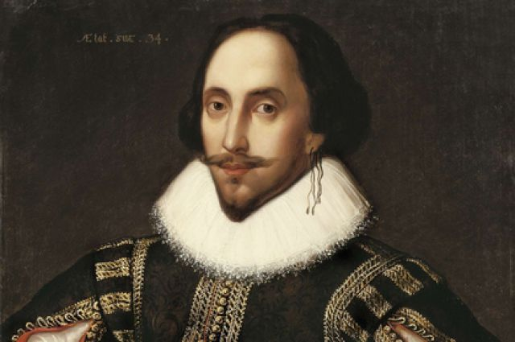  W. Shakespeare | 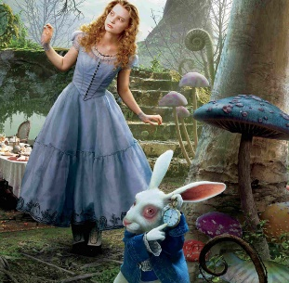  Alice | 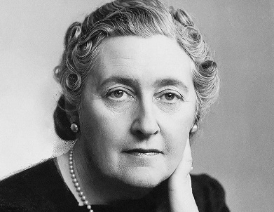  A. Christie | 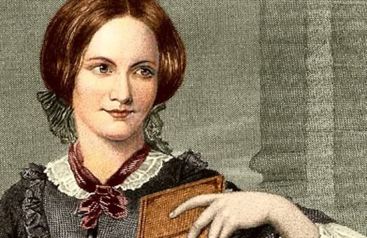  Сh. Bronte
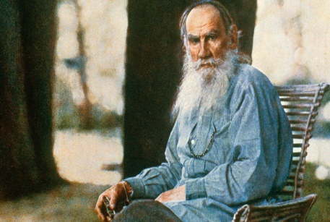  L.N. Tolstoy | 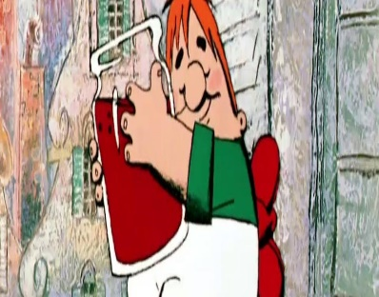  Karlson | 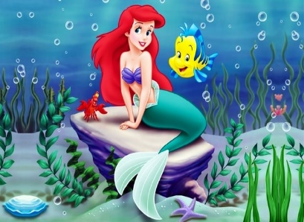  Mermaid | 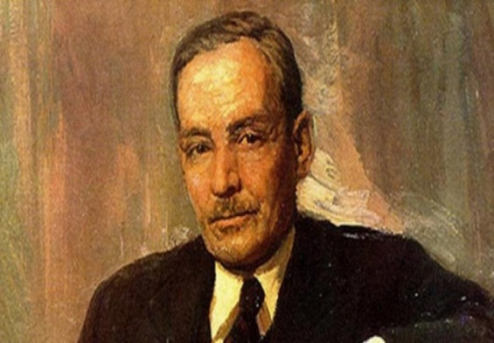  Y. Kupala

Helping cards for situation solving
Prompts | Notes
- Genre
- Main characters (appearance and inner world)
- Place
- Main problem of your book

Question cards:
- Do you agree with the quote? Why?/ Why not?
- What is the main function of books in our lives?
- Some people don’t like reading books. How do you think what are the reasons?
- Will the Internet replace reading one day or not? Why?

Reflection cards
Task: answer the following questions, please.
- What was for you easy and difficult during the lesson?
- What activity was the most exciting and what was the most boring?
- Were you active or passive during the lesson? Why?
- What information was new for you?

Teacher’s self-reflection card

- Were my students excited?
- What task was the most difficult for them?
- What should I improve next time? etc

