Appendix 2
The owner`s name is not included into the list of names on the dial.
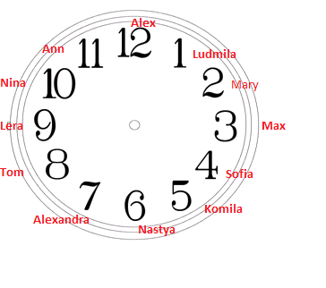
This card belongs to Tatyana

