Кроссворд по теме «Животные»

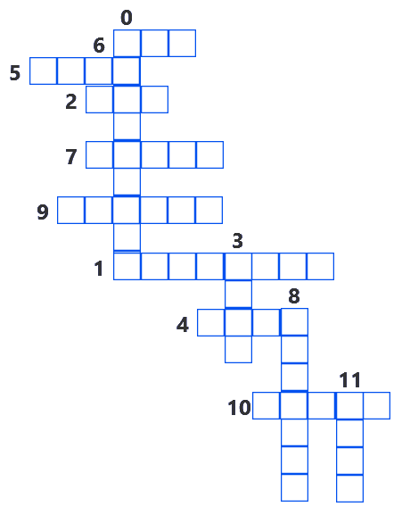

Questions
- It’s green and it lives in the river.
- It is very big and grey. It has 4 legs and a lives in the zoo.
- Her nice tail is bushy (густой) and the color of this animal is red.
- In winter it is white, in summer it is grey, it likes carrot and cabbage.
- It is small and green. I has four legs. It can jump well. It lives in the river
- It is brown. It lives in the forest. It likes to eat honey.
- It has four legs. Its nose is pink. It is afraid of dogs, but it likes fish and milk.
- It has four legs but it is not a dog. It likes carrots but it is not a rabbit. I can run fast.
- It is yellow and brown. It havs 4 long legs and a very long neck. It likes to eat green leaves.
- It is small and shy. It has eight legs. It eats bugs.
- It is black and white, it’s a kind of bear. It is very nice and funny. It lives in China.
- It can swim and dive. It has two legs. It can quack.

Answers

