Приложение 5
Карточка для рефлексии
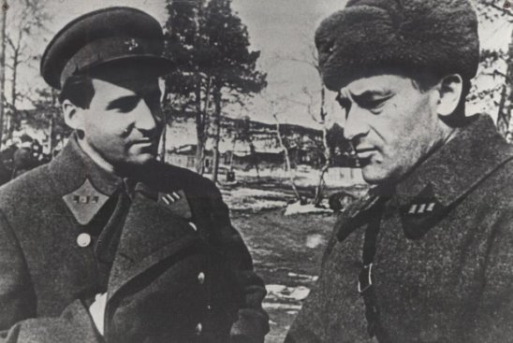  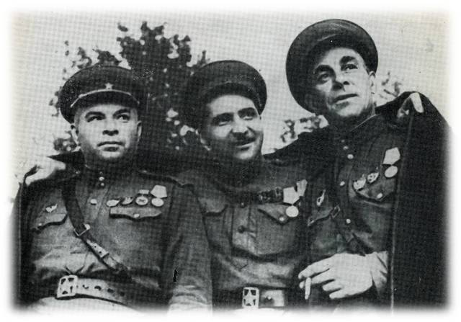 | What is (are) the most interesting fact (s) I have learnt?
 | What facts about the Great Patriotic War, its heroes, poets, etc. I would like to learn in the future? Why?

