Приложение 2
Resource pack – Сборник дидактических материалов

Photocopiable

Write two instruction manuals on how to use VK, Facebook, or any of those other social media things college students are so good at.
- Write the first manual for people like your Uncle Peter who goes to his mailbox to check his e-mail.
- Write the second manual for your peers.

Photocopiable

Take a multi-step plan of one of your English classes in Russian and rewrite the instructions in English. Make the instructions step-by-step. Show the newly written instructions to your teacher and make sure you captured the essence of the plan. He or she may want a copy of them. Ask for money in return.

Photocopiable

Write a contract regarding chores around your house. Be sure to define all terms. Be specific in what you will do and what is required of the head of household. If you can get your parents to sign the contract, watch out. They probably found a loophole.

Photocopiable

- Using your class schedule, write a course catalog with the detailed descriptions.
- Another option is to write a survival guide for a class you are taking. Use humor, if you’ve got it.
- Rewrite a school policy.

Photocopiable

Write a recipe. This is harder than it seems. The directions must be specific enough for someone to make the food properly.

Photocopiable
When you type search terms (also called queries or keywords) into the Google search box, save some time by crafting simple, specific search queries. Remember these basic search rules when you use Google in its simplest form:
1. Punctuation doesn’t count. In fact, it is stripped out of the query automatically.
2.

Photocopiable

You probably have lots of files you want to copy from a computer to your Android phone: pictures, videos, and audio files. You can also copy vCards exported from your e-mail program, which helps to build the phone’s address book. Likewise, you may want to copy files from the phone to the computer. Either way it works the same. Follow these steps:

Photocopiable

Write specific instructions on how to complete an ordinary task.

Photocopiable
Virus Protection.
Viruses are one of the most misunderstood computer phenomena around these days. What is a virus? How does it work? How does it spread from computer to computer? What is the best way to protect your network from virus infection? What other additional precautions can you take to ensure virus-free computing?

Photocopiable

How to Make a Conference Call on an Android Phone.
Unlike someone interrupting a conversation by making an incoming call, a conference call is one you set out to make intentionally: You make one call and then add a second call. Touch an icon on the phone’s touchscreen and then everyone is talking. Here’s how it works:

Photocopiable

Most people want a camera for their drone. It’s part of the fun! Camera technology has come a long way in the past 25 years. With so many digital cameras available, you have many features to choose from. Aside from price, here are the primary features that require consideration when selecting your new camera:

Photocopiable

Getting Started with Skype in Windows 10.
Skype can be a handy tool to use with Windows 10. It’s a good way to keep in touch with family, friends, or even business contacts. Keep reading for some tips on getting started with Skype...

Photocopiable
How to Introduce Your Business in a Letter.
An introductory business letter is supposed to make a good impression with a potential customer (called a prospect). Writing a letter to introduce your business to someone involves shifting the focus to your correspondent, engaging his or her interest, and launching a conversation, rather than a lecture:
1. Start with a bang. Open with a sentence that grabs interest and establishes a reason to keep reading.
2.

Photocopiable
Everything worth doing benefits from proper planning, and taking a test is no exception. The last chance a student has to influence the outcome of a test is the night before they take it. Here are ten must-dos to positively affect the outcome of a test:
1. Eat a well-balanced meal. It’s a proven fact that what you eat will have an effect on your physical and mental performance...
10. Reward yourself. Treat yourself right...

Photocopiable

Write an annual report on your accomplishments during the current school year. Be sure to provide data.

Photocopiable _____________________________________________________
1. The main screen on an Android phone is called the Home screen. It’s where all the action takes place: where you start the apps, work the widgets, and check out what’s going on via notification and status icons.
Each phone may sport a different skin, or appearance. The stock Android phone Home screen is shown in the figure. You can find the items in the figure on your own phone’s Home screen, although they may not look exactly the same.
Describe how to use this product. Use as much information as possible.
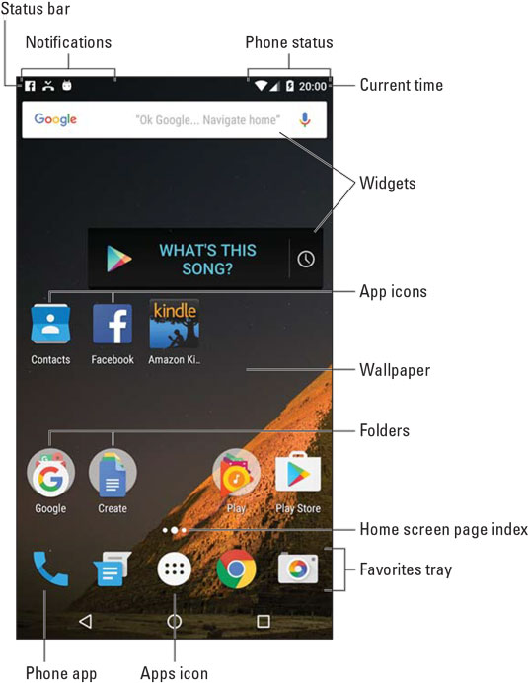
Photocopiable _____________________________________________________
2. The Windows Vista-era parlor trick commonly called “God Mode” is alive and well in Windows 10, as shown in this figure. It’s surprising to see that it made the transition to Win10, because it’s based on hooks into the Control Panel — and the Control Panel is being disassembled rapidly in Windows 10.
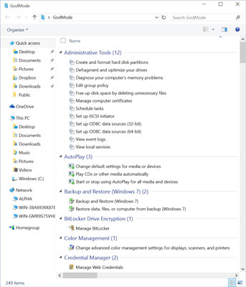
“God Mode” is a massive collection of 262 shortcuts into all sorts
of Windows settings, many of which are quite obscure.

The parts of God Mode that appear in Windows 10 are slightly different from the elements in Windows 8.1 (which, in turn, is slightly different from Windows 7). But the overall effect is the same.
Follow these steps to access God Mode on your Windows 10 desktop:

Photocopiable _____________________________________________________
3. If you are looking for a change of employment or just starting out in the workforce, in most cases, you will need to know how to create a resume. A resume is a document that lists your degrees, accolades, skills, employment history, and work experience. This document is important because it’s a first impression to the person considering you for hire.
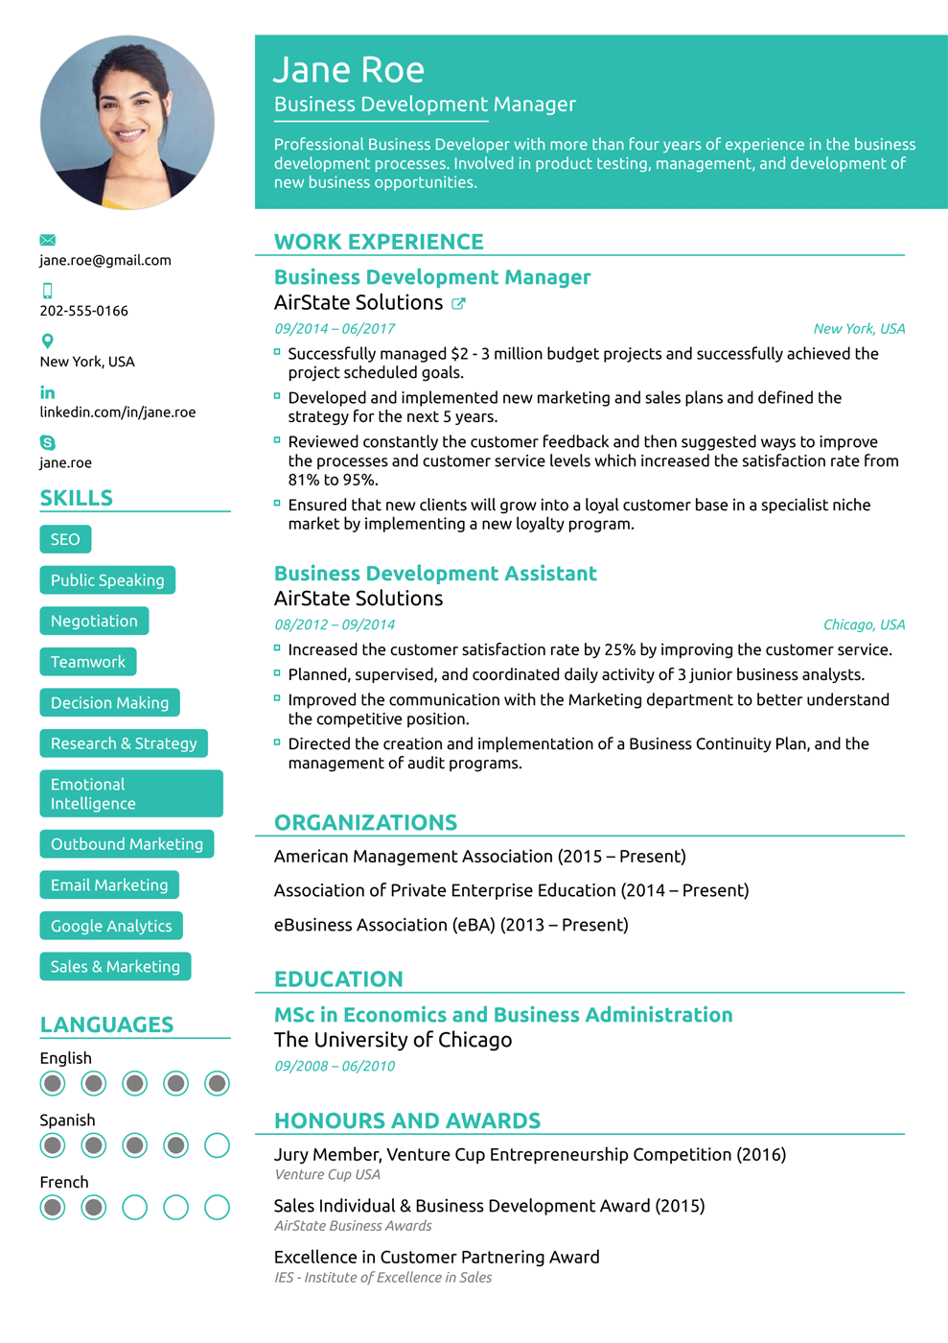
Photocopiable _____________________________________________________
The following questions will give you a hand:
What skills should you list in your resume?
How crucial is the education section in your resume?
What should you list in the employment history section in your resume?
What is listed in the awards section of your resume?

Photocopiable _____________________________________________________
4. How to Jump Start a Car.
If your battery has died, you may be able to use jumper cables to jump start it from some good Samaritan’s (GS) vehicle. If you can safely use jumper cables on your vehicle, make sure that the battery on the good Samaritan’s vehicle has at least as much voltage as your own. As long as you hook up the cables properly, it doesn’t matter whether your vehicle has negative ground and the GS’s vehicle has positive ground, or your vehicle has an alternator and the GS’s vehicle has a generator.
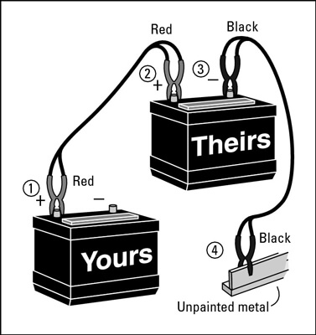
To safely jump a start, follow these steps:
1. Take out your jumper cables. It’s a good idea to buy a set of jumper cables and keep them in the trunk compartment. If you don’t have jumper cables, you have to find a good Samaritan who not only is willing to assist you but who has jumper cables as well.

