Приложение №3 Worksheet №1
Match the photos of the Victory monuments of Mtsensk land and the names:

- 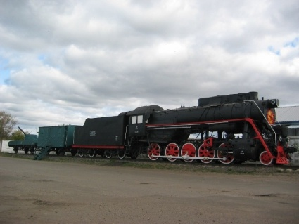 2. 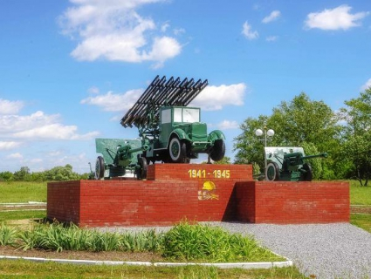

- 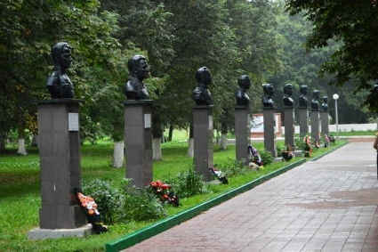 4. 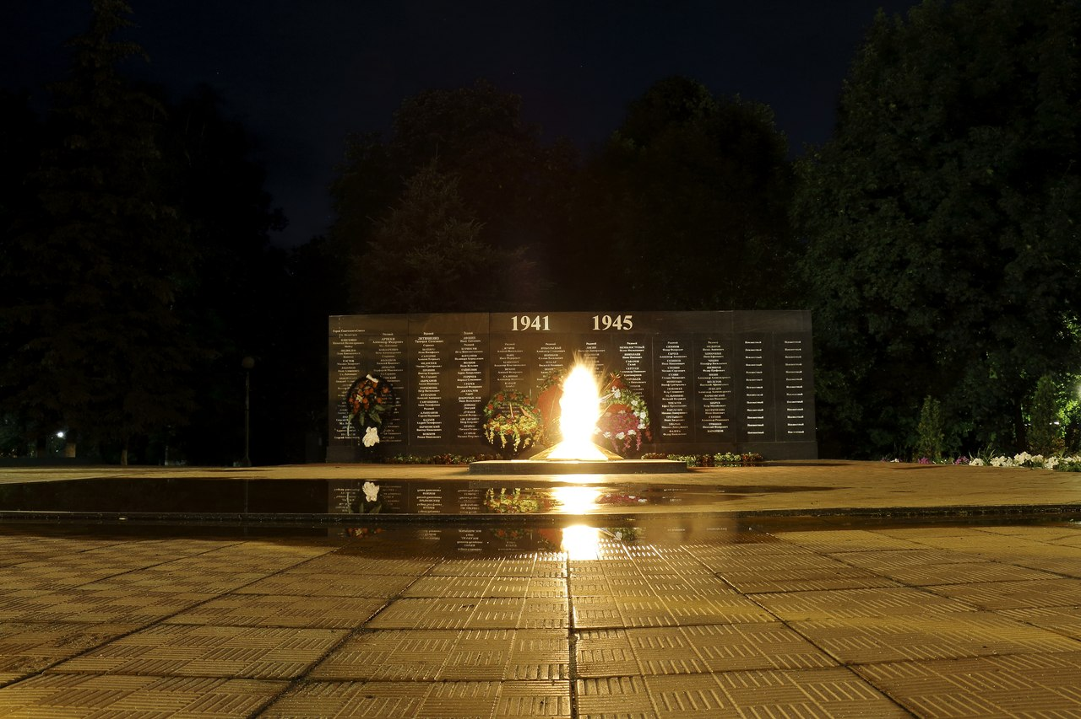
- 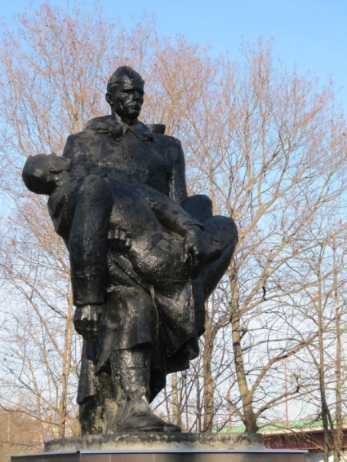 6. 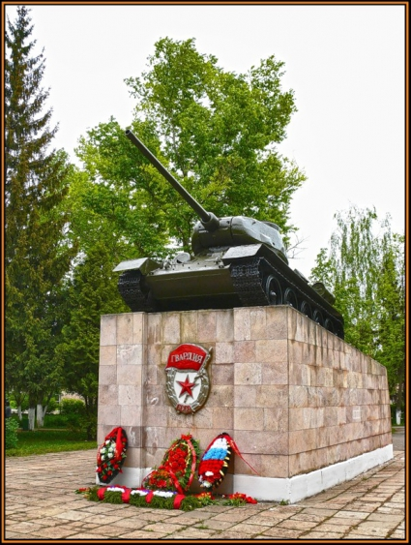

- a monument to the tank T – 34 and tankmen, Tankmen’s Park
- a monument to a legendary railway engine and the defenders of Motherland
- a monument to a rocket launcher Katyusha and the defenders of Motherland
- Heroes’ of the Soviet Union memorial busts (Alley of Glory)
- Eternal light, Park of Heroes
- a monument to the unknown soldier, Park of Heroes

Fill in the table:
1 | 2 | 3 | 4 | 5 | 6

