Приложение № 2 (текст к презентации)
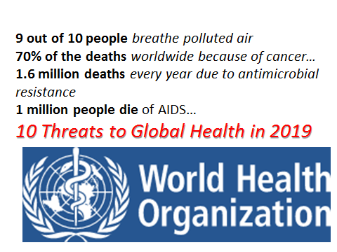
Air pollution and climate change
Nine out of ten people breathe polluted air every day. In 2019, air pollution is considered by WHO as the greatest environmental risk to health.
Noncommunicable diseases
Noncommunicable diseases, such as diabetes, cancer and heart disease, are collectively responsible for over 70% of all deaths worldwide, or 41 million people. This includes 15 million people dying prematurely, aged between 30 and 69.
Antimicrobial resistance
Resistance to tuberculosis drugs is a formidable obstacle to fighting a disease that causes around 10 million people to fall ill, and 1.6 million to die, every year.
Dengue, a mosquito-borne disease that causes flu-like symptoms and can be lethal and kill up to 20% of those with severe dengue, is spreading to less tropical and more temperate countries such as Nepal, that have not traditionally seen the disease.
HIV/AIDS
(human immunodeficiency virus)
22 million are on treatment
nearly a million people die of HIV/AIDS every year
Since the beginning of the epidemic, more than 70 million people have acquired the infection, and about 35 million people have died. Today, around 37 million worldwide live with HIV

