Приложение №1
Учебный модуль

Chemical elements and the Periodic table.
Computer lesson: P.A. Freshney “Periodic Table”

Lead-in
- Why is it important to classify things?
- Can you comment on D.I.Mendeleyev’s words: “…the future won’t threaten the periodic law, the future will promise it only superstructures and development …”

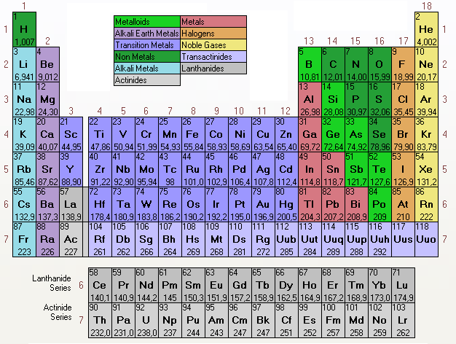

Working with the Windows application (Internet)

Work in groups of 3-4. Choose any element you want, find it and read the information about it. Complete the table below.
Name,  symbol | Atomic  weight | Atomic  number | Period,  group | Atomic structure | Atomic radius | Availa  bility | Discovery  information | Uses

Problem-solving
Review questions for discussion
1.What is the periodic table, and what is its significance in the study of chemistry? What are groups and periods in the periodic table?
2.Describe the changes in properties (from metals to nonmetals or from nonmetals to metals) as we move a) down a periodic group and b) across the periodic table.
4.You are a group of researches that obtained an element in laboratory conditions. Describe this element: give its main characteristics, name it after one of the famous chemists.

