Приложение к уроку
1
Listen and draw lines
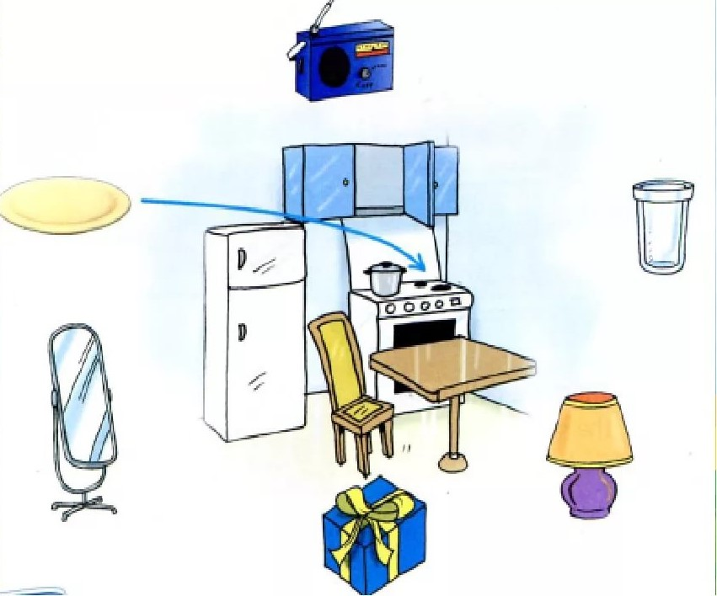
2
Fill in is / are
- There ... 4 beds in the bedroom.
- There … 6 chairs in the kitchen.
- There … a bath in the house.
- There … 2 living rooms in the house.
- There … a mirror in the bathroom.

