Food

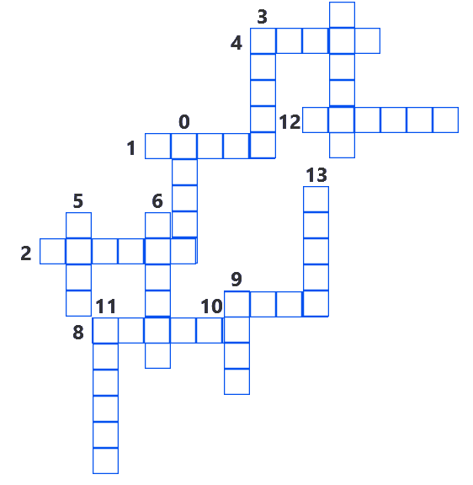

Вопросы и ответы.
1.You can’t cook without it.
2.People make oil from it.
3.It’s a drink from milk.
4.It’s a fruit. It is very sour.
5.It’s a very good starter.
6.They are a good snack. They can be salty and spicy.
7.It’s a spice. It is hot and spicy.
8.It’s an orange vegetable.
9.You use it to make a tasty sandwich.
10.Vegetarians don't eat it.
11.Little children have to drink it.
12.We can drink a cup of it in the morning.
13.It’s an individual cup-shaped dessert made with eggs, flour, sugar and baked.
14.It’s a sour thick liquid (жидкость) made from milk with bacteria added to it.
15.It’s a small amount of food that is eaten between meals.

Waffles
List of ingredients
flour
salt
baking powder
white sugar
eggs
milk
butter
vanilla extract

Directions

Stir in the milk, butter and vanilla.
Cook the waffles until golden and crisp.
Preheat waffle iron to desired temperature.
In a large bowl, mix together flour, salt, baking powder and sugar; set aside.
In a separate bowl, beat the eggs.
Pour the milk mixture into the flour mixture; beat until blended.
Ladle the batter into a preheated waffle iron.
Serve immediately.

