|  |  |  |
| --- | --- | --- |
| **7 + 6 =** |  | **л**  **Знания собираются по капле!** |
| **12 – 9 =** |  | **р** |
| **52 – 40 =** |  | **о** |
| **5 + 6 =** |  | **г**  4  3  1 |
| **13 – 7 =** |  | **я** |
| **8 + 9 =** |  | **и** |
| **16 – 8 =** |  | **м** |
| **3 + 7 =** |  | **у**  2 |
| **11 – 2 =** |  | **о**  5 |
| **7 + 7 =** |  | **ь** |
| **14 + 5 =** |  | **к** |
| **9 + 6 =** |  | **н** |
| **20 – 19 =** |  | **п** |



|  |  |  |  |  |  |  |  |  |  |  |  |  |
| --- | --- | --- | --- | --- | --- | --- | --- | --- | --- | --- | --- | --- |
|  |  |  |  |  |  |  |  |  |  |  |  | **3.** |
|  |  |  |  |  |  |  |  |  |  |  |  |  |

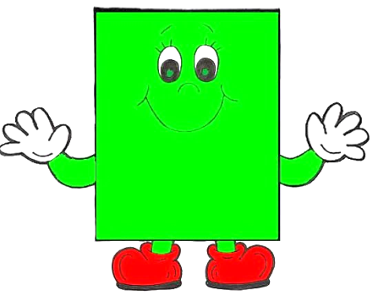

Приложение 2

Прямоугольник – это __________________ ,

у которого_____________________________

______________________________________

______________________________________