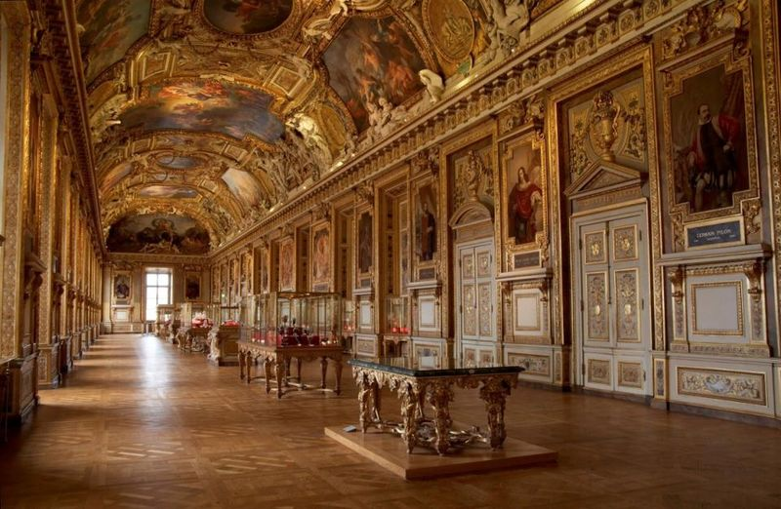
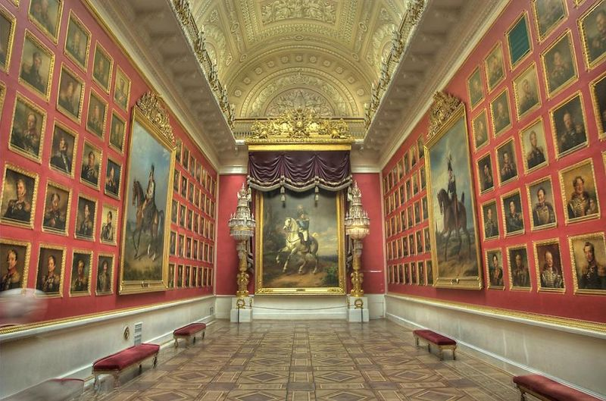
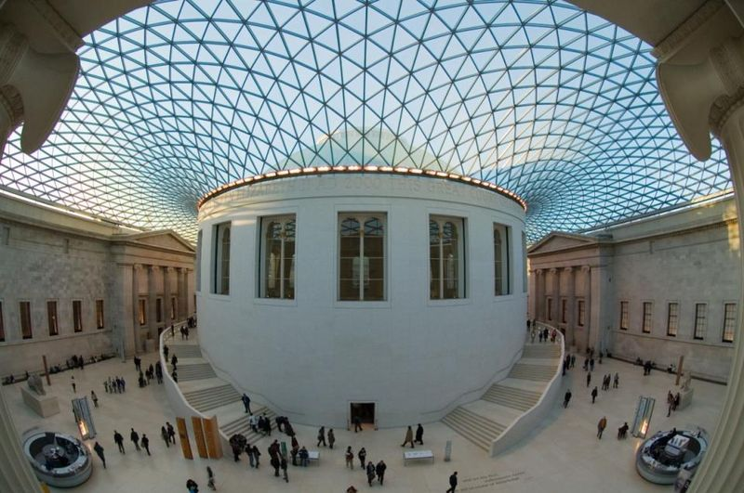
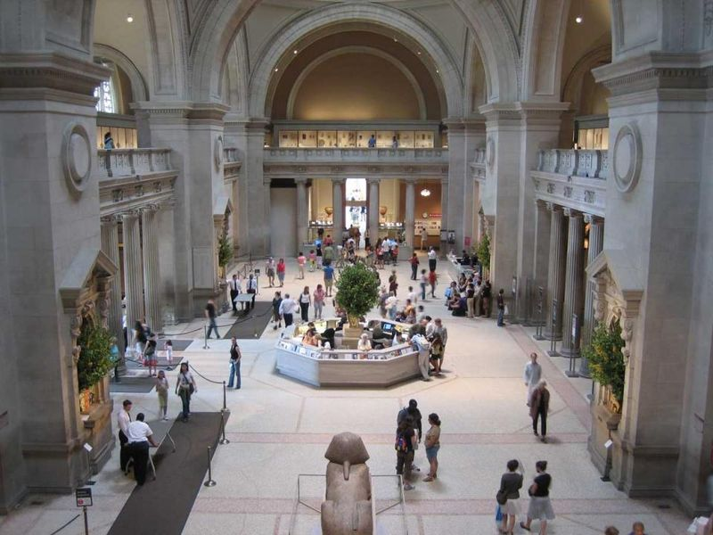
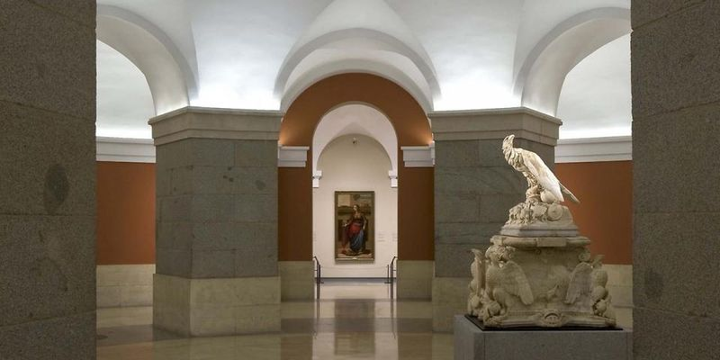
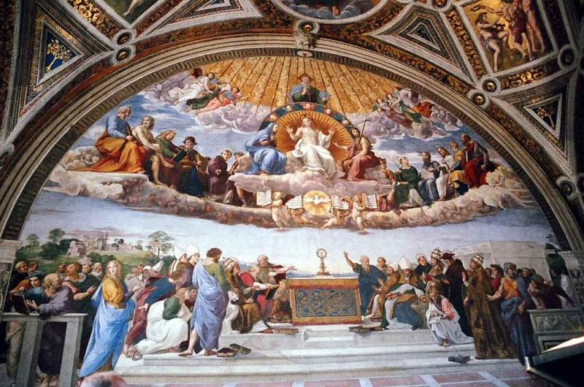

The Louvre, Paris

The Hermitage, Saint Petersburg

The British Museum, London

The Metropolitan Museum of Art, New York

The Prado, Madrid

The Vatican Museum, Vatican

MUSEUM
1.Match the words to make up phrases. Put the letters in the correct order.
1.bump a) among
2. life- b) into
3. state-of c) sized
4. a great d) models
5. voyage e) –the-art
6. wax f) success
2. Guess the prepositions and fill in the gaps.
Where … (1) the world can you bump … (2) Princess Diana, meet David and Victoria Beckham or gaze … (3) Charlie Chaplin’s eyes? Only … (4) Madame Tussauds, the London landmark that’s been pulling … (5) the crowds … (6) 1835.
3.Сhoose the right answer
1. The story_____ (1) (begin/begun/ began) in 1777 when Madame Tussaud _____(2) (to learn/ learned/ learns) the art of ______(3) (sand/water/wax) modelling from Dr Philippe_______(4) (Smith/Curtius/Brown) while working as his ______(5) (worker/nurse/housekeeper).

