Doctors
- Put necessary advice
- Give advice to the patient.
Start with the phrase:
If you want to be healthy you should consult a doctor.
Have a medical check Drink cold milk Sleep 8-9 hours
Take medicine without doctor’s advice
Watch TV much Get out of the house
Take the temperature Drink warm tea with honey
Put a warm compress Walk without hat
Carry heavy things Stay in bed

- If you have got a headache you must ……………………………… .
You mustn’t ……………………………………………………….……..
- If you have got backache you must………………………………..…
You mustn’t ………………………………………………………...…...
- If you have got the flu you must …………………….…………
You mustn’t ………………………………………………………..………...
- If you have got earache, you must……………………………….
You mustn’t …………………………………………………….………….
- If have got a sore throat you should ………………………….………
You shouldn’t …………………………………………………….…….
- If you have got red eyes, you should ……………………………………
You shouldn’t ……………………………………………………………...

Check yourselves.
Patient 1.
Good afternoon, Doctor! I have got a headache.
What must I do? What mustn’t I do?
Doctor
If you have got a headache, you must have a medical check.
You mustn’t take medicine without doctor’s advice.
Patient 2.
P.: Hello, Doctor! I’ve got a sore throat.
What should I do? What shouldn’t I do?
D.: If you have got a sore throat, you should drink warm tea with honey.
You shouldn’t drink cold milk.
Patient 3.:
P.: Hello, Doctor! I’ve got the flu.
What must I do? What mustn’t I do?
D.: If you have got the flu, you must take the temperature.
You mustn’t get out of the house.
Patient 3.
P.: Good afternoon, Doctor! I’ve got red eyes.
What should I do? What shouldn’t I do?
D.: If you have got red eyes, you should sleep 8-9 hours.
You shouldn’t watch TV much.
Patient 4
P.: Hello, doctor! I have got earache.
What must I do? What mustn’t I do?
D.: If you have got earache, you must put a warm compress on your ear.
You must not walk without your hat.
Patient 6.
P.: Hello, doc! I’ve got backache.
What must I do? What mustn’t I do?
D.: If you have got backache, you must stay in bed.
You must not carry heavy things.

Dietologists
- Read and translate the sentences.
- Add pictures to the food pyramid.
- Make an experiment with the studio.

!!!! Start with the phrase:

If you eat a balanced diet, you always be healthy!
- A balanced diet is based on bread and grains (foods like rice and cereal).
- You should eat plenty of vegetables and fruit every day .
- You should eat dairy products (milk, cheese). Also this category includes meat, fish, eggs, nuts.
- Food that should be minimized is fats, salt and sugar.

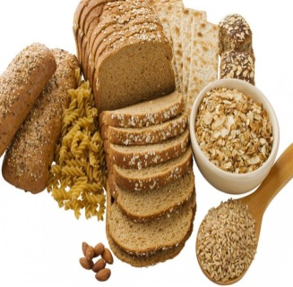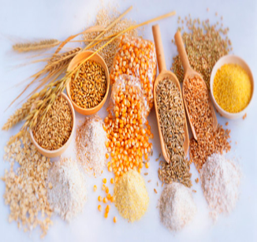

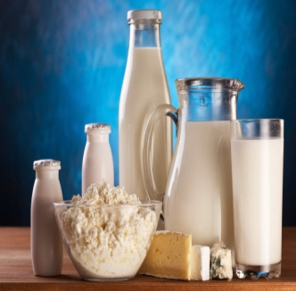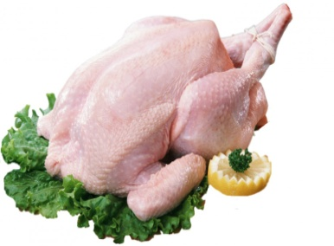

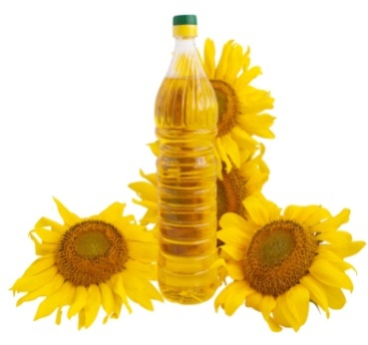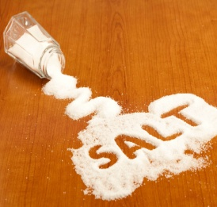

Check Yorselves!!!

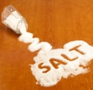

Trainers
- Read and translate the sentences.
- Watch the video.
- Put the sentences in the correct order.
- Do the exercises together with the studio.
Start with these phrases:
To be healthy you should be active. Let’s be active and do exercises all together.
Jump! Jump! Jump!
Lift (Поднимите) your knees (колени).
Tilt (Наклоните) your head forward (вперёд) and back.
Tilt (Наклоните) your body to the left.
Rotate (Вращайте) your shoulders (плечи) forward (вперёд).
Rotate (Вращайте) your shoulders (плечи) back.
Tilt your body to the right.
Squat! Squat! Squat! (Приседайте!)
Tilt (наклоните) your head to the left and to the right.

Check yourselves!!!

1.Tilt your head to the left and to the right.
2. Tilt your head forward and back.
3. Rotate your shoulders forward.
4. Rotate your shoulders back.
5. Tilt your body to the left and to the right.
6. Jump! Jump! Jump!
7. Tilt your body forward
8. Squat! Squat! Squat!
9. Lift your knees.

Psychologists
- Fill in the missing words
- Sing the song karaoke together with the studio

Start with the phrase: !!!!
To be healthy you should avoid stress, smile and sing the songs.
Let’s sing all together.

song worry trouble happy double note

Here's a little ……… I wrote
You might want to sing it note for………….
Don't …………be…………..
In every life we have some…………….
When you worry you make it ………....
Don't worry honey, be happy
(Don't worry, be happy now)

Check Yorselves!!!
Here's a little song I wrote
You might want to sing it note for note.
Don't worry ,be happy!
In every life we have some trouble,
When you worry you make it double
Don't worry honey, be happy
(Don't worry, be happy now)

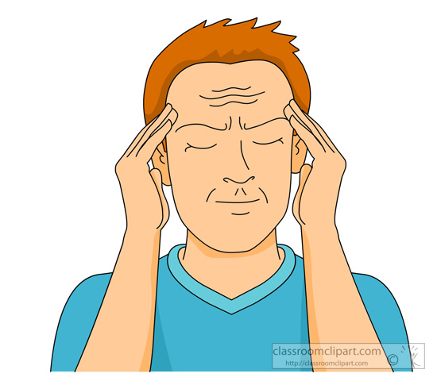

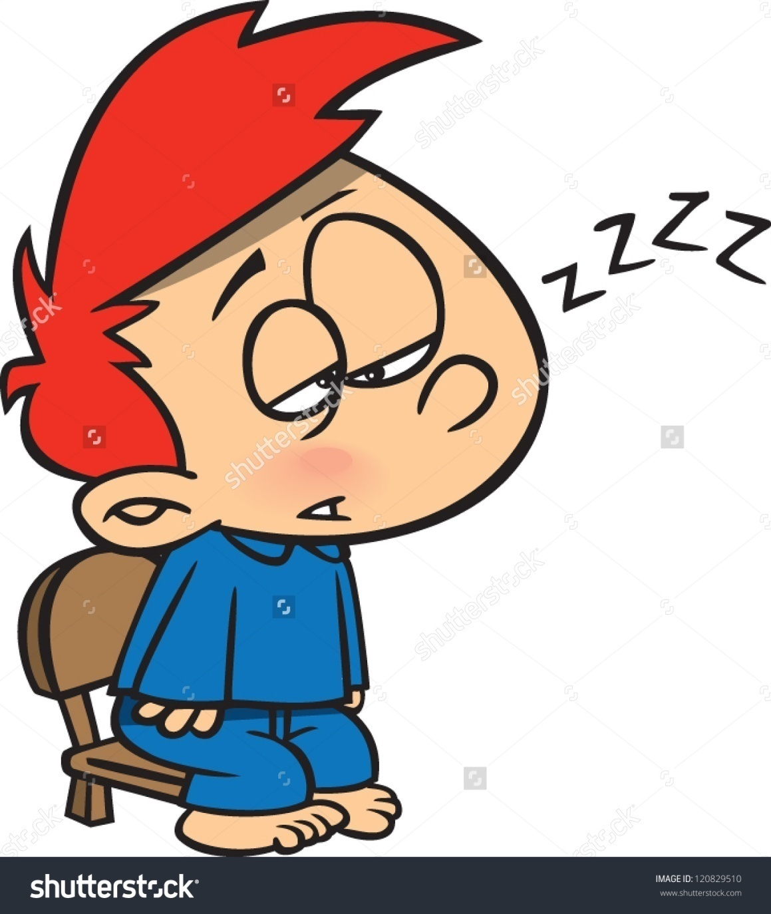

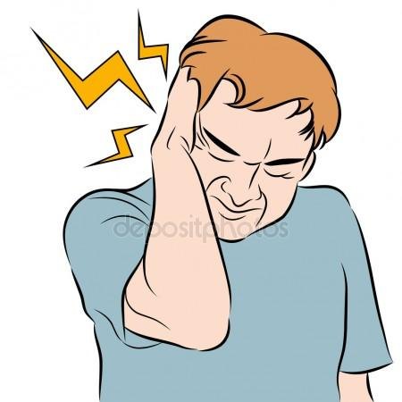

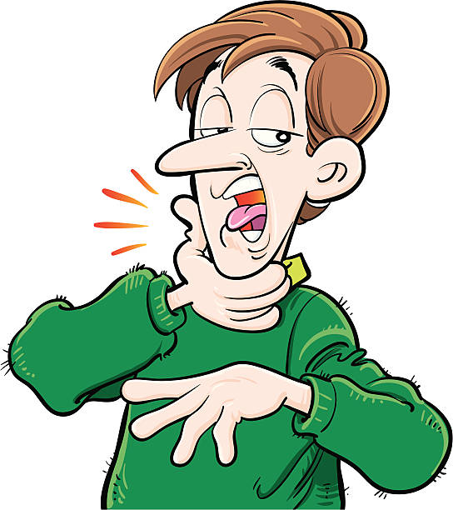

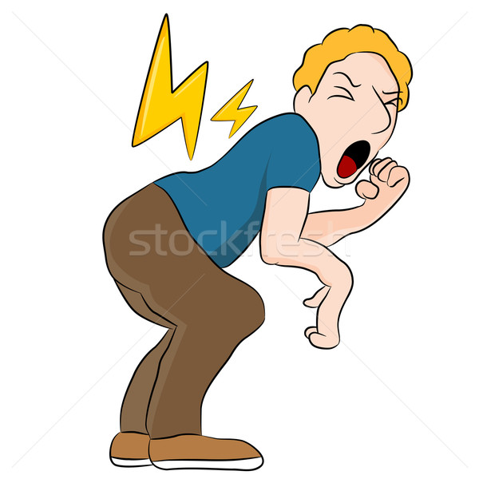

Фразы для картинок пациентов
Patient 1.
Good afternoon, Doctor! I have got a headache.
What must I do?
Patient 2.
P.: Hello, Doctor! I’ve got a sore throat.
What should I do?
Patient 3.:
P.: Hello, Doctor! I’ve got the flu.
What must I do?
Patient 4.
P.: Good afternoon, Doctor! I’ve got red eyes.
What should I do?
Patient 5
P.: Hello, doctor! I have got earache.
What must I do?
Patient 6.
P.: Hello, doc! I’ve got backache.
What must I do?

