Рисунок 2.

It is not very big.  [ɪt ɪz nɒt verɪ bɪg]  It’s red and white.  [ɪts red ən waɪt]  It _________ run, jump and hunt very well.  [ɪt kən rʌn | ʤʌmp ən hʌnt verɪ wel]  It _________ fly.  [ɪt kɑːnt flaɪ]  It _________ climb trees.  [ɪt kɑːnt klaɪm tri:z] | 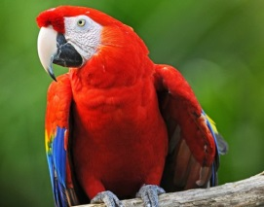  parrot
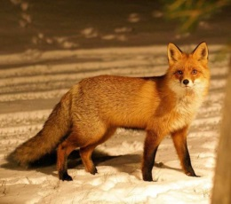
fox
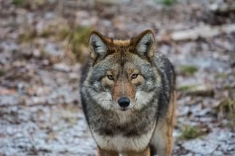
wolf

It is not very big.  [ɪt ɪz nɒt verɪ bɪg]  It’s red, white, blue and yellow.  [ɪts red waɪt blu: ən jeləʊ]  It _________ run, jump and hunt.  [ɪt kɑːnt rʌn | ʤʌmp ən hʌnt]  It _________ fly very well.  [ɪt kən flaɪ verɪ wel]  It _________ climb trees.  [ɪt kɑːnt klaɪm tri:z] | parrot
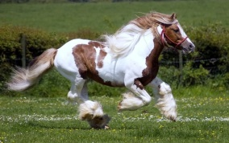
horse
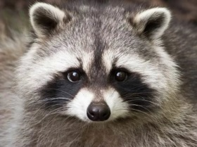
raccoon

It is big.  [ɪt ɪz bɪg]  It’s white and brown.  [ɪts waɪt ən braʊn]  It _________ fly and hunt.  [ɪt kɑːnt flaɪ ən hʌnt]  It _________ run very well.  [ɪt kən rʌn verɪ wel]  It _________ climb trees.  [ɪt kɑːnt klaɪm tri:z] | 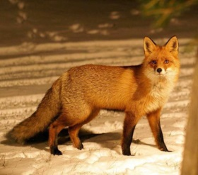  fox
 | horse
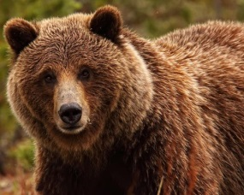
bear

