present

ball | 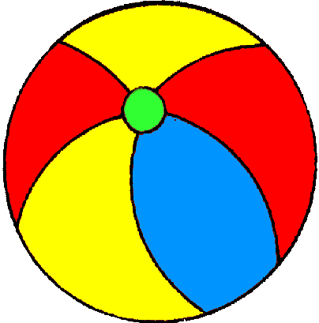
cake | 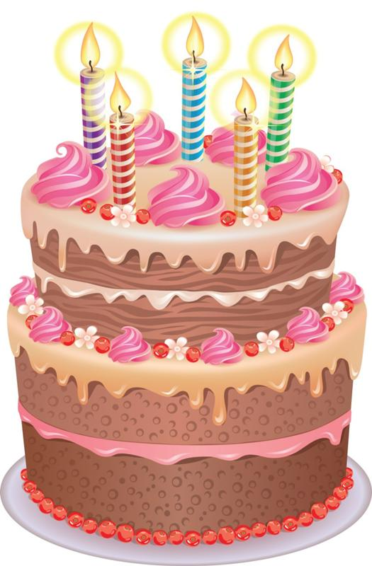
postcard | 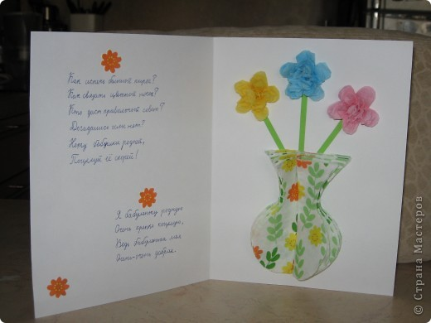
flowers
balloons
toys | 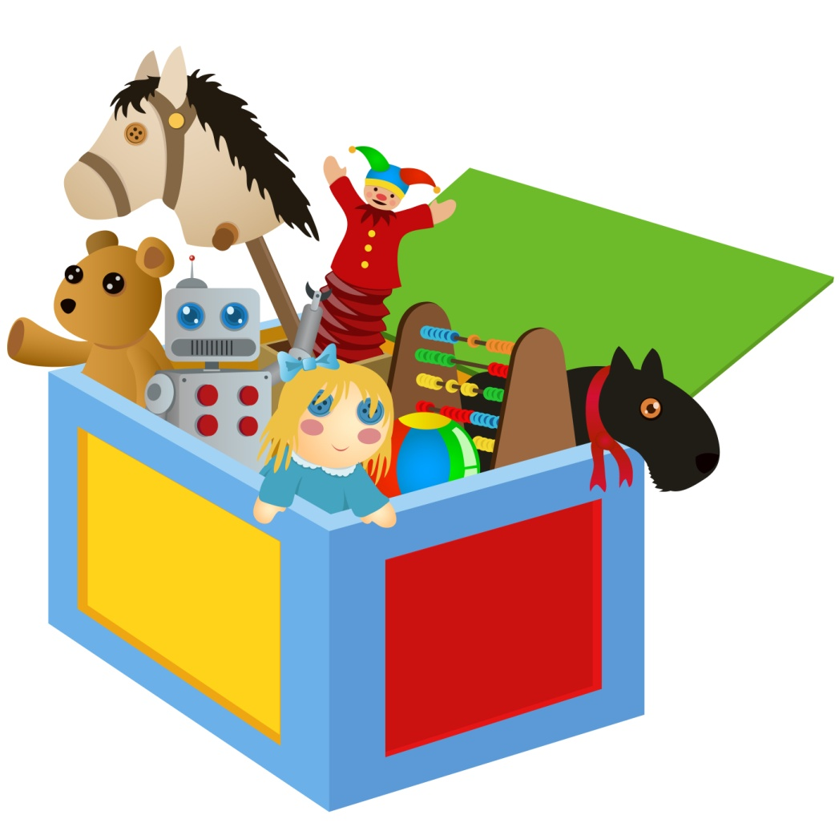
holiday | 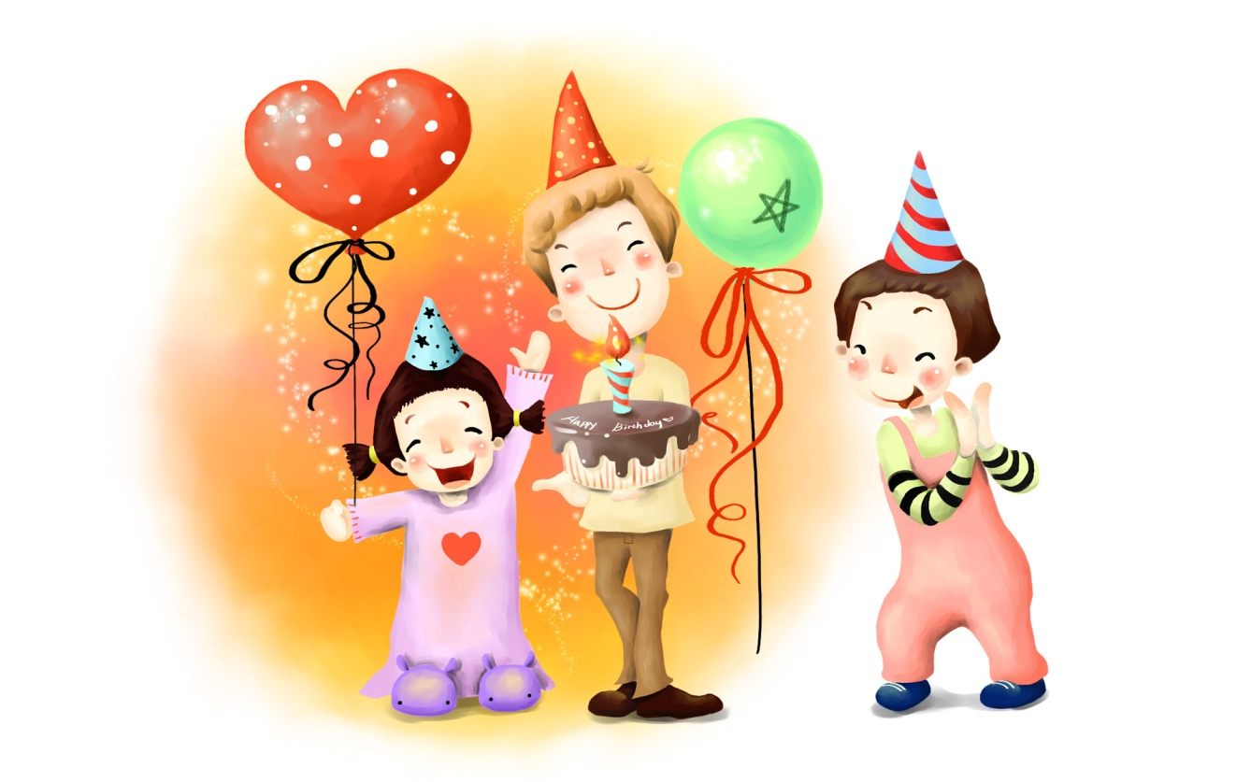
year
sweets
Teddy bear | 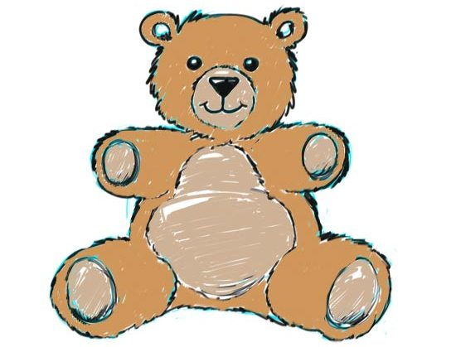

Источники картинок:
present | http://meddovidka.ua/images/stories/1_spisok_preparatov/3330007788930.jpg
ball | http://cliparts.co/cliparts/kTM/nRA/kTMnRALjc.gif
cake | https://otvet.imgsmail.ru/download/u_4e3ac4d76dfbeb53133ac27bfa606c96_800.jpg
postcard | http://img.searchmasterclass.net/uploads/posts/2013-06-09/image_1059071.jpg
flowers | http://vserisunki.ru/papka2/buket/buket_mini.png
balloon | http://cs4460.vk.com/u6202631/-14/x_83a33982.jpg
toys | http://images.easyfreeclipart.com/198/toy-swap-mercer-island-preschool-association-198065.jpg
holiday | https://im1-tub-ru.yandex.net/i?id=6fc5e58bb0381be721884a31e08d68f3&n=33&h=215&w=323
year | http://galerey-room.ru/images/073523_1412912123.png
sweets | http://samlib.ru/img/c/chernjaewa_w_j/podarkidedamoroza-1/konfety_copy.jpg
Teddy bear | https://im1-tub-ru.yandex.net/i?id=7657ca276e7550329fe7020a3d08b01a&n=33&h=215&w=282

